.

TABLE OF CONTENTS
1 Summary 3
2 Background 3
3 Requirements for New System 3
3.1 Controller Requirements 3
3.1.1 Control Actuators 3
3.1.2 Temperature Control 3
3.1.3 Temperature Set Point 3
3.1.4 Exchanger Icing Condition 3
3.1.5 Mirror Condensation Prevention 3
3.2 Electrical Requirements 4
3.2.1 Heater 4
3.2.2 Cooling Water Flow Actuator 4
3.2.3 Fan 4
3.2.4 Air Handler Temperature Sensor 4
3.2.5 Board Temperature Sensor Error! Bookmark not defined.
3.2.6 Spare Temperature Sensor 4
3.2.7 Differential Pressure Sensor 4
3.3 Mechanical Requirements 4
3.4 Interface & Communications Requirements 4
3.4.1 TCS3 Interface 4
3.4.2 Dew Point Temperature Sensor 4
3.4.3 Mirror Temperature Sensors 4
4 Design 5
4.1 Overview 5
4.2 Major Components 6
4.2.1 Ethernet Hub Error! Bookmark not defined.
4.2.2 Galil Pocket PLC 6
4.2.3 Relay Board and Temp Filter 6
4.3 Controller Algorithm 6

TABLE OF FIGURES & REPORT TABLES
Figure 1 Mirror Cooling Control System Block Diagram 5

Summary
This document lists the specifications and requirements for a new Mirror Cooling Controller and also includes the design and other information. This is not a major project, so much of the information can be conveniently placed in one document (excluding software).

Background
Cold air is blown over the mirror during the day to cool it down before observing at night, when it is off to avoid air turbulence which affects seeing. The goal is to cool the mirror down to the outside air temperature.
As of August 2009, the IRTF has a manual system for cooling the mirror – it is turned on when the day crew arrives and off when they leave (Mon – Fri). Just prior to this, it was a combination of manual and limited automation. This system was also powered on when the day crew arrived and then turned off when they left. However, it also had a controller that would simply blow cold air on the mirror and when it detected ice build up on the heat exchanger, it would stop cooling, turn on a heater for 30 minutes to melt the ice, and then resume cooling. The microcontroller on the Relay Board failed and it was decided to just make it completely manual since its operation was very close to being manual anyway and to then design a new Mirror Cooling Controller. Being able to automatically control the air and heater on weekends when nobody is up at the summit will be a requirement.
Continuously blowing cold air bas been acceptable since there is not sufficient cooling capacity to lower the mirror temperature below the outside air temperature. However, in the future, the intention is to have sufficient cooling capacity to lower and control the mirror’s temperature at a specified set point. Thus, a new controller will be required to accomplish this.

Requirements for New System

Controller Requirements

Control Actuators
The control system shall control a fan to blow air on the mirror, a valve to control the cold glycol from the cooling system to the heat exchanger, and a heater to melt ice that collects on the heat exchanger from condensation.

Temperature Control
The temperature of the mirror (average of the 6 mirror temperature sensors) shall be controlled to within +/- 1 deg C of the set point. Since the mirror cooling system only has the ability to cool, it is only required to control the mirror temperature if the set point is below dome air ambient temperature.

Temperature Set Point
The control system shall accept temperature set points from -10C to 20C.
NOTE: The input range can be large, but it just won’t be used in practice. It also won’t drive the design, so it can be anything really as long as it encompasses the actual temperature range that will be used.

Exchanger Icing Condition
The control system shall detect and remove heat exchanger icing conditions.

Mirror Condensation Prevention
The control system shall monitor the dew point temperature and cease cooling if the mirror temperature is less than ??? deg C above the dew point temperature.

Electrical Requirements
Since this is not a new design, many of the interfaces and components exist.

Heater
The control system shall power two heaters that are each rated at 208 Vrms and 5.5 A (resistance measured at 38Ω). Total power will be about 2300 Watts (11 A @ 208 Vrms).

Cooling Water Flow Actuator
The control system shall control a glycol flow actuator that has a nominal control voltage of 6 -9 VDC which is directly proportional to valve stroke, i.e. 6 VDC (fully closed) to 9 VDC (fully open). The control signal input impedance is 10kΩ.

Fan
The control system shall power a fan, via a contactor, used to blow air over the mirror.

Air Handler Out Temperature Sensor
The controller shall monitor the outgoing air temperature from the air handler. The temperature sensor is a 10 kΩ (25 °C) NTC thermistor.

Air Handler Out Temperature Sensor
The controller shall monitor the incoming air temperature for the air handler. The temperature sensor is a 10 kΩ (25 °C) NTC thermistor.

Glycol Temperature Sensor
The controller shall monitor the glycol temperature. Sensor will be mounted to the glycol metal piping. The temperature sensor is a 10 kΩ (25 °C) NTC thermistor.

Differential Pressure Sensor
The controller shall monitor the differential pressure sensor. Its output is an on/off type switch which is normally open.

Fire Alarm Protection
The fire alarm system has a normally closed switch output that is wired in series with one voltage leg of the motor contactor.

Mechanical Requirements
There are no stringent mechanical requirements. Controller board must simply fit in a box mounted on the wall.

Interface & Communications Requirements

TCS3 Interface
The control system shall be built around the TCS3 control system. The TCS3 system shall be the actual controller in the control system and other hardware essentially carries out its commands. Remote hardware shall interface to TCS3 via Ethernet and provide relevant telemetry and accept on/off commands.

Dew Point Temperature Sensor
The control system shall query and receive dew point temperature data from the dew point temperature sensor via Ethernet. Describe model and equipment here.

Mirror Temperature Sensors
The control system shall receive mirror temperature data from the mirror temperature sensors. The values are provided by the iqup system. The temperature sensors , known as TD1 thru 6, are archived in the iqup mysql database.

Design

Overview
All of the sensors and actuators already exist and are in place for this design. In actuality, only the controller and interface is being designed as opposed to an entire control system. The design goal was to make this control system as simple as possible while not making it too dependent on other systems. Below is a block diagram illustrating the entire control system with new components highlighted in orange.
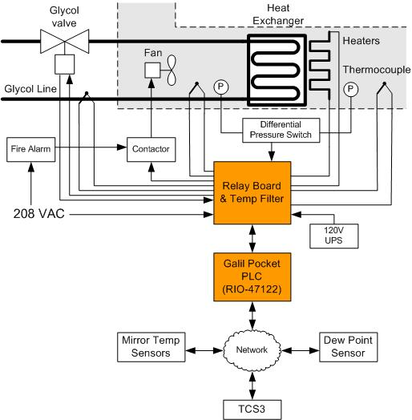

Figure 1 Mirror Cooling Control System Block Diagram

Major Components

Galil Pocket PLC
This device offers an assortment of I/O and other options suited for industrial applications, particularly:
6 PID controllers
8 analog inputs (+/- 10V, 12 bit ADC)
8 analog outputs (+/- 10V, 12 bit DAC)
16 optically isolated digital inputs
8 isolated digital outputs
Ethernet connection
The type and number of I/O offered meet the requirements for the control system and the PID controllers can be used if desired. This device is relatively inexpensive (~$345) and small (3.88” x 4.26” x 1.26”).

Relay Board and Temp Filter
As its name implies, the board will provide relays and buffers that can be activated to provide power to the fan, heater, and glycol valve. In addition, filtering for the thermistors will also be provided as well as AC to DC conversion to supply power to the Galil Pocket PLC.

Controller Algorithms (section is TBD)

Thermistor Temperature Conversion
Thermistors are extremely nonlinear. However, their temperature vs. resistance curve can be accurately approximated by the Steinhart-Hart equation. Since computers are cheap and readily available, a somewhat complex equation is not an issue. Equations are copied directly out of a Mathcad sheet that derived them. The units should be ignored in the equations. The units are not entirely correct since Mathcad has issues with the natural log and units so some “fudging” of units occurred. Strip off the units (but keep exponents like ‘k’)and the answer will be in Kelvin. Equations could be arranged differently, but this is what Mathcad displayed by default.
The equation to get the temperature (in Kelvin) for a given resistance is:
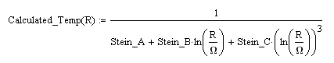
Where:
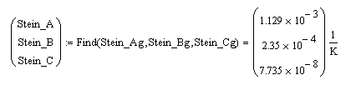
R is equal to:
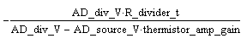
Where:
AD_div_V is the thermistor voltage measured by the AD.
AD_source_V is the source voltage (about +9V) measured by the AD.
R_divider_t is nominally 36.5 kΩ.
thermistor_amp_gain is nominally (1 + 10kΩ/36.5 kΩ) = 1.274

Heater Cycle

