5. Encoder Replacement

5.1 Top Level Encoder Requirements.

The encoder requirements for the new TCS are as follows:

Absolute position resolution: 6.0 arcsec, 3.0 desired [>6.0 arcsec is current TCS resolution]
Incremental position resolution:
5x position resolution specification of 0.1 [0.2 arcsec is current TCS resolution]
Maximum slew rate: 2000 arcsec/sec on sky
Maximum slew acceleration: 2000 arcsec/sec²
Environment: -10 to 50 deg C.
Humidity: 100% Relative Humidity.

The old TCS is currently unsupported and the implication of this is that we cannot modify any of the existing encoding hardware, until after the new encoders are commissioned. Unfortunately, the old encoders are installed at the best locations (easy access, stiffness, protected, etc.) on the telescope.

5.2 Absolute Position Encoders (APES)

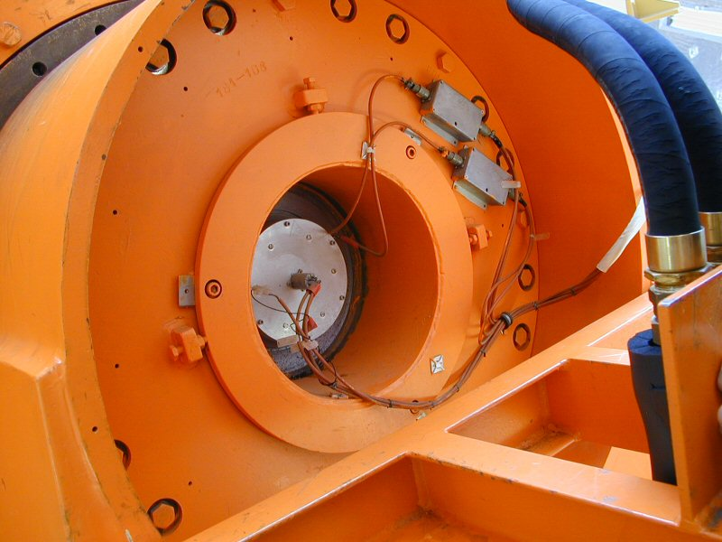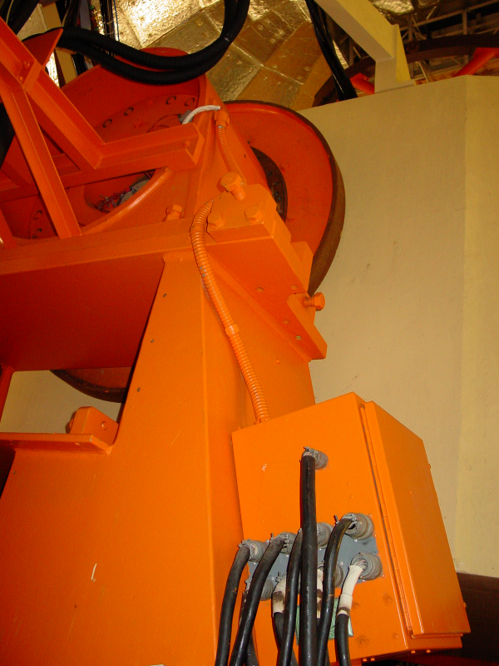
HA APE sensor & PreAmps HA JBOX

The Absolution Position Encoder (APE) sensors consist of a resolver and an inductosysn transductor, which provides coarse (0-360 degrees) and fine (~2-0.5 degrees ) resolutions. Electronics circuits combine the coarse and fine data into a 19-bit work. This parallel data is transmitted to the MCC using parallel-to-serial converts. The resolution of the APE is about 6 arc seconds.

The HA absolute position encoder (APE) is located at the North Pier. The sensor and amplifiers are locate at the north axis, and JBOX with the A/D converter hardware is located on the side of the structure.
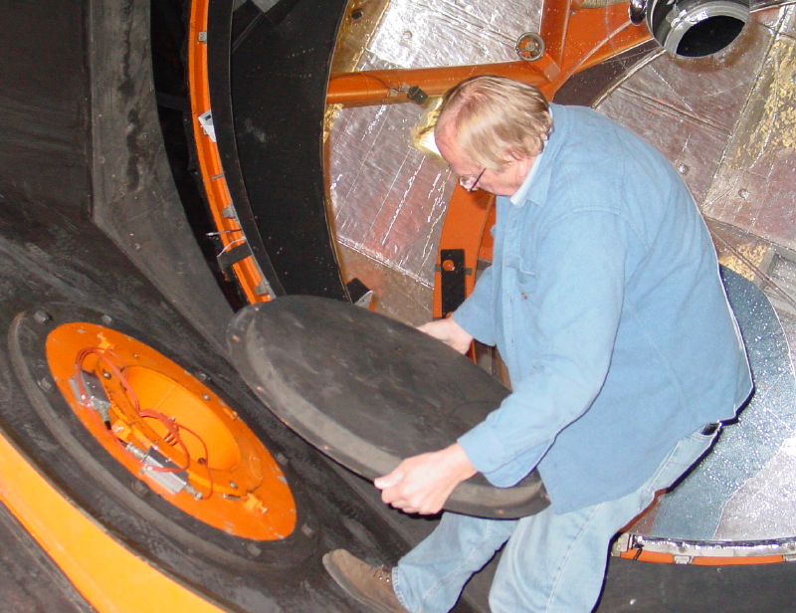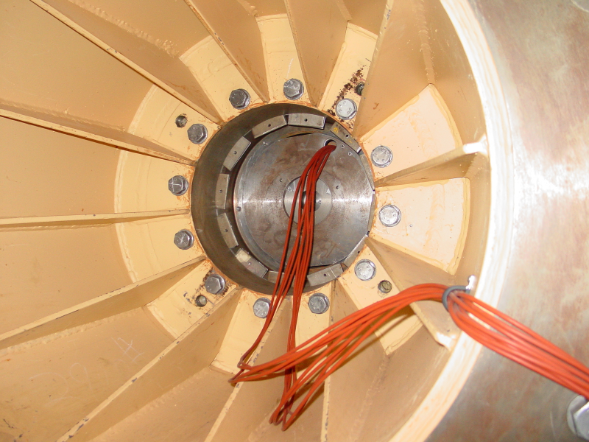
HA APE sensor & PreAmps in mirror cell West area of yoke (JBox out of view)

The DEC APE is located in the west arm of the yoke. This sensors and pre-amps are accessed by opening a cover in mirror cell at the west axis. The senor/preamp wiring exits via the west arm of the yoke where the JBox electronics.

Numerous Photos of the APE hardware can be found at here:

http://irtfweb.ifa.hawaii.edu/~tcs3/systems/tcs3/0309_Design/06_Encoders/photos/2004-09.web/

http://irtfweb.ifa.hawaii.edu/~tcs3/systems/tcs3/0309_Design/06_Encoders/photos/2004-09.raw/

The following diagram summaries the APES Installation plan. (Larger version located with this document as the visio document APE_block_diag.vsd )

APES Block Diagram

For TCS3 new electronics will be installed along side the existing APE electronics. The pre-amp and transformation will be located near the existing pre-amps near the sensor (resolver/transductor). A new APE JBox will be mounted near the existing TCS1 APE JBox. The resolver and transductor’s convert boards, and embedded CPU board will be located in side the new JBox. The embedded CPU will perform the correlation algorithm and provide APE data via remote-procedure-calls. The power to the system is provide by the existing JBox. The APE sensor can only be attached to a single system, TCS1 or TCS3. It may be possible for the TCS3 to feed APES data to tcs1, either by using the forth hhmmss.ss ddmmss.s !START command or feeding parallel data directory to the MCC.

The correlation logic was provided by Farrand Controls. Review the vendor data at:
http://irtfweb.ifa.hawaii.edu/~tcs3/systems/tcs3/vendor_info/Farrand_Controls/

The following directory also contains a detailed block diagram of the new system and electronic schematics:

http://irtfweb.ifa.hawaii.edu/~tcs3/systems/tcs3/0309_Design/06_Encoders/
5.3 Incremental Encoding.

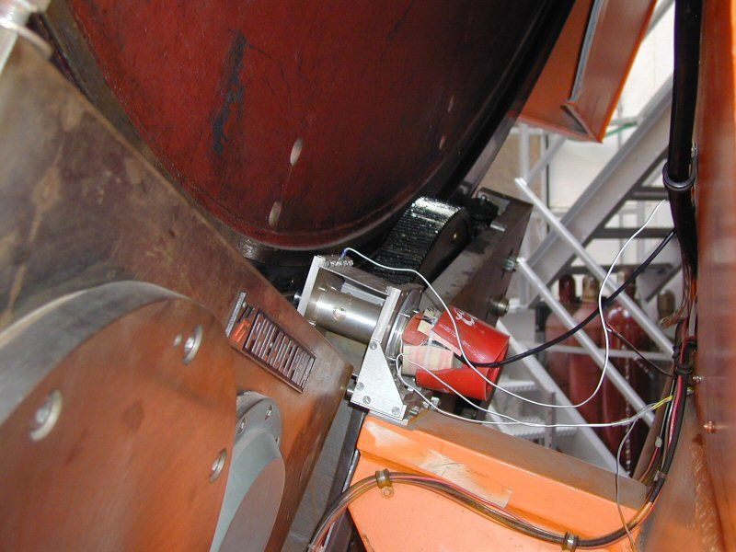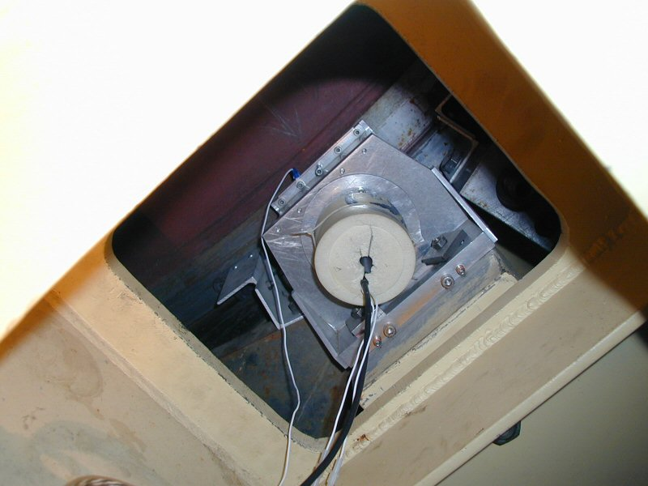
RA Inc. Encoder Dec Inc. Encoder

The current RA incremental encoder is located on the South Pier. It is an optical type encoder (manufacturer – Teledyne Gurley) driven through (approximately) a 180:1 gear ratio friction drive on the back of the bull gear.

The current DEC incremental encoder is located in the west arm of the yoke and access is from inside the yoke. It is also an optical type encoder (identical to the RA encoder) also driven through (approximately) a 180:1 gear ratio friction drive on the back of the bull gear.

Both of the current incremental encoders have a 3600 line count and associated electronics capable of 40x interpolation for a total of 144 000 pulses/ revolution. After accounting for the gear ratio, this works out to about (3600 x 40 x 180) / (360 x 60 x 60) = 20 pulses per arcsec or 0.05 arcsec resolution.

*** Currently, the exact gear ratio is determined through a calibration procedure and works out to be about 19.9041?!?

5.6 Dome Encoder

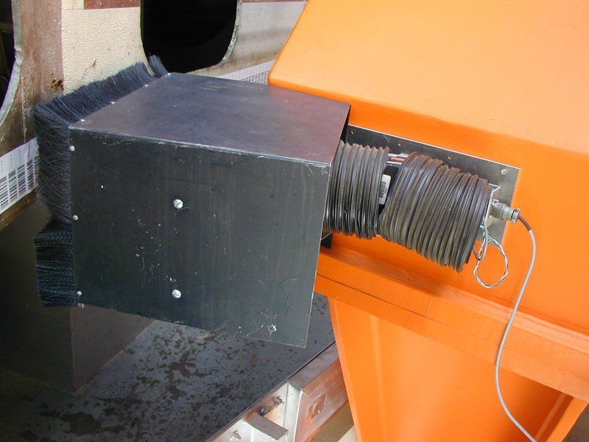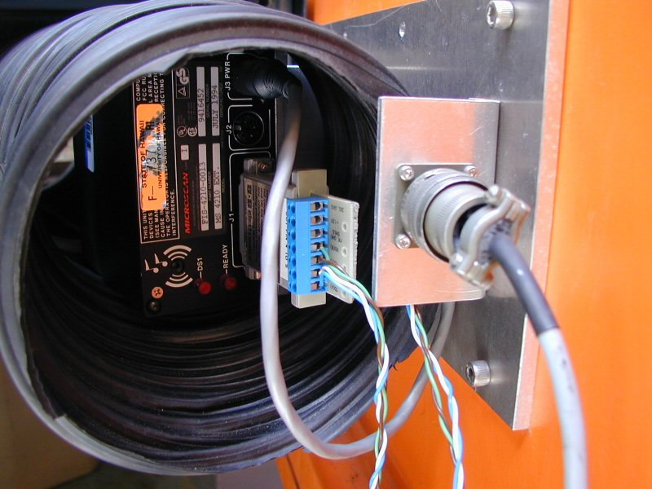
Dome Scanner (side view) Dome scanner (back)

The dome is encoded using a bar code label and a scanner. The scanner outputs is serial (RS-232?). The serial is converted into a parallel graycode using an embedded CPU board.

The barcode values range from 1 to 1800, giving the dome a resolution of 0.2 degrees.

The RS-232 or 422 outputs will be mirror, and feed into the TCS3 Facility IO box. An opto22 serial module will receive the dome scanner data. The TCS3 main program will read the Opto22 serial data and provide the dome position to TCS3.

5.7 Budget / Manpower

The IRTF will provide the mechanical, electrical, and software support via Bond, Keske, and Denault.

Initial cost estimates are as follows:

