Replacement Telescope Control System for the IRTF
Final Report

1 Introduction

The IRTF Telescope Control System has been in development since May 2003. The project was named ‘TCS3’ as it is the third version of the TCS to be designed. The objective of this project was to replace the obsolete Master Control Console (MCC) servo electronics and Forth computer system with a new servo system and a new computer system and software since we are no longer able to purchase spare parts or to maintain the software of the old TCS.

Prior to starting work on the TCS, we purchased a backup computer that was able to run the old software. Should the current TCS fail, we would be able to continue operations with the backup computer.

A set of top-level requirements was developed and this is shown in Attachment A. A critical design review was conducted in Aug. 2003 with internal and external experts. The resulting review document is shown in Attachment B. A servo design review was conducted in June 2004 and this is shown in Attachment C. Finally, a safety review was held on Feb. 2005 to make sure that the design met safety requirements and this is shown in Attachment D.

The approach taken was to design the new TCS so that it could be installed and tested while still using the old TCS. This approach allowed for testing to be done in the daytime without interrupting the night time observations. The switch over between the old and new TCS requires switching a few cables and takes only about 15 minutes.

The core project members were: A. Denault (Software/Project Manager), F. Keske (Electronic/Servo Engineer), and D. Watanabe (Electronic Tech). We also employed a junior software engineer for about one year and the IRTF Day Crew also helped with the installation of the TCS at the telescope.

2 Summary of work performed.

An overview of the TCS3 system is provided in Figure 1. The blue boxes show the components of the TCS that were built to replace the old TCS functions. The black boxes show the telescope hardware that was left unchanged. The red box shows the remaining component of the old TCS system. This is the MCC, a picture of which is shown in Figure 2.

A laboratory system was constructed that allowed testing of all the components of the TCS3 system. It included a mechanical simulator for the right ascension (RA) and declination (DEC) axes. This laboratory system was completed in Feb. 2006. The lab system allows testing to be done in Hilo and it provides a complete backup of the servo system.

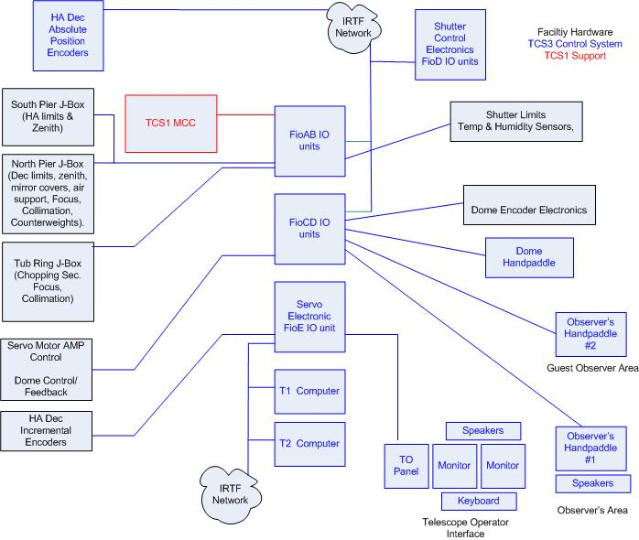
Figure 1. Block diagram of the TCS.

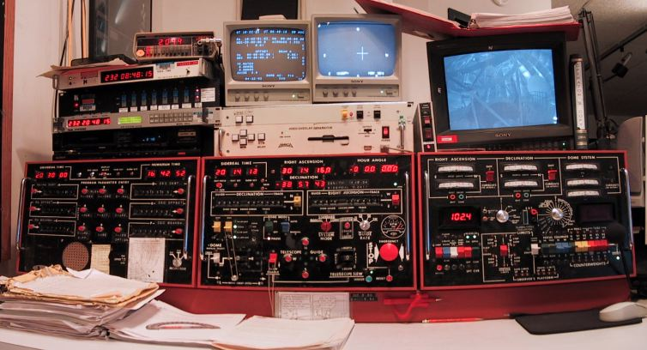
Figure 2. Master Control Console (MCC). This is the old TCS. Many of its functions have already been transferred to TCS3. When the new servo system has been certified to be operational, the entire MCC will be removed.

A staged installation of components at the summit was started in Apr. 2006. As components were installed and successfully tested, the corresponding components were disabled in the old TCS. This work was accomplished in the daytime so that there was no impact on the observing at night. The TCS3 electronics is currently performing all of the following functions every night:

1. Mirror cover control
2. Mirror support control
3. Collimation control
4. Focus control
5. Environmental monitoring of temperature and humidity.
6. Counterweight control
7. Dome control
8. Shutter control

The servo electronics was the final component to be installed and tested. The design allowed quick switching of the old and new servo systems, and therefore no observing was affected by this work. Once we were able to switch between TCS1 and TCS3, our goal was to demonstrate a stable system under TCS3 control. It took a few weeks to identify and correct problems, but stable control was accomplished in May 2006. We ran the TCS3 in tracking and slewing modes.

In June 2006, TCS3 had its first engineering night. Our goals were to take comparison data between TCS1 and TCS3 for tracking and to take pointing data using TCS3. This was accomplished successfully.

The safety board circuit board required numerous fixes, and it was decided to remanufacture the board in April. Revision 2 of the safety board was built and installed at the IRTF in August 2006.

As of the date of this report, we have successfully operated the servo system. We are able to slew, track on stellar sources, and offset in both the HA and Dec axes. We see about 0.5 arcsec peak-to-peak tracking errors and a settling time for offsets of about 5-10 seconds. Our goal is 0.1 arcsec peak-to-peak tracking errors and less than 2 seconds settling time after offsets. A review by an experienced servo engineer indicates that this is now just a matter of tuning the servo system.

Additional tasks completed under the TCS3 upgrade project:

1. Spare amplifiers for HA, DEC motors purchased in April 2006.
2. T. Bond completed the spare HA and DEC motor mount hardware in June 2006.
3. A new weather sensor was installed at the IRTF (temperature, humidity, dew point) in Nov. 2006.

Other items that are being completed are:

1. Installation of observer's hand paddle.
2. Instrument support: Modify SpeX, NSFCAM2, and acquisition camera software for native TCS3 commands. Implement tcsd.v3 to mimic a subset of TCS1 commands for legacy software.
3. Documentation for the Day Crew.

These are straightforward items to implement and no difficulties are anticipated.

The Project Manager, Tony Denault, has been documenting the project online. The top-level of the documentation is shown below:

In addition, there is an on-line User’s Manual for the Telescope Operators and Day Crew. The top-level of this site is shown below:
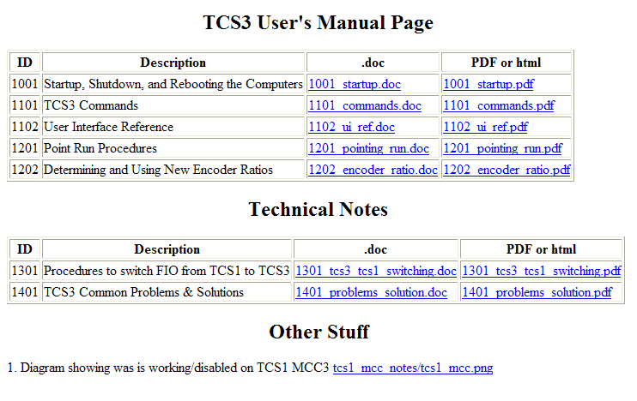

3 Photos of the TCS3 equipment installed at the summit.
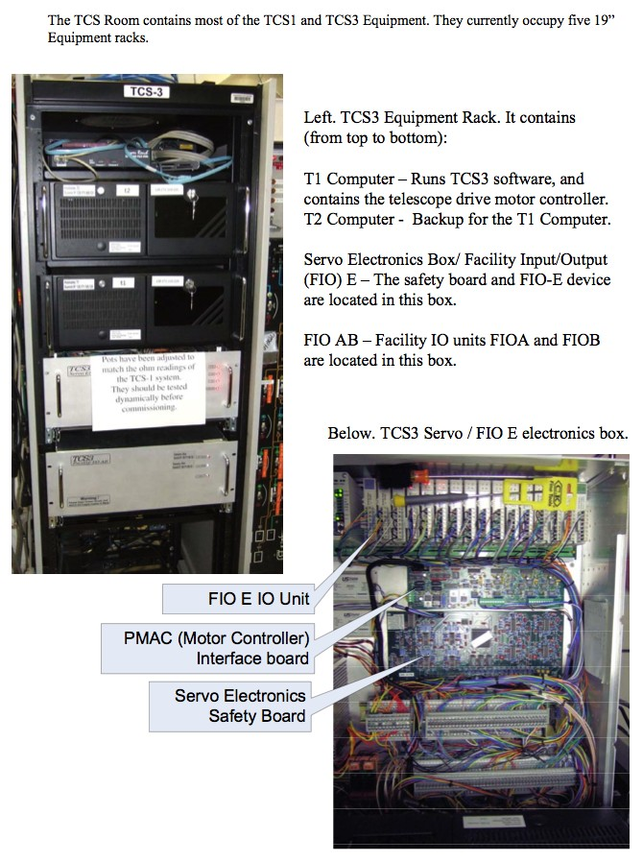

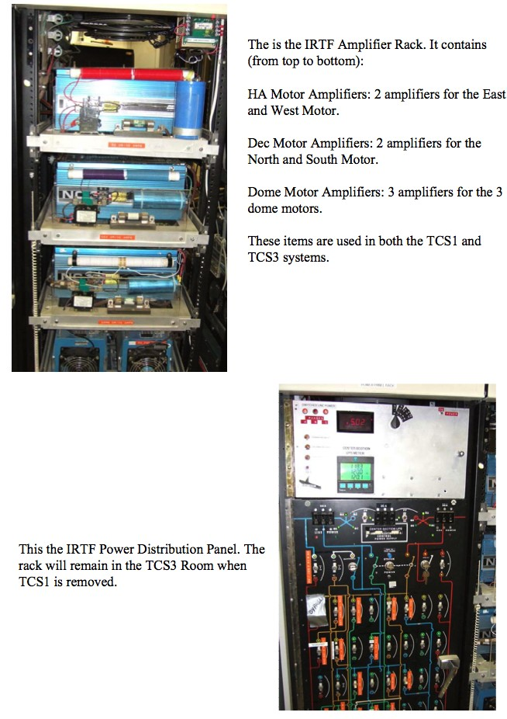

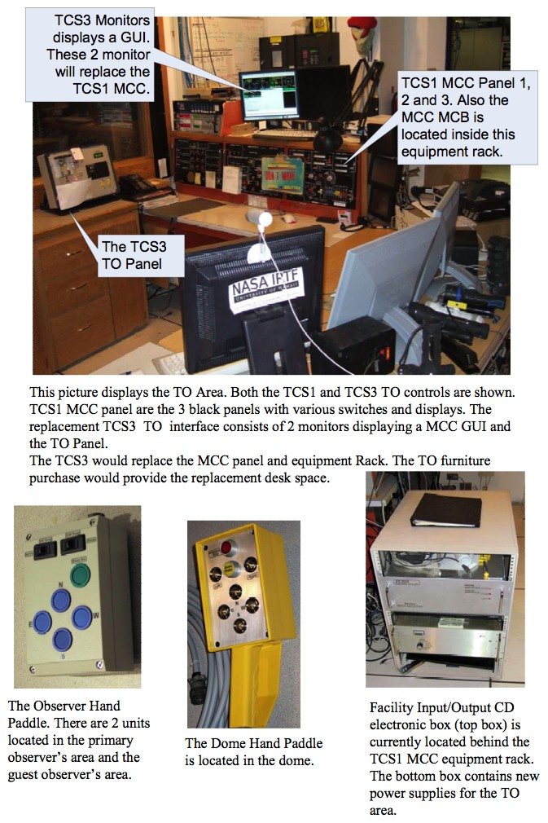

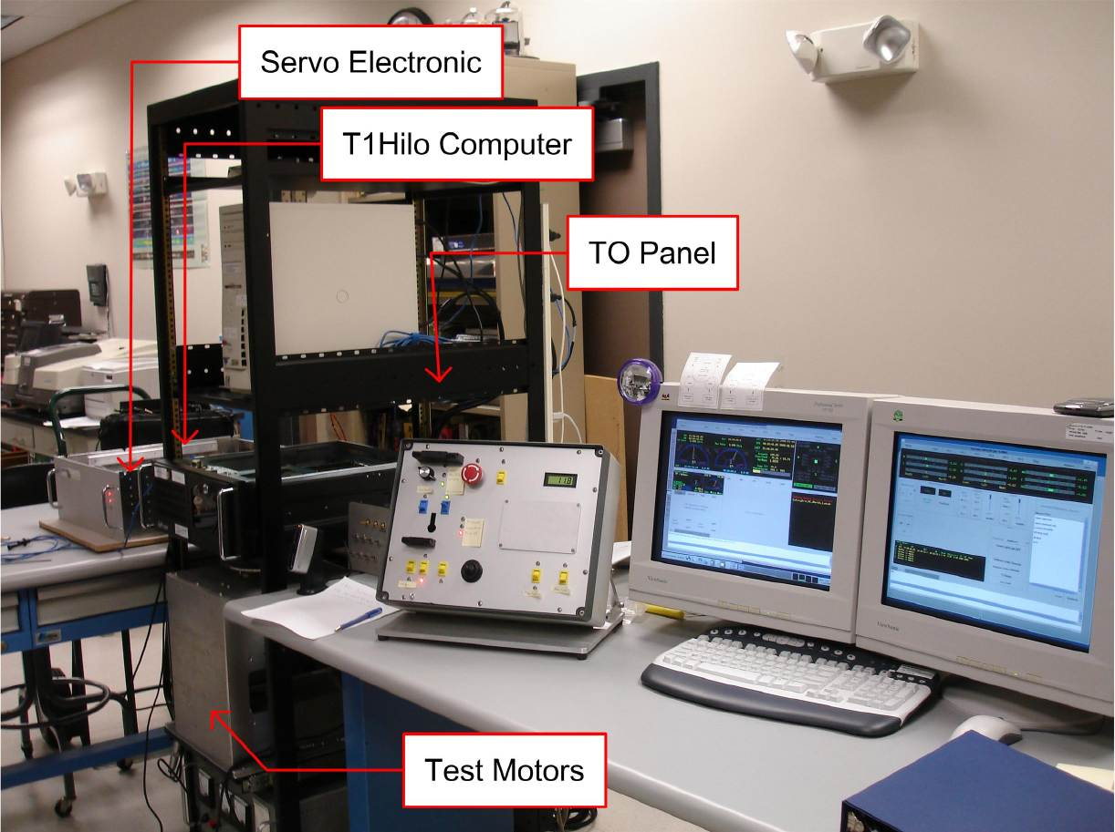

Lab system in the IFA Hilo facility building. This system duplicates the TCS3 electronics at the summit.

Attachments

Attachment A. Top-level Specifications.

Attachment B. Critical Design Review.

Attachment C. Servo Design Review.

Attachment D. Safety Review.

