StarCat

IRTF Star Catalog Application

User’s Guide v2302

Table of Contents
1. What is STARCAT? 2
2. Setting up your user account 2
3. Starting STARCAT 3
4. Main Catalogs Search Options 3
4.1 About the Radius Parameter 4
5. Main Catalog Display options 6
6. User List 7
6.1 How to load your object list: 7
6.2 Other User List functions: 7
7. SkyMap Panel 7
8. Setup Panel 10
9. Userlist v3 11
9.1 The Userlist v3 text format 11
9.2 The Userlist FAQ 11
Appendix A – Dictionary of Commands 13
Appendix B – Depreciated UserList Formats 20
9.1 New_Format – Starcat2 to Starcat4 v2109. 20
9.2 Old_Format 20

1. What is STARCAT?

The STARCAT software is a tool used to search star catalog files. Its 2 main functions are to provide Main Catalogs and manage the User List:

Main Catalog – There are numerous standard astronomical catalog available. User can specify a search coordinates and starcat will search the indicated catalogs and list the nearby stars.
User List – User can load their object list (a text file of objects) into the user list window.

Startcat can send slew request to the TCS using these catalogs lists, and query the TCS for its position for new search coordinate. These catalog lists can be viewed in a variety of formats, and sorted based on different fields. Starcat calculates the observed positional information on all listed objects. Is also display a diagram of the sky showing where the stars are located related to the IRTF’s view of view.

If you have questions or comments concerning STARCAT, you may contact the IRTF. The starcat home page is at http://irtfweb.ifa.hawaii.edu/~tcs3/related/starcat/.

The current version of starcat is StarCat4

2. Setting up your user account

When STARCAT starts up, it read the file ~/.starcat-init in your home directory. Using a text edit, you can customized STARCAT using commands from Appendix A. For example, the file may contain the following instructions to set the search radius, and load the user catalog from the user’s home directory.

If this file exist, STARCAT expects it to contain STARCAT commands. See the STARCAT Command Dictionary for the syntax. Using a text editor you can place instructions in this file to configure when STARCAT starts up. Here an example of a .starcat-init file:

guider none
mainsort Ang.Offset
catalog.clear
catalog.set nomad
SkyMap.ShowSmokey on

3. Starting STARCAT

STARCAT is installed in all IRTF observing workstation. Type ‘starcat’ on your terminal start it. Many observing desktop may have a STARCAT icon for you to use.

When starcat stars this window should appear on your screen:

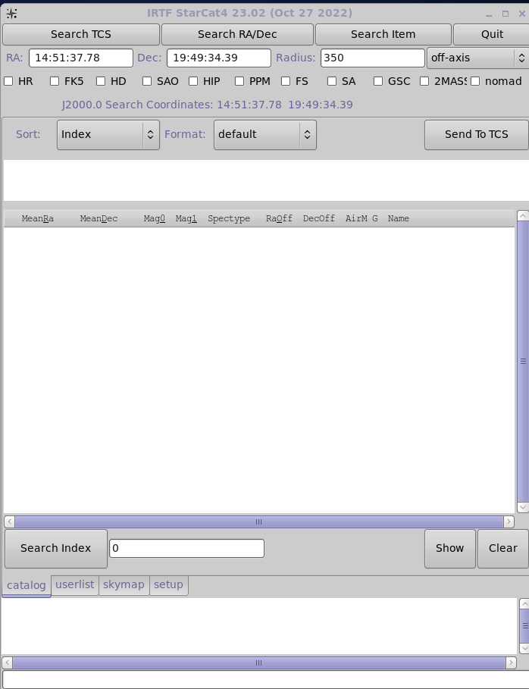
Figure 3.1 – The Base Window

4. Main Catalogs Search Options

These widgets allows you to search the Main Catalogs (HR, FK5, HD, ..) for data.
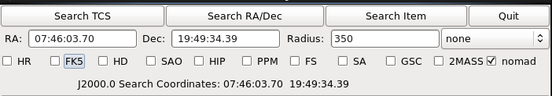
First select the catalog you wish to search, and insure the Radius is correct. You have 3 options as indicated by the 3 search buttons:

Search TCS – Starcat will query the TCS, update the RA/DEC field with the TCS's position, and perform a search on this position.
Search RA/DEC – First enter the coordinates in the RA/DEC text fields. Press this button to search the entered RA/DEC position.
Search Item - if you have catalog data loaded in the Main or User catalog list. You can highlight an entry and use that position as your search position. After highlighting a catalog entry, click the Search Item button.

Below the list of star is Search Index.
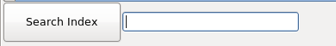
Enter the Numeric ID for the star to find a particular star, for example, to find SAO_45859 enter 45859. For SA stars, the enter 4 digit for each NNN-NNN part, ie SA-35-535 would be “00350535”. GSC, 2MASS, and NOMAD are not supported.

4.1 About the Radius Parameter

Search will look for star at the FK5 J2000.0 search coordinates. Stars within the search radius will be placed in the main catalog. The Radius has 2 widget associated with it. The text field and pull down menu.

The pull down menu has selection which determine is the radius is automatically. The options are:

Off-axis – The radius is set to the field of view of the off-axis camera (350 arcseconds).
Cshell – The radius is set to the field of view of the cshell guider (90 arseconds)
None – When set to none, the radius is set to the minimum suggest value of all the selected catalogs. The minimum values are:
HR 18000 arcseconds or 5 degs
FK5 36000 arcseconds or 10 degs
HD 2500 arcseconds, or 0.7 degs
SAO 3600 arcseconds, or 1 degs
HIP 7200 arcseconds, or 2 degs
PPM 7200 arcseconds, or 2 degs
FS 108000 arcseconds, or 30 degs
SA 36000 arcseconds, or 10 degs
GSC 540 arcseconds, or 0.15 degs
2MASS 900 arcseconds, or 0.25 degs
nomad 350 arcseconds (offaxis guider FOV).

5. Main Catalog Display options

Clicking on the Catalog tab will display the Main Catalog Panel.
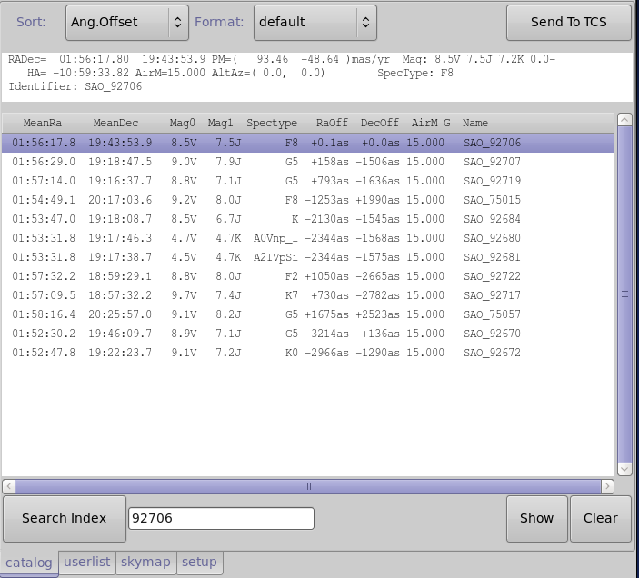

This tab displays the search results from the main catalogs. When you select a star from the list, more
detailed informtion about his object is displayed just about the list. Using you mouse you can highlight/copy information for input into other applications (ie, SIMBAD data searches).

Sort menu – Specifies the sort field for the object list.
Format menu – Specifies the text format for the object list.
Sent To TCS button – Sends the highlighted object’s coordinates to the TCS
Show button – prints the list to standard output.
Clear button – clears the object in the main catalog list.

6. User List

Clicking on the Userlist tab will display the User List Panel.
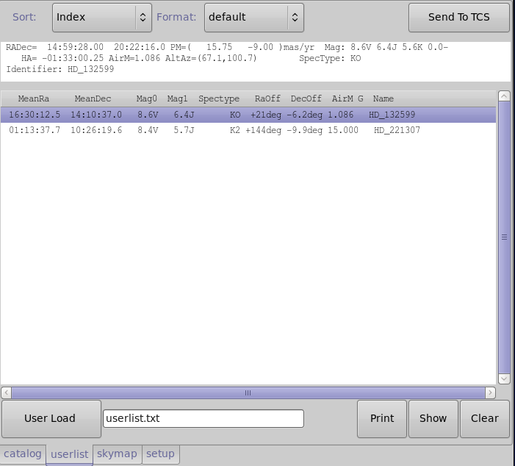

6.1 How to load your object list:

Enter the name of your user list file (the example shows userlist.txt).
Select the format you are using on the menu next to the filename text entry (new or old format).
Select the Load button.

6.2 Other User List functions:

Sort menu – Specifies the sort field for the object list.
Format menu – Specifies the text format for the object list.
SentToTCS button – Sends the highlighted object’s coordinates to the TCS.

Show button – prints the list to standard output.
Clear button – clears the object in the main catalog list.

7. SkyMap Panel

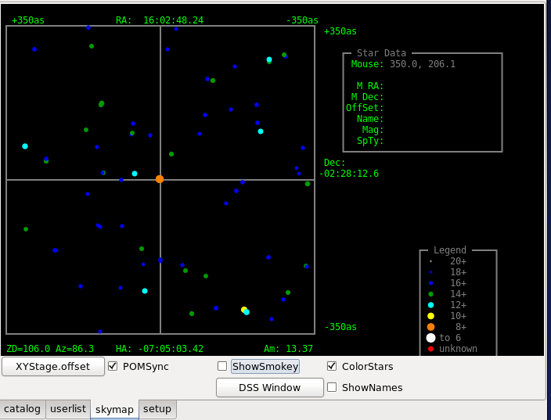 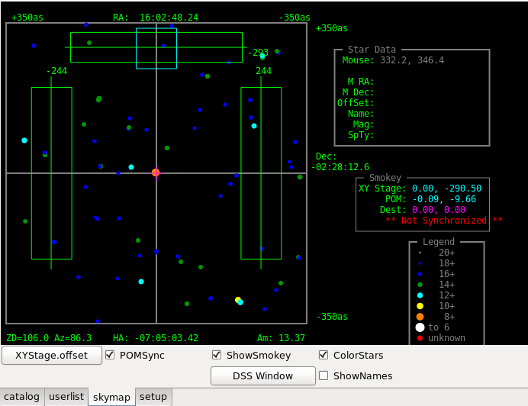 Skymap with ShowSmokey Off and ON

Clicking on the SkyMap tab will present the skymap panel. The SkyMap displays a drawing of the main catalog stars centered on the search coordinates.

The Star Data box on the left will display relevant data based on the mouse cursor position. When positioned on a star, details of the star is displayed.
The Legend box at the left of the coordinate system displays the current magnitude legend. This legend can be used to visually estimate the magnitude of stars shown in the skymap.

ColorsStars – this checkbox switches the legend from a grayscale to a colored scale.
ShowName – When checked, the names of the stars are display in the starmap.

DSS Window – Pressing the DSS Window button will instruct stacat to download a DSS image and display in it a dialog window. This DSS FOV is fixed at 12 arcmin, it is intended to display the star within the smokey offaxis guiding area to help the TO select an offaxis guide star. Note: It may take from 5 to 10 seconds for the DSS window to appear or update, as the image are queried from the DSS server.

Note: Controlling the XYStage should only be done by the Telescope Operator.

If ShowSmokey is enabled, the Smokey box (center-right) will display information relevant to the x-y stage and the POM. The XYstage and POM fields display the positions of x-y stage and POM, respectively. The cyan box show the current located of the smokey's mirror/POM. Clicking on the mouse will move the Magenta “+”. This “+” show the destination for the POM with the XYState.offset button is pressed.

XYStage.offset – Move the x-y stage to the destination RA and DEC.
POMSync – Toggle whether the POM should sync with the XYStage when moved.
ShowSmokey – Toggle advanced Smokey controls.

Here is a screen shot of the SkyMap and DSS window.
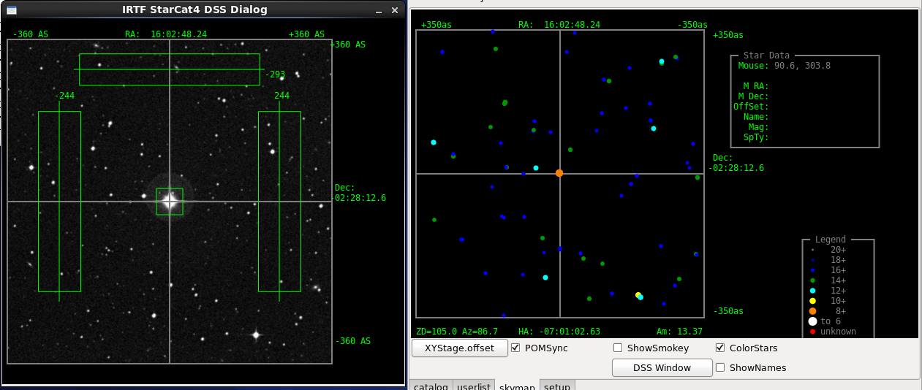

8. Setup Panel

Clicking on the setup tap will present the setup panel. This panel simply displays the value of some starcat parameters and variables.
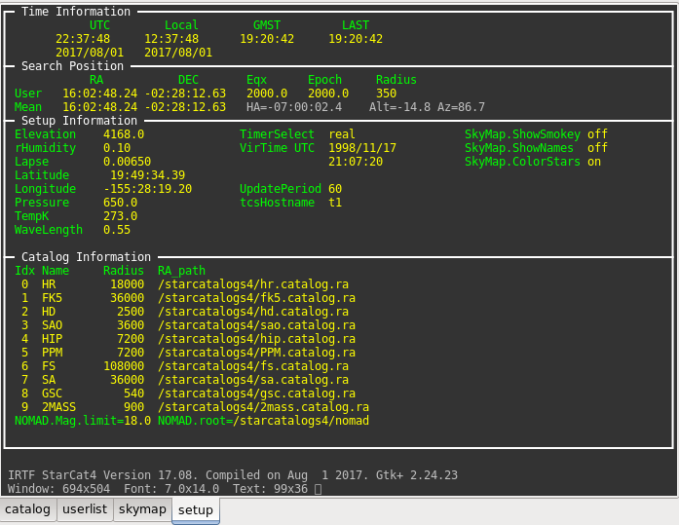

9. Userlist v3

9.1 The Userlist v3 text format

The user list version 3 is the only suppoted userlist format as of the 2023A semester. Previous userlist formats known as new(v2), and old (v1) are not supported.

The userlist is a text file. Each line describes an object. The column data is sparated by white spaces (any combination of spaces and tabs). Lines beginning with ‘#’ are comment lines.

Column | Name | Description
1 | Index | Numeric index of catalog
2 | Name | Name as a string , max 30 chars (no blanks)
3 | Right Ascension | hh:mm:ss.ss in ICRS coordinates.
4 | Declination | dd:mm:ss.ss in ICRS coordinates.
5 | RA Proper Motion | s.ss in milli-arcseconds/year. Use 0.0 if not known
6 | Dec Proper Motion | s.ss in milli-arcseconds/year. Use 0.0 if not known
7 | Spectra Type | 7 chars max. Use ‘n/a’ if not known
8,9 | Mag[0] value & type | m.m c. Use '0.0 -' if not known.
10,11 | Mag[1] value & type
12,13 | Mag[2] value & type
14,15 | Mag[3] value & type

Here is an example:
#
#Index _________Name________ __ICRS_RA__ _ICRS_DEC__ RA_PM Dec_PM __ST___ Magn_0 Magn_1 Mang_2 Mang_3
# 30 chars max,no spaces hh:mm:ss.ss +dd:mm:ss.s mas/y mas/y (7chars) xx.x V xx.x C xx.x C xx.x C
1 HD_132599 14:59:28.00 20:22:16.0 15.75 -9.00 KO 8.6 V 6.4 J 5.6 K
2 HD_221307 23:31:01.82 -00:35:45.6 13.05 -5.80 K2 8.4 V 5.7 J 4.7 K

9.2 The Userlist FAQ

How do I convert the 'new' format to this v3?
- Only convert object with epoch=2000 (FK5). Object with epoch of 1950 (FK4) should be updated with IRCS coordinates, or removed.
- Column 5, Epoch, can be removed. The v3 format use ICRS coordinates, so the epoch field is not needed.
- Proper motion values should be conveted to mas/yr.
  - To conver RA seconds /year to mas/yr: multiply by 15000. IE: 0.00105 * 15000 = 15.75
  - To convert Dec arcseconds/year to mas/yr: multiply by 1000. IE: -0.009 * 1000 = -9.00
Here is an example line of the new format (top), and the v3 format
New format:
#Index Name________ ____RA_____ ____DEC____ _Epoch_ RaPM DecPM __ST__ Magn_0 Magn_1 Mang_2 Mang_3
1 HD_132599 14:59:28.00 20:22:16.0 2000.0 0.00105 -0.009 KO 8.6 V 6.4 J 5.6 K
V3 Fomat:
#Index _________Name________ __ICRS_RA__ _ICRS_DEC__ RA_PM Dec_PM __ST___ Magn_0 Magn_1 Mang_2 Mang_3
# 30 chars max,no spaces hh:mm:ss.ss +dd:mm:ss.s mas/y mas/y (7chars) xx.x V xx.x C xx.x C xx.x C
1 HD_132599 14:59:28.00 20:22:16.0 15.75 -9.00 KO 8.6 V 6.4 J 5.6 K

What if I still have my 'new' format when I started observing?
The new format can still be read into starcat, but you have to enter this command on the command widget. Type:
userload.v2 userlist.txt
You shoud use the 'Print' button to display your list in the v3 format to stdout (terminal window). This way you will have a copy in the new format going forward. Starcat only prints FK5 objects. The userload.v2 command will be removed in future version of starcat.

Appendix A – Dictionary of Commands

This section describes the command set for STARCAT. Command can be type into the command widget (located on the bottom of the main GUI).

For the syntax, the following conventions are used:
Normal Courier fonts must be typed as showed.
Italic Courier fonts represent choices or values to be determined by the user.

These are further explained under the Range. Some examples:
{off|on} – represent a list of choice. You must select one.
[value] – the [] represent an optional parameter.

azel – Issues a LOAD RA,DEC command using observed Az El values.
Syntax azel Az El
Range Az – Azimuth, in degrees (N=0, E=90, S=180, w=270).
El – Elevation in degrees (0 to 90).
Example AzEl 180 85.5

Catalog.clear – Untoggles any catalog selection.
Syntax Catalog.Clear
Example Catalog.Clear

Catalog.set – Sets the toggle for a catalog by name.
Syntax Catalog.set catalog_name
Range catalog_name – can be {bsc5, fk5, gsc, irtf, sao, ukirt, hd.sao }.
Example Catalog.set fk5

CatFile.Inx.Path
CatFile.Name
CatFile.Ra.Path
CatFile.Radius – A set of properties are associated with each catalog: Name, Default Radius, and file paths to its RA and Index sorted files. These 4 commands allow you to set these properties.
Syntax catfile.name index name
Catfile.radius index radius
Catfile.inx.path index inx_file_path
Catfile.ra.path index ra_file_path
Range index – 0-7 (8 main catalog are supported)
Name – name of catalog (any string).
Radius - in arcseconds (1 to 200000)
Inx_file_path – full pathname of index sorted catalog.
Ra_file_path – full path name of RA sorted catalog

Example Catfile.name 0 bsc5
Catfile.radius 0 27000
Catfile.inx.path 0 /starcatalogs2/bsc5.catalog.inx
Catfile.ra.path 0 /starcatalogs2/bsc5.catalog.ra

Catalog.show – Print the catfile variable to stdout.
Syntax Catalog.show
Example Catalog.show

DSS – The DSS command invokes the download and display of the Digital Sky Survey image, and update the DSS window.
Syntax DSS
Example DSS

Echo – Prints the parameter string to the text feedback window.
Syntax Echo string
Range string – Any message.
Example Echo Hello, can you see this message?

Elevation – Specifies the elevation in meters above sea level of the telescope. Used to calculate airmass and observed parameters.
Syntax Elevation meters
Range Meters – the elevation in meters.
Example elevation 4168

Guider – Tells starcat what guider is used. The guider affects the default search radius.
Syntax Guider {off-axis | tip-tilt | cshell | none}
Range off-axis – The default range is 250.
Tip-tilt – The default range is 160.
cshell – The default range is 90.
none – The default radius is based on the catalog selection for searching.
Example guider off-axis

HaDec – Issues a LOAD RA,DEC command using observed Ha Dec values.
Syntax HaDec Ha Dec
Range HA – Hour Angle (units of time)
Dec – Declination in degrees.
Example HaDec -1:00 19:50

Lapse – Given in Kelvin per minute. Used to calculate airmass and observed parameters.
Syntax Lapse rate
Range Rate – rate in Kelvin/minute.
Example lapse 0.0065

Latitude – Specifies the latitude of the telescope. Used to calculate airmass and observed parameters.
Syntax Latitude deg:min:sec {N | S}
Range Deg:Min:Sec – must be 90 degrees or less north or south of the equator.
Example latitude 19:49:34.39 N

Load – Specifies the parameters for the search position.
Syntax Load ra dec [eqx] [epoch] [pm_ra] [pm_dec]
Range ra – Right Ascension (Time format)
Dec – Declination (degrees)
Eqx – equinox. Default is 2000
Epoch – Epoch. Default is equinox value.
Rapm – RA proper motion. Default is 0.
Decpm – Dec proper motion. Default is 0.
Example Load 20:34:23.4 19:49:34.39

Longitude – Specifies the longitude of the telescope. Used to calculate airmass and observed parameters.
Syntax Longitude deg:min:sec {E | W}
Range Deg:Min:Sec – must be 180 degrees or less east or west of Greenwich.
Example longitude 155:28:19.20 w

LTOffset – Specifies the universal time to local time offset in minutes. Used to calculate airmass and observed parameters.
Syntax LTOffset value
Range Value – offset in minutes (-720 to 720).
Example ltoffset –600

MainClear – Clears the Main catalog list from the main catalog display area.
Syntax MainClear

MainFormat – Specifies the data format for the main catalog.
Syntax MainFormat { Default | Obs | Mag }
Range Default – The default data format
Obs – Data format highlighting observed position information.
Mag – Data format highlighting magnitude information.
Example MainFormat Obs

MainSearchID – Searches the selected MainCatalogs for matching index or catalog ID. Matching records are loaded into the Main Catalog List.
Syntax MainSearchID ID
Range ID – Numeric ID value to search for.
Example MainSearchID 100334

MainSearchRA – Searches the selected MainCatalogs using the search parameter (mean J2000 ra, dec, and radius). Matching records are loaded into the Main Catalog List.
Syntax MainSearchRA
Example MainSearchRA

MainSentToTCS – Issues a C.SLEW command to the TCS using the coordinates from the selected entry in the Main Catalog.
Syntax MainSentToTCS
Example MainSentToTCS

MainShow – Prints the main catalog to stdout (the terminal window).
Syntax MainShow
Example MainShow

MainSort – Indicated the sort field for the MainCatalog.
Syntax MainSort { Index | RA | Dec | Mag | Ang.Offset | RA.Offset | Dec.Offset | Airmass | Name | HA | Alt | Azi }
Example MainSort RA

NewEntryPos – Does a new catalog search using the coordinates in RA,DEC entry field, ie “Search RA/Dec” button.
Syntax NewEntryPos
Example NewEntryPos

NewItemPos – Does a new catalog search using the coordinates of the highlighted object in the catalog, ie “Search Item” button.
Syntax NewItemPos
Example NewItemPos

Nomag.mag.limit – Set the faint magnitude limit for the nomad catalog searches.
Syntax NOMAD.Mag.Limit mag
Range mag – the faint magnitude limit. Range is 0 to 29.
Example NOMAD.Mag.Limit 18.5

Nomag.mag.root – Tell starcat where the NOMAD catalog files are.
Syntax NOMAD.Mag.Root dir
Range dir – the directory with the NOMAD files are located.
Example NOMAD.Mag.Root /starcatalog3/nomad

OutTab – Select the (output) tab for the display window.
Syntax OutTab { catalog | userlist | skymap | setup }
Range {catalog | userlist | skymap | setup }
Example OutTab catalog

POM.getOffset – Retrieves the POM offset by querying smokey.
Syntax POM.getoffset}
Example POM.getOffset

POM.Sync – Toggle whether the POM should synchronize its position with that of the x-y stage. The synchronization occurs only after using XYStage.offset.
Syntax POM.Sync {on | off}
Range {on|off}
Example POM.Sync on

PosFromTCS – Loads a new search position by querying the TCS for its position..
Syntax PosFromTCS
Example PosFromTCS

Pressure – Specifies the atmospheric pressure at the telescope. Used to calculate airmass and observed parameters
Syntax Pressure value
Range Value – pressure in mBars (200 to 2000).
Example pressure 650

Quit – Exits the STARCAT program.
Syntax Quit

Radius – Sets the search box size. The number given is the “radius” of the box.
Syntax Radius value
Range Value – radius in arcseconds.
Example radius 400

RHumidity – Specifies the relative humidity at the telescope. Used to calculate airmass and observed parameters.
Syntax RHumidity value
Range Value – relative humidity (0.0 to 1.0).
Example rhumidity 0.10

SkyMap.ColorStars – If ON uses color for display skymap stars, else a gray scale is used.
Syntax SkyMap.ColorStars { off | on }
Range off – Use gray scale.
On – Use color scale.
Example SkyMap.ColorStars on

SkyMap.showNames – Indicate if the star name are displayed on the map.
Syntax SkyMap.showNames { off | on }
Range off – Do not display names.
On – Display the names.
Example SkyMap.showNames on
SkyMap.showSmokey – Indicate if the skmap show the guide area for smokey.
Syntax SkyMap.showSmokey { off | on }
Range off – Do not display the guider guide area.
On – Show the guide are as green boxes.
Example SkyMap.showSmokey on

TCS – Sends a command to the TCS.
Syntax TCS command
Range Command – the TCS command to be sent.
Example tcs 0:00:00 0:00:0 0.0000 0.000 2000.0 C.SLEW

TCSHostname – Identifies the host used to handle communications to the TCS.
Syntax TCSHostname host
Range Enter a valid hostname
Example tcshostname vtcshost

TempK – Specifies the temperature at the telescope in Kelvin. Used to calculate airmass and observed parameters.
Syntax TempK value
Range Value – temperature in Kelvin (100 to 350).
Example tempk 273.0

UpdatePeriod– Indicate the period when the catalog observed positions are updated (using the UpdatePosition command).
Syntax UpdatePeriod sec
Range sec – Update period in seconds.

UpdatePosition – The command updates all positional information. (Automatically executed by starcat every UpdatePeriod).
Syntax UpdatePosition
Example UpdatePosition

UpdateTime – Updates the time information. This command is automatically execute every second by the starcat application.
Syntax UpdateTime
Example UpdateTime

UserClear – Clears the user’s catalog list from the user catalog display area.
Syntax UserClear

UserFormat – Specifies the data format for the user list.
Syntax UserFormat { Default | Obs | Mag }
Range Default – The default data format
Obs – Data format highlighting observed position information.
Mag – Data format highlighting magnitude information.
Example UserFormat Obs

UserLoad – Loads the user’s catalog file into the user catalog display area. On the supportted userlist v3 format is supported.
Range Filename – the user’s catalog list file.
Syntax UserLoad filename
Range Filename – The userlist catalog's filename.
Example UserLoad Userlist.txt

Older formatted can still be loading using these commands:
UserLoad.v2 filename – loads the “New” or v2 format, depreciated in 2023A.
UserLoad.v1 filename – loads the “Old” or v1 format, depreciated in 2023A

UserPrint – Prints the user catalog in the v3 format to stdout (the terminal window).
Syntax UserPrint
Example UserPrint

UserSentToTCS – Issues a C.SLEW command to the TCS using the coordinates from the selected entry in the UserCatalog.
Syntax UserSentToTCS
Example UserSentToTCS

UserShow – Prints the user catalog to stdout (the terminal window) as displayed in the user list area
Syntax UserShow
Example UserShow

UserSort – Indicated the sort field for the UserCatalog.
Syntax UserSort { Index | RA | Dec | Mag | Ang.Offset | RA.Offset | Dec.Offset | Airmass | Name | HA | Alt | Azi }
Example UserSort RA

Wavelength – Specifies the observed wavelength in microns. Used to calculate airmass and observed parameters.
Prompt ‘Wavelength’ text box on the Setup Options Page.
Range Value – wavelength in microns (0.1 to 50.0).
Syntax Wavelength value
Example wavelength 0.550

XYStage.GetOffset – Retrieves the XY Stage position from smokey.
Syntax XYStage.GetOffset
Example XYStage.GetOffset

XYStage.Offset – Move the x-y stage to the specified RA, DEC position.
Syntax XYStage.Offset ra dec
Range
Example XYStage.Offset 64.0 32.25

Appendix B – Depreciated UserList Formats

As of the 2023A (Feb 2023) the format known are 'old' and 'new' are no longer supported. Observers should used the v3 userlist format. The old format is documented here for historical purposes.

9.1 New_Format – Starcat2 to Starcat4 v2109.

This is the text file format for importing user's list. Each line describes an object. The column data is separated a white space (any combination of spaces and tabs).

Column | Name | Description
1 | Index | Numeric index of catalog
2 | Name | Name as a string , max 30 chars (no blanks)
3 | Right Ascension | hh:mm:ss.ss
4 | Declination | dd:mm:ss.ss
5 | Epoch/Equinox | 1950.0 assumes FK4. Otherwise FK5. Default to 2000.0
6 | RA Proper Motion | s.ssss in seconds of time/year. Defaults to 0.
7 | Dec Proper Motion | a.aaaa in second of arc/year. Defaults to 0
8 | Spectra Type | 7 chars max. Defaults to ‘n/a’
9,10 | Mag[0] value & type | m.mmm c. Default to ‘0’ and ‘-‘ if not given.
11,12 | Mag[1] value & type
13,14 | Mag[2] value & type
15,16 | Mag[3] value & type

Lines beginning with ‘#’ are comment lines.
Here is an example:

#
#Index Name________ ____RA_____ ____DEC____ _Epoch_ RaPM DecPM __ST__ Magn_0 Magn_1 Mang_2 Mang_3
#
1 IRTF-1 00:02:45.93 35:48:55.86 2000.0 0.00 -0.00 A0 7.30 V 99.90 P 0.00 x 0.00 x
2 IRTF-2 00:15:57.26 04:15:03.75 2000.0 0.00 -0.02 A0 7.00 V 99.90 P 0.00 x 0.00 x
3 IRTF-3 00:30:02.36 -03:57:26.35 2000.0 0.00 -0.01 K5 6.00 V 99.90 P 0.00 x 0.00 x
4 IRTF-4 00:31:18.42 -43:36:24.78 2000.0 -0.00 -0.02 A2 7.50 V 99.90 P 0.00 x 0.00 x

9.2 Old_Format

This older format is the text format using by previous xstarcat and starcat version 1. Each line describes an object. The column data is separated a white space (any combination of spaces and tabs).

Column | Name | Description
1 | Name | Name of object (no blanks allowed)
2 | Right Ascension | hh:mm:ss.ss
3 | Declination | dd:mm:ss.ss
4 | RA Proper Motion | s.ssss in seconds of time/year.
5 | Dec Proper Motion | a.aaaa in second of arc/year
6 | Magnitude | m.mmm
7 | Epoch | eeee.e . Equinox of 2000.0 is assumed.
Lines beginning with ‘#’ are comment lines.

Here is an example:
#name RA DEC paRA pmDec Mag epoch
IRTF-1 00:02:45.93 35:48:55.86 0.00 0.00 7.30 2000
IRTF-2 00:15:57.26 04:15:03.75 0.00 0.00 7.00 2000
IRTF-5 00:32:49.08 28:16:49.08 0.00 0.00 6.40 2000
IRTF-6 00:33:39.52 20:26:02.36 0.00 0.00 7.60 2000
IRTF-7 01:09:43.94 35:37:13.93 0.00 0.01 2.40 2000

