TABLE OF CONTENTS
1 Introduction 3
1.1 Quantum efficiency (QE) 3
1.2 read noise 3
1.3 dark current 3
1.4 bias stability 3
1.5 Residual image and persistence 4
1.6 on-chip intergration time (itime) 4
1.7 number of co-additions (co-adds) 5
1.8 read out overhead 5
1.9 linearity 5
1.10 crosstalk 5
1.11 fixed pattern noise 5
1.12 flat field stability 6
1.13 sub-arraying 6
1.14 well depth 6
1.15 cadence 6
1.16 data rate and data loss 7
1.17 guiding 7
2 ISHELL requirements 8
2.1 faint object spectroscopy (R=70,000, S/N~10 in one hour) 8
2.2 faint object spectroscopy (R=70,000, S/n~100 in one hour) 10
2.3 Very Bright object spectroscopy (R=70,000, S/N>1000 in 10 s) 11
2.4 standard star spectroscopy (R=70,000, S/N~100 in one minute) 12
3 Spex requirements 13
3.1. SXD faint object spectroscopy (R=2000, s/n~10 in one hour) 13
3.2. PRISM faint object spectroscopy (R=100, S/n~25 in one hour) 15
3.3. prism faint & Fast occultation mode (R=100, S/N~25 in 0.1 s) 17
3.4. prism Bright & Fast occultation mode (R=100, S/N~25 in 0.1 s) 18
3.5. LXD faint object spectroscopy (R=1500, s/n~50 in one hour) 19
3.6. LXD bright object spectroscopy (R=2000, s/n~1000 in 10 s) 20
4 Slit viewers 22
4.1. POINT-source guiding (JHK, and narrow-band filters) 22
4.2. planet disk guiding (narrow-band filters) 24
4.3. background-limited imaging – low background 25
4.4. background-limited imaging - high background 28
5 nsfcam2 30
5.1. background-limited imaging – low background 31
5.2. background-limited imaging - high background 33
5.3. sub-array imaging 34
5.4. OPTIOn: on-chip guided imaging (windowed Read out) 34
6 overall H2RG controller requirements 35
6.1. slow readout full array 35
6.2. standard readout full array 36
6.3. fast readout full array 37
6.4. occultation mode 38
7 overall alladin 2 (Slit viewer) controller requirements 39
7.1. slow readout full array 39
7.2. standard readout full array 40
7.3. fast readout full array 41

Introduction

The goal of this document is to derive technical requirements for the new array controller from the science cases for ISHELL, SpeX, and NSFCAM2. All three instruments will use the 2048 x 2048 Hawaii-2RG array. We have requested that each device be wired for 32 outputs since fast read out (~1 s) is a requirement for several observing programs. In addition ISHELL and SpeX will each use a 512 x 512 Aladdin 2 array for slit viewing (acquisition, guiding, and imaging). To simplify development and support of the new controller we have decided that the controller should be common to all three instruments. Rather than deriving requirements from every science case or observing scenario we have constructed several generic observing scenarios for each instrument that we consider will drive the array controller requirements. Useful requirements are those that can be measured and form a metric for verification of performance. Since it is difficult to separate some requirements into purely array controller requirements the requirements given refer to the array plus array controller system.

Quantum efficiency (QE)
This requirement is intrinsic to the array and is not a function of array controller performance but is given for completeness. We do not plan to measure QE separately but as part of the instrument throughput.

read noise
Read noise has components due to the array and the array controller. It can be reduced with as many non-destructive reads (NDRs) as can be fitted into the observation-dependent allowable read out overhead. Read noise needs to be minimized for observations in which the object or background photon noise is comparable (e.g. faint object spectroscopy). For bright targets or background-limited observations the read noise requirements can be relaxed (e.g. spectroscopy of standard stars, thermal imaging). For programs requiring very short on-chip integration times (~0.1 s) the standard read out time may need to be decreased (decrease pixel dwell time). The most challenging programs of this type are occultations. These may require short integrations time and low read noise. Reducing the number of pixels to be read (sub-arrays) may be required to meet certain low read noise and short integration time requirements.

dark current
Dark current is intrinsic to the array and is a function of operating temperature and detector bias. It is measured by blanking off the array. The act of reading out the array can cause regions on the array to glow and this glow also adds to the dark current. Consequently the read out history (read out frequency, on-chip integrations times etc.) can affect dark current stability.

bias stability
For the purposes of this discussion we define a bias frame as a very short exposure dark current image and the bias level as the base level in a dark current exposure. Our experience with Aladdin 3 arrays is that the bias level can change shape when the read out state of the array changes (e.g. changing from idle to long integration times). As an example Figure 1 (left) shows the result of the subtraction of the first two dark frames in a sequence of five 120 s darks, and Figure 1 (right) the subtraction of the final two dark frames in the sequence. Note the ‘dome’ effect in the shape of the bias level in the first subtraction (magnitude about 10 DN). This effect is probably intrinsic to the array and results when array read out changes from continuous background resets (done to minimize persistence) to long on-chip integration times. The difference between successive bias levels disappears after several frames but small quadrant offsets remain (about 1 DN), see Figure 1 (right). The latter effect is probably due to instabilities in the array controller. For faint object spectroscopy the dome effect sometimes means that the first pair of observations in a sequence needs to be rejected. Both bias effects need to be minimized.

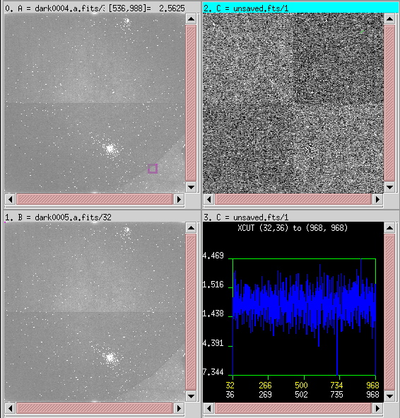

Figure 1. The subtraction (buffer C) of the first two 120 s dark frames (buffers A and B) (left). The subtraction (buffer C) of the fourth and fifth 120 s dark frames (buffers A and B) (right).

H2RG arrays do not have the four-quadrant structure of Aladdin arrays and are read out in stripes, one for each output. The new IRTF arrays will have 32 outputs (the default is four).

Residual image and persistence
In most arrays exposure to light results in the pattern of the exposure still being visible once the light source is removed, for example, when the exposure is immediately followed by a dark (blanked-off) exposure. This residual image can be manifested in two ways. First as a bias offset in the pattern of the original exposure, an offset that does not increase with the integration time of the following exposure. Second, as enhanced dark current (known as persistence) in the pattern of the original exposure (signal that increases with integration time).

on-chip intergration time (itime)
For faint objects the maximum on-chip integration should be long enough for shot noise from the integrated signal to overcome read noise. However, in practise the maximum on-chip integration time is limited by the need to median together at least six frames to reject random events such as cosmic rays. With maximum integration times of about one hour, on-chip integration times are typically limited to 600 s. Integration times as short as 0.1 s may be required to prevent pixel saturation on bright objects or for time resolution during occultations for example.

A ‘read out up the ramp and fit’ sampling scheme might be able to reject cosmic ray events and allow longer on-chip integration times for better optimization of read noise.

number of co-additions (co-adds)
To improve observing efficiency and reduce storage requirements images are sometimes co-added in local memory and then transferred and stored rather than transferred and stored individually. Examples include thermal imaging where short integration times are required to avoid saturation on sky background but many images are required for good S/N on the fainter target, and spectra in which short on-chip integration times are need because of widely different signal levels.

read out overhead
The read out overhead is the read out time per NDR multiplied by the number of NDRs required to reach the desired total read noise for a given on-chip integration time. The longer the read out overhead, the lower the observing efficiency (duty cycle). The read out overhead is a compromise between read noise, integration time, and observing efficiency.

linearity
Linearity sets the accuracy to which signal rates can be determined when measured at different detector well depths (effective bias). For example, if the photon flux from a bright standard star measured high in the detector well is used to determine the photon flux of an object that is measured low in the well, the accuracy depends on how well non-linearity can be corrected for. Intrinsic device linearity is not important so long as it is stable and can be calibrated. Linearity changes with bias and well depth. Linearity can be determined by measuring the signal level of each pixel as a function on integration time observed from a stable source (e.g. flat field).

crosstalk
Crosstalk occurs when signal detected in a pixel leaks into other pixels either during detection or on read out. Most of this leakage is into contiguous pixels but signal can be mirrored (due to symmetry and crosstalk in the read out) into other parts of the array during read out. Crosstalk is best measured by under-filling a pixel with bright flux and examining the full read out, although over-filling a pixel with bright flux can identify mirroring.

fixed pattern noise
Fixed pattern noise is any high spatial frequency (pixel-to-pixel) noise that is not removed by dividing by a flat field. As an example, Figure 2 shows the high frequency spatial structure seen in flat fields observed with Aladdin arrays. The pattern is intrinsic to the unit cell structure of arrays but is removed by flat fielding to the level of 0.1% in the spectrograph if the flat field is taken within minutes. On timescales of about one hour flat fielding of the spectrograph is accurate to about 0.3% (the contrast in the odd/even row and column pattern). The reappearance of the pattern, albeit at lower contrast, is probably due to temporal instabilities in the array or array controller.
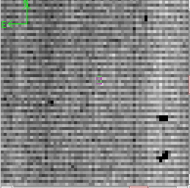
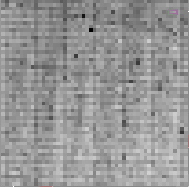

Figure 2. Examples high spatial frequency (pixel-to-pixel) flat field structure seen in flat field images taken with the guider (right – Aladdin 2, ~7% RMS) and spectrograph (right – Aladdin 3, ~2% RMS) arrays in SpeX

Generic methods to decrease fixed pattern noise in the H2RG array and new controller include reduced pixel-to-pixel variation and improved array controller stability.

flat field stability
The majority of science cases require photometry and spectro-photometry to a precision of about 1% (S/N=100). Since it is not practical to put the standard star on precisely the same array pixels as the object, this requires the capability to flat field the array to the same level. For imaging photometry the flat field precision is measured by placing a star at tens of different locations on the array (e.g. a 6 x 6 grid) and measuring the RMS of the summed stellar flux in the flat-fielded images. For NSFCAM typical precisions were 1% at JHK (NSFCAM2 is worse due to the large number of bad pixels). For spectroscopy one way to measure precision is to measure the depth of the shallowest spectral features that can be reproduced. For SpeX the limit is about 0.3% (S/N=300).

Changes in the flat field can result from differences in illumination but also from instabilities in the array and array controller as described in the section on fixed pattern noise. A practical way to measure flat field stability is to take sequences of flat field exposures on the time scales of interest.

sub-arraying
The minimum on-chip integration time is proportional to the number of pixels that need to be read (assuming the individual pixel dwell time is fixed). Consequently, a standard way to reduce the minimum on-chip integration time, to avoid saturating signal on a bright star or on thermal sky background, for example, is to use a sub-array. A corollary is to improve read noise for a given minimum on-chip integration by increasing pixel dwell time in proportion to reducing the number of pixels to be read out. An example of the latter is the prism occultation mode in SpeX where given a minimum integration time of say 0.1s set by the required time resolution of the event, the array size o be read out is reduced to improve the read noise on what are typically faint signals.

well depth
Array well depth increases with reverse bias voltage. However, dark current and noise also increase with reverse bias. The optimum operating bias depends on the application. Broadband thermal imaging requires operation at large well depths to avoid saturation on background flux and where array noise and dark current are dominated by photon noise. Conversely, the very low background operation typical of high-resolution spectroscopy needs to be optimized for low dark current and low array noise, and where large well depth is not needed. Operationally it is desirable to work at just one bias since this simplifies characterization and calibration. Given the wide range of operating conditions for ISHELL. SpeX, and NSFCAM2, several bias modes might be required.

cadence
Some observing programs require that frames be taken at certain rate, which we will call cadence. For example, stellar occultations need to be sampled at a frequency dependent upon the geometry of the event (typically 0.1-1s). Other examples of high cadence observations include impact events such as Deep Impact with Comet Wild 2 and the upcoming LCROSS lunar impact mission. Extra-solar planet transits require cadences of typically about one minute. More general observations also have an effective cadence due to a variety of different observing requirements. To achieve a given cadence trade-offs might be required in integration time, read noise, sub-array etc.

data rate and data loss
Closely related to cadence is the implicit data rate, the rate at which data needs to be transferred and stored in order to keep up with the observations. Some programs, such as occultations, require relatively high data rates, whereas others, such as faint object spectroscopy (long integration times), require relatively low data rates.

A critical requirement is the acceptable rate of any data loss and the timing of any data loss. A stellar occultation, for example, might require a cadence of one frame per second for a duration of one hour. During this period a system crash requiring a recovery of a minute or more would be unacceptable, whereas the loss of a few isolated data frames would have little effect. On the other hand, any data loss in a sequence of six 600 s integrations needed for faint object spectroscopy is unacceptable. Consequently an acceptable level of frame loss would be < 0.1% (one frame in 1000), and a system crash affecting data taking two orders of magnitude less than this (say one crash in 100 one-hour-long occultations).

guiding
Both SpeX and ISHELL have infrared slit viewers for object acquisition, guiding, and scientific imaging and photometry. A fundamental requirement of the slit viewer is that the read out must operate independently of the spectrograph read out, i.e. with the exception of moving mechanisms and the telescope, there must be no mutual influence on the operation of the two arrays (no need to sequence integration times or read outs, no induced noise, independent computer operation, independent data transfer and storage etc.). This mode of operation is working extremely well in SpeX.

ISHELL requirements
These requirements assume a resolving power of R≡λ/Δλ ~ 70,000 matched to a 0.375″ slit, a slit efficiency of 0.4 (0.7″ seeing at K), and an average instrument throughput of 0.1. From a model of the sky, telescope, and instrument, the predicted background in ISHELL is plotted in Figure 3.

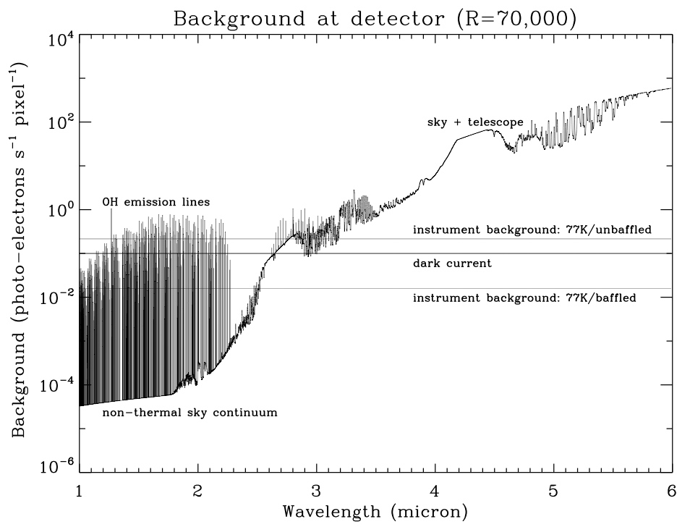
Figure 3. Predicted background at the array in ISHELL assuming a resolving power of R ~ 70,000 matched to a 0.375″ slit, a slit efficiency of 0.4 (0.7″ seeing at K), and an average instrument throughput of 0.1.

faint object spectroscopy (R=70,000, S/N~10 in one hour)
The 10σ 1 hour sensitivity (R=70,000) for a range of read noise and dark current values is given in Table 1. The dominant noise at short wavelengths (J to K) is dark current and read noise, while at longer wavelengths (L′ and M′) the dominant noise is sky background. Clearly it is important to optimize for the best possible read noise and dark current in this ISHELL mode, except at the longest wavelengths. Photo-electron rates at the detector from a typical source and the sky are given in Table 2. The array/array controller requirements derived for this case are given in Table 3.

Table 1. Sensitivity 10σ 1 hour R=70,000 (Mag) (600s x 6)
Read noise  (e RMS) | Dark current  (e/s) | J | H | K | L′ | M′
5 | 0.01 | 13.92 | 13.43 | 13.03 | 10.14 | 7.63
5 | 0.10 | 13.40 | 12.91 | 12.51 | 10.10 | 7.63
5 | 1.00 | 12.33 | 11.84 | 11.44 | 9.83 | 7.61
15 | 0.01 | 12.87 | 12.38 | 11.97 | 10.07 | 7.62
15 | 0.10 | 12.75 | 12.26 | 11.86 | 9.98 | 7.62
15 | 1.00 | 12.19 | 11.69 | 11.29 | 9.76 | 7.61

Table 2. Typical photo-electron (pe) rates at the detector
 | J | K | L′ | M′ | Note
Magnitude | 13.3 | 12.4 | 10.3 | 7.9
Object rate (pe/pixel/s) | 0.01 | 0.01 | 0.03 | 0.16 | Average in 3x14 pixel box (0.38″x1.4″)
Sky background rate (pe/pixel/s) | 0 | 0 | 1 | 30
Time to sky background limit (3 x read noise) |  |  | 75 s | 2.5 s | Assume 5 e RMS read noise with NDRs
Time to full well |  |  |  | 1600 s | Assume 5x10⁴ e

Table 3. Derived array/array controller requirements for case 2.1
Parameter | Requirement | Goal | Note
QE | > 0.8 | > 0.9 | 1-5 μm
Read noise | < 5 e RMS | < 2 e RMS | With multiple NDRs
Dark current | < 0.1 e/s | < 0.01 e/s
Dark current stability | < 0.002 e/s up to 12 hours
Bias stability | Flatness difference < 10 e (~ 1 DN) in up to 12 hours |  | Measured in successive dark/bias exposures
Persistence | < 0.1 e/s | < 0.01 e/s
Max/min on-chip itime | 3600 s / 60 s
Max/Min co-adds | 10/1
Typical itime | 600 s x 6 cycles
Read out overhead for full array | < 30 s |  | Per co-add
Linearity | < 1% | < 0.1 % | Over range 0-5x10⁴ e using fit if necessary
Cross-talk, next pixel | < 5% | < 1%
Cross-talk, far pixel | < 0.1%
Fixed pattern (odd/even) noise | < 1 % | < 0.1%
Flat field stability | < 1% per hour | < 1 % per 12 hours
Sub-array | No
Well depth | Low (~5x10⁴ e)
Cadence | ~6 frames per hour

faint object spectroscopy (R=70,000, S/n~100 in one hour)
The 100σ 1 hour sensitivity (R=70,000) for a range of read noise and dark current values is given in Table 4. The requirements for this case are very similar to those for case 2.1. Again it is important to optimize for the best possible read noise and dark current in this ISHELL mode, except at the longest wavelengths. Photo-electron rates at the detector from a typical source and the sky are given in Table 5. The array/array controller requirements derived for this case are given in Table 6.

Table 4. Sensitivity 100σ 1 hour R=70,000 (Mag) (600s x 6)
Read noise  (e RMS) | Dark current  (e/s) | J | H | K | L′ | M′
5 | 0.01 | 10.93 | 10.43 | 10.43 | 7.54 | 5.11
5 | 0.10 | 10.59 | 10.10 | 10.10 | 7.50 | 5.09
5 | 1.00 | 9.72 | 9.23 | 9.23 | 7.25 | 5.08
15 | 0.01 | 10.18 | 10.18 | 9.69 | 7.43 | 5.10
15 | 0.10 | 10.09 | 10.09 | 9.60 | 7.40 | 5.10
15 | 1.00 | 9.59 | 9.59 | 9.10 | 7.19 | 5.09

Table 5. Typical photo-electron (pe) rates at the detector
 | J | K | L′ | M′ | Note
Magnitude | 10.5 | 9.6 | 7.7 | 5.4
Object rate (pe/pixel/s) | 0.15 | 0.14 | 0.3 | 1.6 | Average in 3x14 pixel box (0.38″x1.4″)
Sky background rate (pe/pixel/s) | 0 | 0 | 1 | 30
Time to full well |  |  | 3300 s | 1600 s | Assume 5x10⁴ e

Table 6. Derived array/array controller requirements for case 2.2
Parameter | Requirement | Goal | Note
QE | > 0.8 | > 0.9 | 1-5 μm
Read noise | < 5 e RMS | < 2 e RMS | With multiple NDRs
Dark current | < 0.1 e/s | < 0.01 e/s
Dark current stability | < 0.01 e/s up to 12 hours
Bias stability | Flatness difference < 10 e (~ 1 DN) in up to 12 hours |  | Measured in successive dark/bias exposures
Persistence | < 0.1 e/s | < 0.01 e/s
Max/min on-chip itime | 3600 s / 60 s
Max/Min co-adds | 10/1
Typical itime | 600 s x 6 cycles
Read out overhead for full array | < 30 s |  | Per co-add
Linearity | < 1% | < 0.1 % | Over range 0-5x10⁴ e using fit if necessary
Cross-talk, next pixel | < 5% | < 1%
Cross-talk, far pixel | < 0.1%
Fixed pattern (odd/even) noise | < 1 % | < 0.1%
Flat field stability | < 1% per hour | < 1 % per 12 hours
Sub-array | No
Well depth | Low (~5x10⁴ e)
Cadence | ~6 frames per min

Very Bright object spectroscopy (R=70,000, S/N>1000 in 10 s)
These are requirements to observe the brightest stars in the sky. No limiting requirements are found and some can be relaxed due to the object-limited nature of the observations. Photo-electron rates at the detector from a typical source and the sky are given in Table 7. The array/array controller requirements derived for this case are given in Table 8.
Table 7. Typical photo-electron (pe) rates at the detector
 | J | K | L′ | M′ | Note
Magnitude | ~ -2.6 | ~ -3.5 | ~ -4.7 | ~ -5.1
Object rate (pe/pixel/s) | 5x10⁴ | 5x10⁴ | 5x10⁴ | 5x10⁴ | Average in 3x14 pixel box  (0.38″x1.4″)
Sky background rate (pe/pixel/s) | 0 | 0 | 1 | 30
Time to full well | 1 s | 1 s | 1 s | 1 s | Assume 5x10⁴ e

Table 8. Derived array/array controller requirements for case 2.3
Parameter | Requirement | Goal | Note
QE | > 0.8 | > 0.9 | 1-5 μm
Read noise | < 100 e RMS | < 30 e RMS | CDS
Dark current | < 10 e/s | < 1 e/s
Dark current stability | < 1 e/s up to 12 hours
Bias stability | Not important within expected range  (<100 e) |  | Measured in successive dark/bias exposures
Persistence | < 10 e/s | < 1 e/s
Max/min on-chip itime | 10 s / 0.5 s
Max/Min co-adds | 100/1
Typical itime | 1 s x 10 co-adds
Read out overhead for full array | < 1 s |  | Per co-add
Linearity | < 1% | < 0.1 % | Over range 0-5x10⁴ e using fit if necessary
Cross-talk, next pixel | < 5% | < 1%
Cross-talk, far pixel | < 0.1%
Fixed pattern (odd/even) noise | < 1 % | < 0.1%
Flat field stability | < 1% per hour | < 1 % per 12 hours
Sub-array | No
Well depth | Low (~5x10⁴ e)
Cadence | ~10 frames per min

standard star spectroscopy (R=70,000, S/N~100 in one minute)
For typical standard star observation read noise and dark current requirements can be relaxed compared to cases 2.1 and 2.2. Photo-electron rates at the detector from a typical source and the sky are given in Table 9. The array/array controller requirements derived for this case are given in Table 10.
Table 9. Typical photo-electron (pe) rates at the detector
 | J | K | L′ | M′ | Note
Magnitude | ~ 6 | ~ 6 | ~ 6 | ~ 4
Object rate (pe/pixel/s) | 10 | 18 | 1.4 | 6 | Average in 3x14 pixel box  (0.38″x1.4″)
Sky background rate (pe/pixel/s) | 0 | 0 | 1 | 30
Time to full well | 1120 s | 2900 s | 20,000 s | 1400 s | Assume 5x10⁴ e

Table 10. Derived array/array controller requirements for case 2.4
Parameter | Requirement | Goal | Note
QE | > 0.8 | > 0.9 | 1-5 μm
Read noise | < 15 e RMS |  | CDS
Dark current | < 1 e/s | < 0.1 e/s
Dark current stability | < 0.1 e/s up to 12 hours
Bias stability | Flatness difference < 10 e (~ 1 DN) in up to 12 hours |  | Measured in successive dark/bias exposures
Persistence | < 1 e/s | < 0.1 e/s
Max/min on-chip itime | 100 s / 5 s
Max/Min co-adds | 100/1
Typical itime | 10-60 s x 6 co-adds  (J-M′)
Read out overhead for full array | < 1 s |  | Per co-add
Linearity | < 1% | < 0.1 % | Over range 0-5x10⁴ e using fit if necessary
Cross-talk, next pixel | < 5% | < 1%
Cross-talk, far pixel | < 0.1%
Fixed pattern (odd/even) noise | < 1 % | < 0.1%
Flat field stability | < 1% per hour | < 1 % per 12 hours
Sub-array | No
Well depth | Low (~5x10⁴ e)
Cadence | ~1 frame per min

Spex requirements
In contrast to ISHELL, SpeX has several different observing modes with very different resolving powers (R~100-2000) and backgrounds. Consequently some the requirements depend on the observing mode as well as the targets. From a model of the sky, telescope, and instrument, the predicted background in SpeX is plotted in Figure 4.

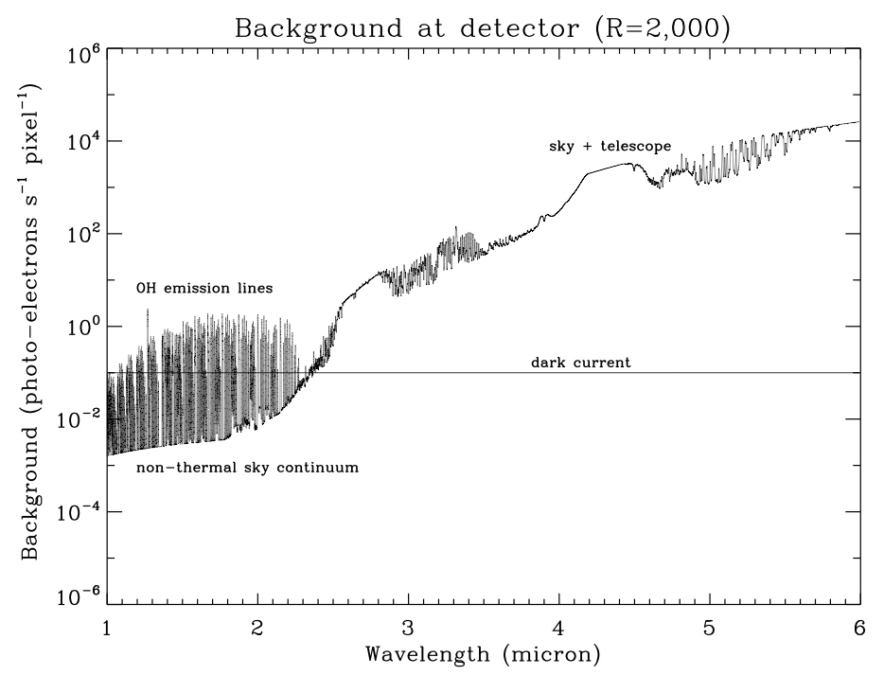
Figure 4. Predicted background at the array in SpeX assuming a resolving power of R ~ 2,000 matched to a 0.3″ slit, a slit efficiency of 0.4 (0.7″ seeing at K), and an average instrument throughput of 0.2.

SXD faint object spectroscopy (R=2000, s/n~10 in one hour)
The SXD mode covers 0.8-2.4 μm at R~750-2000. The average throughput is about 0.2. Here we assume R=2000 matched to a 0.3″ slit and a slit efficiency of 0.4 (0.7″ seeing at K). The 10σ 1 hour sensitivity (R=2000) for a range of read noise and dark current values is given in Table 11. Clearly it is important to optimize for the best possible read noise and dark current in this SpeX mode. Photo-electron rates at the detector from a typical source and the sky are given in Table 12. The array/array controller requirements derived for this case are given in Table 13.

Table 11. Sensitivity 10σ 1 hour R=2,000 (Mag) (600 s x 6)
Read noise  (e RMS) | Dark current  (e/s) | Y | J | H | K
5 | 0.01 | 18.25 | 17.61 | 16.09 | 16.88
5 | 0.10 | 17.92 | 17.27 | 16.03 | 16.46
5 | 1.00 | 16.98 | 16.33 | 15.65 | 15.47
15 | 0.01 | 17.47 | 16.83 | 15.89 | 15.98
15 | 0.10 | 17.37 | 16.73 | 15.85 | 15.88
15 | 1.00 | 16.83 | 16.19 | 15.55 | 15.32

Table 12. Typical photo-electron (pe) rates at the detector (R=2000)
 | Y | J | H | K | Note
Magnitude | 18.6 | 17.9 | 16.8 | 17.1
Object rate (pe/pixel/s) | 0.01 | 0.01 | 0.02 | 0.01 | Average in 3x14 pixel box (0.3″x1.4″)
Sky background rate (pe/pixel/s) | 0.01 | 0.03 | 0.1 | 0.07 | Average OH
Time to sky background limit (3 x read noise) | 8x10³ s | 3x10³ s | 750 s | 1x10³ s | Assume 5 e RMS read noise with NDRs
Time to full well |  |  |  | ~ days | Assume 5x10⁴ e

Table 13. Derived array/array controller requirements for case 3.1
Parameter | Requirement | Goal | Note
QE | > 0.8 | > 0.9 | 1-5 μm
Read noise | < 5 e RMS | < 2 e RMS | With multiple NDRs
Dark current | < 0.1 e/s | < 0.01 e/s
Dark current stability | < 0.002 e/s up to 12 hours |  | Compare with object rate
Bias stability | Flatness difference < 10 e (~ 1 DN) in up to 12 hours |  | Measured in successive dark/bias exposures
Persistence | < 0.1 e/s | < 0.01 e/s
Max/min on-chip itime | 3600 s / 60 s
Max/Min co-adds | 10/1
Typical itime | 600 s x 6 cycles
Read out overhead for full array | < 30 s |  | Per co-add
Linearity | < 1% | < 0.1 % | Over range 0-5x10⁴ e using fit if necessary
Cross-talk, next pixel | < 5% | < 1%
Cross-talk, far pixel | < 0.1%
Fixed pattern (odd/even) noise | < 1 % | < 0.1%
Flat field stability | < 1% per hour | < 1 % per 12 hours
Sub-array | No
Well depth | Low (~5x10⁴ e)
Cadence | ~6 frames per hour

PRISM faint object spectroscopy (R=100, S/n~25 in one hour)
The prism mode covers ~0.75-2.5 μm at R~50-250. The average throughput is about 0.35. Here we assume R=100 matched to a 0.8″ slit and a slit efficiency of 0.6 (0.7″ seeing at K). For these conditions the background at the detector is shown in Figure 5. The dominant noise in this mode is sky (JHK) and dark current (Y).

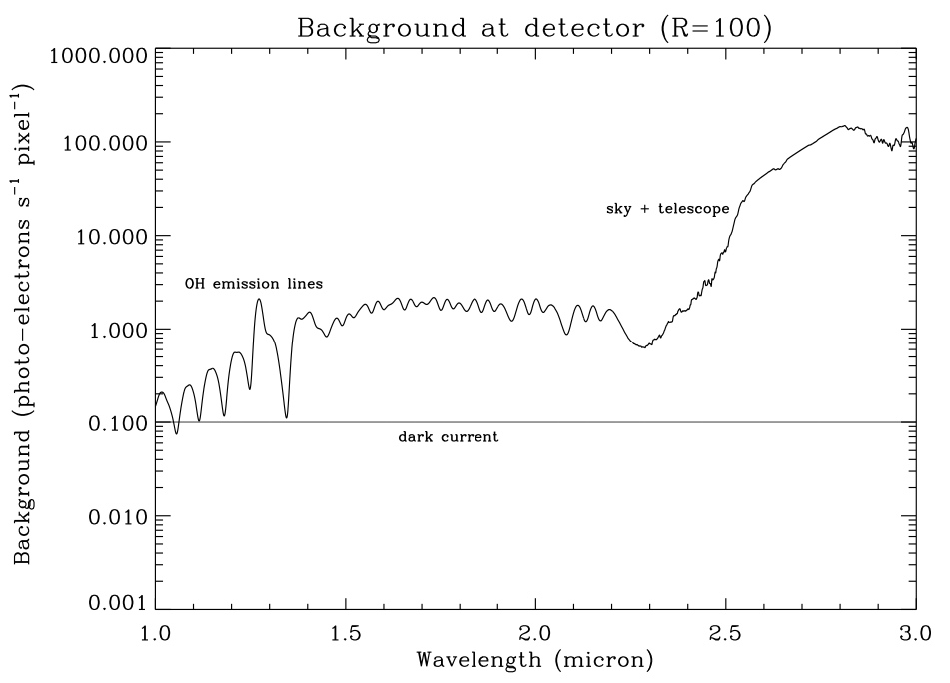
Figure 5. Predicted background at the array in SpeX assuming a resolving power of R ~ 100 matched to a 0.8″ slit, a slit efficiency of 0.6 (0.7″ seeing at K), and an average instrument throughput of 0.35.

The 25σ 1 hour sensitivity (R=100) for a range of read noise and dark current values is given in Table 14. The dominant noise in this mode is sky (JHK) and dark current (Y) but again, both read noise and dark current need to be optimized for best sensitivity. Photo-electron rates at the detector from a typical source and the sky are given in Table 15. The array/array controller requirements derived for this case are given in Table 16.

Table 14. Sensitivity 25σ 1 hour R=100 (Mag)
Read noise  (e RMS) | Dark current  (e/s) | Y | J | H | K
5 | 0.01 | 20.66 | 20.00 | 18.62 | 18.33
5 | 0.10 | 20.51 | 19.86 | 18.59 | 18.29
5 | 1.00 | 19.86 | 19.23 | 18.38 | 18.02
15 | 0.01 | 20.25 | 19.61 | 18.52 | 18.20
15 | 0.10 | 20.18 | 19.53 | 18.50 | 18.17
15 | 1.00 | 19.74 | 19.10 | 18.31 | 17.94

Table 15. Typical photo-electron (pe) rates at the detector (R=100)
 | Y | J | H | K | Note
Magnitude | 21.0 | 20.4 | 19.0 | 18.7
Object rate (pe/pixel/s) | 0.03 | 0.03 | 0.04 | 0.04 | Average in 8x14 pixel box (0.8″x1.4″)
Sky background rate (pe/pixel/s) | 0.1 | 0.5 | 1.0 | 1.0 | Average OH
Time to sky background limit  (3 x read noise) | 750 s | 150 s | 75 s | 75 s | Assume 5 e RMS read noise with NDRs
Time to full well |  |  |  | ~ days | Assume 5x10⁴ e

Table 16. Derived array/array controller requirements for case 3.2
Parameter | Requirement | Goal | Note
QE | > 0.8 | > 0.9 | 1-5 μm
Read noise | < 5 e RMS | < 2 e RMS | With multiple NDRs
Dark current | < 0.1 e/s | < 0.01 e/s
Dark current stability | < 0.01 e/s up to 12 hours
Bias stability | Flatness difference < 10 e (~ 1 DN) in up to 12 hours |  | Measured in successive dark/bias exposures
Persistence | < 0.1 e/s | < 0.01 e/s
Max/min on-chip itime | 3600 s / 60 s
Max/Min co-adds | 10/1
Typical itime | 600 s x 6 cycles
Read out overhead for full array | < 30 s |  | Per co-add
Linearity | < 1% | < 0.1 % | Over range 0-5x10⁴ e using fit if necessary
Cross-talk, next pixel | < 5% | < 1%
Cross-talk, far pixel | < 0.1%
Fixed pattern (odd/even) noise | < 1 % | < 0.1%
Flat field stability | < 1% per hour | < 1 % per 12 hours
Sub-array | No
Well depth | Low (~5x10⁴ e)
Cadence | ~6 frames per hour

prism faint & Fast occultation mode (R=100, S/N~25 in 0.1 s)
This mode requires short integration times (~0.1 s) and continuous read out for periods of about one hour. For good sensitivity the read noise needs to be optimized. This requires reducing the number of pixels read (sub-arrays) in order to maintain the pixel dwell time. The 25σ 1 hour sensitivity (R=100) for a range of read noise and dark current values is given in Table 17. Photo-electron rates at the detector from a typical source and the sky are given in Table 18. The array/array controller requirements derived for this case are given in Table 19.
Table 17. Sensitivity 25σ 0.1s R=100 (Mag)
Read noise  (e RMS) | Dark current  (e/s) | Y | J | H | K
30 | 0.10 | 9.35 | 8.70 | 8.26 | 7.80
30 | 1.00 | 9.35 | 8.70 | 8.26 | 7.80
100 | 0.10 | 8.06 | 7.42 | 6.98 | 6.51
100 | 1.00 | 8.06 | 7.42 | 6.98 | 6.51

Table 18. Typical photo-electron (pe) rates at the detector (R=2000)
 | Y | J | H | K | Note
Magnitude | 9.4 | 8.7 | 8.3 | 7.8
Object rate (pe/pixel/s) | 480 | 440 | 480 | 400 | Average in 8x14 pixel box (0.8″x1.4″)
Sky background rate (pe/pixel/s) | 0.1 | 0.4 | 0.8 | 0.7 | Average OH
Time to full well | ~100 s |  |  |  | Assume 5x10⁴ e

Table 19. Derived array/array controller requirements for case 3.3
Parameter | Requirement | Goal | Note
QE | > 0.8 | > 0.9 | 1-5 μm
Read noise | < 30 e RMS | < 10 e RMS | CDS
Dark current | < 5 e/s | < 0.5 e/s
Dark current stability | < 0.5 e/s up to 12 hours
Bias stability | Flatness difference < 10 e (~ 1 DN) in up to 12 hours |  | Measured in successive dark/bias exposures
Persistence | < 5 e/s | < 0.5 e/s
Max/min on-chip itime | 1 s / 0.1 s
Max/Min co-adds | 10/1
Typical itime | ~0.1 s continuous |  | Typically for one hour
Read out overhead for sub-array | < 0.1 s |  | Per co-add
Linearity | < 1% | < 0.1 % | Over range 0-5x10⁴ e using fit if necessary
Cross-talk, next pixel | < 5% | < 1%
Cross-talk, far pixel | < 0.1%
Fixed pattern (odd/even) noise | < 1 % | < 0.1%
Flat field stability | < 1% per hour | < 1 % per 12 hours
Sub-array | 1024 x 150 pixels |  | 0.75-2.5 μm, 15″ slit  (1/27 of full array)
Well depth | Low (~5x10⁴ e)
Cadence | ~ 5 sub-frames per s

prism Bright & Fast occultation mode (R=100, S/N~25 in 0.1 s)
As before, this mode requires short integration times (~0.1 s) and continuous read out for periods of about one hour. However, a larger sub-array is required at the cost of increased read noise (reduced pixel dwell time). Photo-electron rates at the detector from a typical source and the sky are given in Table 20. The array/array controller requirements derived for this case are given in Table 21.
Table 20. Typical photo-electron (pe) rates at the detector (R=2000)
 | Y | J | H | K | Note
Magnitude | 8.0 | 7.4 | 7.0 | 6.5
Object rate (pe/pixel/s) | 3000 | 3000 | 3000 | 3000 | Average in 8x14 pixel box (0.8″x1.4″)
Sky background rate (pe/pixel/s) | 0.1 | 0.5 | 1.0 | 1.0 | Average OH
Time to full well | ~20 s |  |  |  | Assume 5x10⁴ e

Table 21. Derived array/array controller requirements for case 3.3
Parameter | Requirement | Goal | Note
QE | > 0.8 | > 0.9 | 1-5 μm
Read noise | < 100 e RMS | < 30 e RMS | CDS
Dark current | < 30 e/s | < 3 e/s
Dark current stability | < 3 e/s up to 12 hours
Bias stability | Not important within expected range  (<100 e) |  | Measured in successive dark/bias exposures
Persistence | < 30 e/s | < 3 e/s
Max/min on-chip itime | 1 s / 0.1 s
Max/Min co-adds | 10/1
Typical itime | ~0.1 s continuous |  | Typically for one hour
Read out overhead for sub-array | < 0.1 s |  | Per co-add
Linearity | < 1% | < 0.1 % | Over range 0-5x10⁴ e using fit if necessary
Cross-talk, next pixel | < 5% | < 1%
Cross-talk, far pixel | < 0.1%
Fixed pattern (odd/even) noise | < 1 % | < 0.1%
Flat field stability | < 1% per hour | < 1 % per 12 hours
Sub-array | 1024 x 600 pixels |  | 0.75-2.5 μm, 60″ slit  (1/7 of full array)
Well depth | Low (~5x10⁴ e)
Cadence | ~ 5 sub-frames per s

LXD faint object spectroscopy (R=1500, s/n~50 in one hour)
The LXD mode covers 2-5 μm at R~940-2500. The average throughput is about 0.2. Here we assume R=1500 matched to a 0.5″ slit and a slit efficiency of 0.4 (0.7″ seeing at K). The 50σ 1 hour sensitivity (R=1500) for a range of read noise and dark current values is given in Table 22. To avoid saturating on sky background at 5 μm the minimum on-chip integration time is set to about 5 s. Therefore the dominant noise changes from sky background at long wavelengths (M′ and L′) to read noise at short wavelengths (K). Photo-electron rates at the detector from a typical source and the sky are given in Table 23. The array/array controller requirements derived for this case are given in Table 24.

Table 22. Sensitivity 50σ 1 hour R=1500 (Mag) (5 s x 720)
Read noise  (e RMS) | Dark current  (e/s) | K | L′ | M′
5 | 0.01 | 13.49 | 10.77 | 8.28
5 | 0.10 | 13.38 | 10.76 | 8.27
5 | 1.00 | 13.30 | 10.76 | 8.27
15 | 0.01 | 12.22 | 10.47 | 8.26
15 | 0.10 | 12.21 | 10.47 | 8.26
15 | 1.00 | 12.20 | 10.47 | 8.25

Table 23. Typical photo-electron (pe) rates at the detector (R=1500)
 | K | L′ | M′ | Note
Magnitude | 12.6 | 10.9 | 8.6
Object rate (pe/pixel/s) | 0.5 | 0.8 | 4.7 | Average in 5x14 pixel box (0.5″x1.4″)
Sky background rate (pe/pixel/s) | ~ 0.1 | 30 – 100 | 10³ -10⁴
Time to sky background  limit (3 x read noise) | 750 s | ~ 1 s | < 0.1 s | Assume 5 e RMS read noise with NDRs
Time to full well | Hours | 1700 - 500 s | 50 - 5 s | Assume 5x10⁴ e

Table 24. Derived array/array controller requirements for case 3.5
Parameter | Requirement | Goal | Note
QE | > 0.8 | > 0.9 | 1-5 μm
Read noise | < 15 e RMS | < 5 e RMS | With multiple NDRs
Dark current | < 0.1 e/s | < 0.01 e/s
Dark current stability | < 0.002 e/s up to 12 hours |  | Compare with object rate
Bias stability | Flatness difference < 10 e (~ 1 DN) in up to 12 hours |  | Measured in successive dark/bias exposures
Persistence | < 0.1 e/s | < 0.01 e/s
Max/min on-chip itime | 30 s / 1 s
Max/Min co-adds | 10/1
Typical itime | 5 s x 6 coadd x 120 cyc
Read out overhead for full array | < 2 s |  | Per co-add
Linearity | < 1% | < 0.1 % | Over range 0-5x10⁴ e using fit if necessary
Cross-talk, next pixel | < 5% | < 1%
Cross-talk, far pixel | < 0.1%
Fixed pattern (odd/even) noise | < 1 % | < 0.1%
Flat field stability | < 1% per hour | < 1 % per 12 hours
Sub-array | No
Well depth | Low (~5x10⁴ e)
Cadence | ~ 2 frames per min

LXD bright object spectroscopy (R=2000, s/n~1000 in 10 s)
These are requirements to observe brightest stars. No limiting requirements are found and some can be relaxed due to the object-limited nature of the observations. Photo-electron rates at the detector from a typical source and the sky are given in Table 25. The array/array controller requirements derived for this case are given in Table 26.
Table 25. Typical photo-electron (pe) rates at the detector (R=2000)
 | Y | J | H | K | L′ | M′ | Note
Magnitude | ~6 | ~5.5 | ~5 | ~4.5 | ~3 | ~2.5
Object rate (pe/pixel/s) | 0.01 | 0.01 | 0.02 | 0.01 |  |  | Average in 3x14 pixel box (0.3″x1.4″)
Sky background rate (pe/pixel/s) | 0.01 | 0.03 | 0.1 | 0.07 |  |  | Average OH
Time to full well | 0.1 s | 0.1 s | 0.1 s | 0.1 s | 0.1 s | 0.1 s | Assume 5x10⁴ e

Table 26. Derived array/array controller requirements for case 3.6
Parameter | Requirement | Goal | Note
QE | > 0.8 | > 0.9 | 1-5 μm
Read noise | < 100 e RMS | < 30 e RMS | CDS
Dark current | < 30 e/s | < 3 e/s
Dark current stability | < 3 e/s up to 12 hours |  | Compare with object rate
Bias stability | Not important within expected range  (<100 e) |  | Measured in successive dark/bias exposures
Persistence | < 30 e/s | < 3 e/s
Max/min on-chip itime | 3600 s / 60 s
Max/Min co-adds | 1000/1
Typical itime | 0.1 s x 100 co-adds
Read out overhead for full array | < 0.1s |  | Per co-add
Linearity | < 1% | < 0.1 % | Over range 0-5x10⁴ e using fit if necessary
Cross-talk, next pixel | < 5% | < 1%
Cross-talk, far pixel | < 0.1%
Fixed pattern (odd/even) noise | < 1 % | < 0.1%
Flat field stability | < 1% per hour | < 1 % per 12 hours
Sub-array | No
Well depth | Low (~5x10⁴ e)
Cadence | ~6 frames per minute

Slit viewers
The slit viewer in SpeX is used for object acquisition, guiding, and scientific imaging. In addition it is used as a pupil viewer to measure the emissivity of the telescope and for general image quality measurements. SpeX uses a good engineering grade 512 x 512 Aladdin 2 InSb array (four outputs) with a field-of-view of 60″ x 60″ (0.12″ per pixel). The slit viewer for ISHELL will be functionally identical except for a smaller field-of-view (TBD ~ 30″ x 30″, 0.06″ per pixel).

The following requirements assume the use of the two engineering-grade 512x512 Aladdin 2 devices we have available to use. Both these arrays were characterized by IRTF in 2000. The best of these arrays is being used in SpeX and has the following properties (confirmed in use). The second array has been in storage at GSFC. In 2000 its characterized performance was similar. See Table 27.

Table 27. Measured 512 x512 Aladdin 2 performance (SpeX)
Parameter | Measurement | Note
QE | ~0.6 | 1-5 μm
Gain | 14 e /DN | Lab measurement
Read noise | 80 e RMS  25 e RMS (limit) | CDS (0.25 s read out)  ≥12 NDRs
Dark current | ~ 1 e/s
Persistence | ≥ 1 e/s | Depends on signal
Well depth | ~ 5x10⁴ e | Bias -0.4 V  (~10% linearity)
Linearity | ~1% | Over range 0-3x10⁴ e
Fixed pattern (odd/even) noise | 7 % RMS
Flat field stability | < 1% per hour

POINT-source guiding (JHK, and narrow-band filters)
With the relatively narrow slits used in SpeX (0.3″) and planned for ISHELL normal telescope tracking errors can result in significant decentring in about 60 s. Poor centring of the target in the slit can result in lost flux (lower S/N) and less accurate spectral shapes. Guiding corrections are done by offsetting the telescope. Offsetting the telescope has a minimum response time of a few seconds. The most accurate guiding is done on objects in the FOV of the slit viewer but not in the slit (SpeX limit JHK~17 in 5 s, 0.3″). In practise it is usually more efficient to guide on the science target in the slit since this simplifies guide setup, but since guiding is then done on spill over flux from the target in the slit the guide limit is brighter (SpeX limit JHK~15 in 5 s, 0.3″ slit). A requirement is also to guide on very bright objects. In this case a typical integration time would be 0.1 s x 10 coadds, using a narrow-band filter to prevent saturation (although acceptable centroiding can be done on saturated stars). Guide updates of ~ 10 s are also required for tracking on non-sidereal objects.

In the faint limit, guiding is read noise limited in a typical guider integration time of 5 s. Consequently the guider magnitude limit is sensitive to read noise (see Table 28). Guiding is not very sensitive to the nominal dark current. Photo-electron rates at the detector from a guide stars and the sky are given in Table 29. The array/array controller requirements for faint and bright guide stars are given in Table 30 and Table 31, respectively.
Table 28. Guide sensitivity (Mag): 10σ 5s
Read Noise  (e RMS) | Dark current  (e/s) | J  (R=6) | H  (R=6) | K  (R=6)
30 | 1.0 | 16.5 | 15.8 | 15.4
30 | 10.0 | 16.5 | 15.8 | 15.4
80 | 1.0 | 15.6 | 15.1 | 14.6
80 | 10.0 | 15.5 | 15.1 | 14.6

Table 29. Typical guiding photo-electron (pe) rates at the detector
 | J  (R=6) | H  (R=6) | K  (R=6) | contK (R=65) | Note
Magnitude | ~17 | ~17 | ~16.5 | ~3
Object rate (pe/pixel/s) | 10 | 8 | 7 | 3x10⁵ | Average in 12 diameter (1.4″) aperture (~100 pixels)
Sky background rate (pe/pixel/s) | 50 | 200 | 100 | 10 | Measured with SpeX
Time to background limit  (3 x read noise) | 54 s | 13.5 s | 27 s | 270 s | Assume 30 e RMS with 12 NDRS
Time to full well | 500 s | 150 s | 300 s | 0.1 s | Assume 3x10⁴ e (Aladdin 2 engineering quality array)

Table 30. Guiding on faint point-source array/array controller requirements
Parameter | Requirement | Goal | Note
QE | > 0.5 | > 0.6 | 1-5 μm
Read noise | < 30 e RMS | < 10 e RMS | With multiple NDRs
Dark current | < 5 e/s | < 0.5e/s
Dark current stability | < 0.5 e/s up to 12 hours |  | Compare with object rate
Bias stability | Flatness difference < 10 e (~ 1 DN) in up to 12 hours |  | Measured in successive dark/bias exposures
Persistence | < 5 e/s | < 0.5 e/s
Max/min on-chip itime | 120 s / 1 s
Max/Min co-adds | 10/1
Typical itime | 5.0 s x 1 co-add
Read out overhead for full array | < 5.0 s |  | Per co-add
Linearity | < 10% | < 1 % | Over range 0-3x10⁴ e using fit if necessary
Cross-talk, next pixel | < 5% | < 1%
Cross-talk, far pixel | < 0.1%
Fixed pattern (odd/even) noise | < 5 % | < 0.5%
Flat field stability | < 1% per hour | < 1 % per 12 hours | On-the-fly flat fielding of guide images
Sub-array | No
Well depth | ~3x10⁴ e
Cadence | ~10 frames per minute |  | Guide calculations

Table 31. Guiding on bright point-source array/array controller requirements
Parameter | Requirement | Goal | Note
QE | > 0.5 | > 0.6 | 1-5 μm
Read noise | < 100 e RMS | < 30 e RMS | With multiple NDRs
Dark current | < 5 e/s | < 0.5e/s
Dark current stability | < 0.5 e/s up to 12 hours |  | Compare with object rate
Bias stability | Not important within expected range  (<100 e) |  | Measured in successive dark/bias exposures
Persistence | < 5 e/s | < 0.5 e/s
Max/min on-chip itime | 1.0s / 0.1 s
Max/Min co-adds | 1/1
Typical itime | 0.1 s x 10 co-add
Read out overhead for full array | < 0.1 s |  | Per co-add
Linearity | < 10% | < 1 % | Over range 0-3x10⁴ e using fit if necessary
Cross-talk, next pixel | < 5% | < 1%
Cross-talk, far pixel | < 0.1%
Fixed pattern (odd/even) noise | < 5 % | < 0.5%
Flat field stability | Not required
Sub-array | No | Yes | Sub-arraying for on-chip itimes << 0.1 s
Well depth | ~ 3x10⁴ e
Cadence | ~30 frames per minute |  | Guide calculations

planet disk guiding (narrow-band filters)
Two ISHELL science cases require precision location of the spectrograph slit on planets (Mars and Jupiter). A possible way to do this is by cross-correlation on disk features. This requires good quality guide images and reasonable contrast through the selection of a suitable filter. To avoid saturation on-chip integration times in the range 0.1-0.01 s and sub-array read outs are needed. (Alternatively, neutral density filters could be used.) On-the-fly flat fielding may also be required. Photo-electron rates at the detector for Mars and Jupiter, and for the sky are given in Table 32. The array/array controller requirements for guiding on planet disks are given in Table 33.

Table 32. Typical disk guiding photo-electron (pe) rates at the detector
 | Mars | Jupiter | Note
Estimated surface brightness (K) | ~2.8 mag per sq. arcsec | ~3.9 mag per sq. arcsec
Flux at detector  (pe/pixel/s) | ~1x10⁶ | ~5x10⁵ | 2 μm narrow-band filter (1%) (SpeX 0.12″/pixel)
Sky background rate (pe/pixel/s) | 10 | 10 | Night-time
Time to full well | 0.03 s | 006 s | Assume 3x10⁴ e

Table 33. Guiding on planet disks array/array controller requirements
Parameter | Requirement | Goal | Note
QE | > 0.5 | > 0.6 | 1-5 μm
Read noise | < 100 e RMS | < 30 e RMS | CDS
Dark current | < 5 e/s | < 0.5e/s
Dark current stability | < 0.5 e/s up to 12 hours |  | Compare with object rate
Bias stability | Flatness difference < 10 e (~ 1 DN) in up to 12 hours |  | Measured in successive dark/bias exposures
Persistence | < 5 e/s | < 0.5 e/s
Max/min on-chip itime | 1.0s / 0.01s
Max/Min co-adds | 1000/1
Typical itime | - s x 100 co-add  0.1s x 10 co-adds
Read out overhead for full array | < 0.1 s for 0.1s itime  < 0.01s for 0.01s itime |  | Per co-add
Linearity | < 10% | < 1 % | Over range 0-3x10⁴ e using fit if necessary
Cross-talk, next pixel | < 5% | < 1%
Cross-talk, far pixel | < 0.1%
Fixed pattern (odd/even) noise | < 5 % | < 0.5%
Flat field stability | < 1% per hour
Sub-array | Yes (~100x100 pixels) |  | Sub-arraying for on-chip itimes << 0.1 s
Well depth | ~ 3x10⁴ e
Cadence | ~30 frames per minute |  | Guide calculations

background-limited imaging – low background
The slit viewers are also used for scientific imaging. A fundamental requirement for imaging is to observe multiple sources with a range of brightness’s in the same exposure. When the background flux from the sky is relatively low (night time, λ<2.4 μm), read noise and well depth limit the dynamic range. For the best performance this requires read noise to be minimized while at the same time maximizing well depth. However, increasing well depth (larger reverse bias voltage) can also result in increased dark current and non-linearity, parameters that also need to be optimized. With a given device, read noise can be reduced through non-destructive multiple reads of the integrating signal. The penalty for this is the increase in integration time required to perform the additional reads.

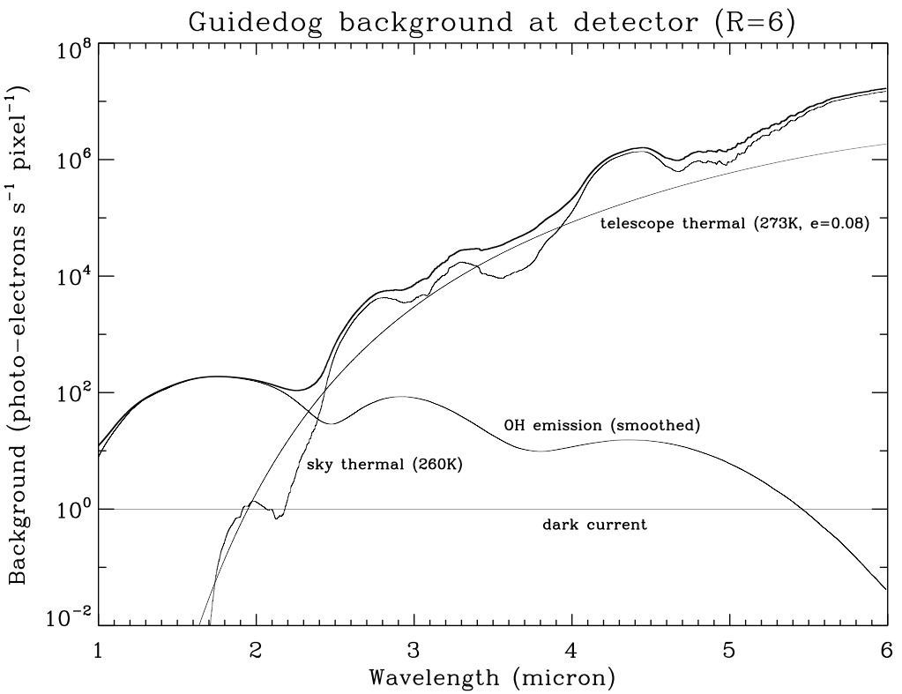
Figure 6. Predicted background at the array the SpeX slit viewer for broadband filters (R~6). The model assumes a pixel size of 0.12″ and a throughput of about 0.2.

In this mode the slit viewer is not sensitive to the nominal range of read noise and dark current (see Table 34) since for the most sensitive observations it is relatively simple to get background limited, the marginal limitation being narrow-band imaging at the shortest wavelengths (see Table 35). The array/array controller requirements for background-limited imaging under low background are given in Table 36.

Table 34. Low background 10σ 1hour sensitivity (Mag) (300 s x 12)
Read Noise  (e RMS) | Dark current  (e/s) | J  (R=6) | H  (R=6) | K  (R=6)
30 | 1.0 | 20.7 | 19.7 | 19.5
30 | 10.0 | 20.7 | 19.7 | 19.5
80 | 1.0 | 20.6 | 19.7 | 19.4
80 | 10.0 | 20.5 | 19.7 | 19.4

Table 35. Time to low-background limit
 | contJ  (R=65) | J  (R=6) | H  (R=6) | K  R=6) | contK (R=65) | Note
Sky background (magnitude/sq. arcsec) |  | 15.5 | 14.2 | 13.9 |  | Measured with SpeX
Sky background rate (pe/pixel/s) | 5 | 50 | ~200 | 100 | 10 | Measured with SpeX at detector (0.12″/pixel)
Time to background  limit (3 x read noise) | 400 s | 50 s | ~10 s | 20 s | 200 s | Assume 25 e RMS read noise with 12 NDRs
Bright magnitude limit |  | ~13 | ~11 | ~11 |  | Given finite time required to become background limited

Table 36. Array/array controller requirements for background-limited imaging under low backgrounds
Parameter | Requirement | Goal | Note
QE | > 0.5 | > 0.6 | 1-5 μm
Read noise | < 30 e RMS | < 10 e RMS | With multiple NDRs
Dark current | < 1 e/s | < 0.1e/s
Dark current stability | < 0.1 e/s up to 12 hours |  | Compare with object rate
Bias stability | Flatness difference < 10 e (~ 1 DN) in up to 12 hours |  | Measured in successive dark/bias exposures
Persistence | < 1 e/s | < 0.1 e/s
Max/min on-chip itime | 600 s / 1 s
Max/Min co-adds | 10/1
Typical itime | 100.0 s x 6 cycles
Read out overhead for full array | < 5.0 s |  | Per co-add
Linearity | < 1% | < 0.1 % | Over range 0-3x10⁴ e using fit if necessary
Cross-talk, next pixel | < 5% | < 1%
Cross-talk, far pixel | < 0.1%
Fixed pattern (odd/even) noise | < 5 % | < 0.5%
Flat field stability | < 1% per hour | < 1 % per 12 hours
Sub-array | No
Well depth | ~3x10⁴ e
Cadence | ~10 frames per minute

background-limited imaging - high background
At thermal wavelengths (see Figure 6) and during daytime the sky background is orders of magnitude brighter than the near-infrared nighttime sky background. Under these conditions most astronomical targets, with the exception of the brightest stars and planets, are small perturbations on the background. With sky background the dominant noise source the requirements for read noise and dark current can be relaxed (see Table 37), and since all observations in a particular filter are located at the same level in the detector well, linearity can also be relaxed. Due to the high backgrounds short integration times and fast read outs are required. Depending on filter and image scale sub-array read outs may be needed to avoid saturation (see Table 38 and Table 39). The array/array controller requirements for background-limited imaging under low background are given in Table 35.

Table 37 High background 10σ 1hour sensitivity (Mag) (0.1 s x 36,000) (nighttime)
Read Noise  (e RMS) | Dark current  (e/s) | L′  (R=6) | M′  (R=20)
30 | 1.0 | 14.7 | 11.5
30 | 10.0 | 14.7 | 11.5
80 | 1.0 | 14.7 | 11.5
80 | 10.0 | 14.7 | 11.5

Table 8 Nighttime sky backgrounds
 | L′  (R=6) | M′  (R=20) |  | 3.454 μm  (R=130) |  | Note
Sky background (magnitude/sq. arcsec) | 4.9 | 1.5 |  |  | Measured with SpeX
Sky background rate (pe/pixel/s) | 1x10⁵ | 4x10⁵ | ~2x10³ |  | Measured with SpeX at detector (0.12″/pixel)
Time to full well | 0.3 s | 0.1 s | ~15 s |  | Assume 3x10⁴

Table 18 Daytime sky backgrounds
 | J  (R=6) | H  (R=6) | K  (R=6) | L′  (R=6) | M′  (R=20) | 3.454 μm  (R=130) | Note
Sky background (magnitude/sq. arcsec) | 6.2 | 6.6 | 6.5 | 4.0 | 1.5 |  | Measured with SpeX  (45° from sun)
Sky background rate (pe/pixel/s) | 3x10⁵ | 2x10⁵ | 3x10⁵ | 2x10⁵ | 4x10⁵ | ~9x10³ | Measured with SpeX at detector (0.12″/pixel)
Time to full well | 0.1 s | 0.15 s | 0.1 s | 0.15 s | 0.1 s | ~3 s | Assume 3x10⁴

Table 19 Array/array controller requirements for high background-limited imaging
Parameter | Requirement | Goal | Note
QE | > 0.5 | > 0.6 | 1-5 μm
Read noise | < 80 e RMS | < 30 e RMS | CDS
Dark current | < 10 e/s | < 1 e/s
Dark current stability | < 1 e/s up to 12 hours |  | Compare with object rate
Bias stability | Not important within expected range  (<100 e) |  | Measured in successive dark/bias exposures
Persistence | < 10 e/s | < 1 e/s
Max/min on-chip itime | 10 s / 0.01s
Max/Min co-adds | 1000/1
Typical itime | 0.1s x 100 co-add  x 6 cycles
Read out overhead for full array | < 0.1 s |  | Per co-add
Linearity | < 10% | < 1 % | Over range 0-3x10⁴ e using fit if necessary
Cross-talk, next pixel | < 5% | < 1%
Cross-talk, far pixel | < 0.1%
Fixed pattern (odd/even) noise | < 5 % | < 0.5%
Flat field stability | < 1% per hour | < 1 % per 12 hours
Sub-array | Yes |  | For itimes < 0.25 s
Well depth | ~3x10⁴ e
Cadence | ~10 frames per minute

nsfcam2
NSFCAM2 is to be optimized for 1-5 μm high-resolution imaging through a range of broadband (R~5) and narrowband (R~60) filters, and CVFs (R~60). With a H2RG array the field-of-view is 82″ x 82″ and pixel scale 0.04″. The camera also contains grisms (R~50-200) and polarizers (used with a warm rotating waveplate). In normal operation photometric precisions of 1% should be standard and precisions of 0.1% should be the goal with careful calibration.

Using a model of the sky, telescope, and instrument, the predicted background in NSFCAM2 is plotted in Figure 7. The model closely reproduces the measured sky backgrounds and is used to estimate sensitivity.

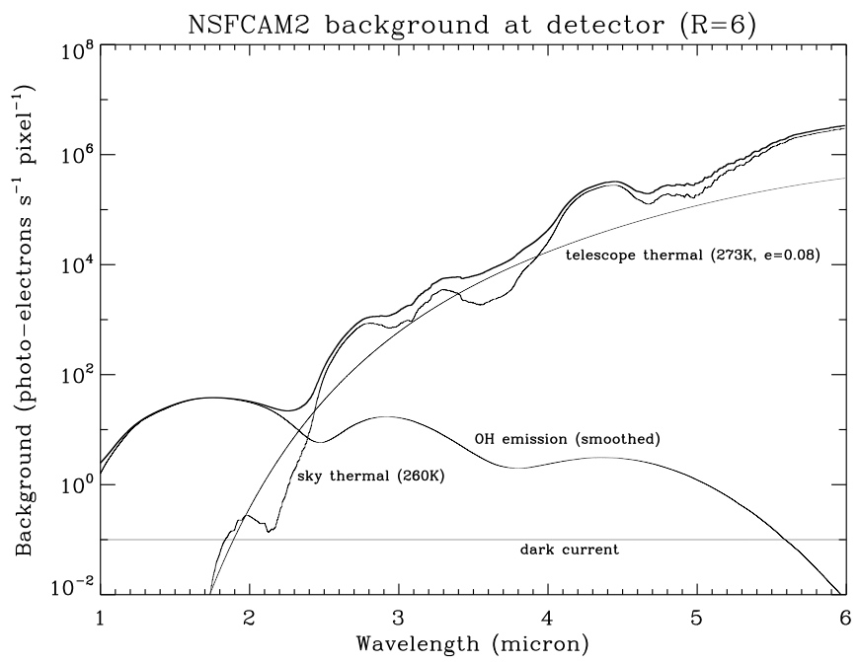
Figure 7. Predicted background at the array in NSFCAM2 for broadband filters (R~6). The model assumes a pixel size of 0.04″ and a throughput of about 0.4.

The slit viewer in SpeX is used for object acquisition, guiding, and scientific imaging. In addition it is used as a pupil viewer to measure the emissivity of the telescope and for general image quality measurements. SpeX uses a good engineering grade 512 x 512 Aladdin 2 InSb array (four outputs) with a field-of-view of 60″ x 60″ (0.12″ per pixel). The slit viewer for ISHELL will be functionally identical except for a smaller field-of-view (TBD ~ 30″ x 30″, 0.06″ per pixel).

background-limited imaging – low background
A fundamental requirement for imaging is to observe multiple sources with a range of brightness’s in the same exposure. When the background flux from the sky is relatively low (night time, λ<2.4 μm, see Figure 7), read noise and well depth limits the dynamic range. This requires read noise to be minimized while at the same time maximizing well depth. However, increasing well depth (larger reverse bias voltage) can also result in increased dark current and non-linearity, parameters that also need to be optimized. With a given device, read noise can be reduced through non-destructive multiple reads of the integrating signal. The penalty for this is the increase in integration time required to perform the additional reads.

Broadband imaging is not sensitive to the nominal range of read noise and dark current (see Table 34) since for the most sensitive observations it is relatively simple to get background limited. However, it is more difficult to get background limited for narrow-band imaging at the shortest wavelengths (see Table 35) and for these observations read noise and dark current needs to be optimized. The array/array controller requirements for background-limited imaging under low background are given in Tables 38 (broadband imaging) and Table 39 (narrowband imaging).

Table 36. Low background 10σ 1hour sensitivity (Mag) (300 s x 12)
Read Noise  (e RMS) | Dark current  (e/s) | J  (R=6) | contJ  (R=65) | H  (R=6) | K  (R=6) | contK  (R=65)
5 | 0.1 | 21.1 | 19.9 | 20.1 | 19.9 | 18.5
5 | 1.0 | 21.1 | 19.6 | 20.1 | 19.8 | 18.3
15 | 0.1 | 21.0 | 19.7 | 20.1 | 19.8 | 18.4
15 | 1.0 | 21.0 | 19.4 | 20.1 | 19.8 | 18.2

Table 20. Time to low-background limit
 | J  (R=6) | contJ  (R=65) | H  (R=6) | K  (R=6) | contK (R=65) | Note
Sky background (magnitude/sq. arcsec) | 15.5 |  | 14.2 | 13.9 |  | Measured with SpeX
Sky background rate (pe/pixel/s) | 3 | 0.3 | ~20 | 10 | 1 | At detector (0.12″/pixel), scaled from Spe
Time to background  limit (3 x read noise) | 100 s | 1000 s | ~15 s | 30 s | 300 s | Assume 10 e RMS read noise with NDRs
Bright magnitude limit | ~11.5 |  | ~9.5 | ~9.5 |  | Given finite time required to become background limited

Table 21. Array/array controller requirements for background-limited broadband imaging under low backgrounds
Parameter | Requirement | Goal | Note
QE | > 0.5 | > 0.6 | 1-5 μm
Read noise | < 15 e RMS | < 5 e RMS | With multiple NDRs
Dark current | < 1.0 e/s | < 0.1e/s
Dark current stability | < 0.1 e/s up to 12 hours |  | Compare with object rate
Bias stability | Flatness difference < 10 e (~ 1 DN) in up to 12 hours |  | Measured in successive dark/bias exposures
Persistence | < 1.0 e/s | < 0.1 e/s
Max/min on-chip itime | 600 s / 1 s
Max/Min co-adds | 10/1
Typical itime | 100.0 s x 1 co-add  x 6 cycles
Read out overhead for full array | < 5.0 s |  | Per co-add
Linearity | < 1% | < 0.1 % | Over range 0-3x10⁴ e using fit if necessary
Cross-talk, next pixel | < 5% | < 1%
Cross-talk, far pixel | < 0.1%
Fixed pattern (odd/even) noise | < 5 % | < 0.5%
Flat field stability | < 1% per hour | < 1 % per 12 hours
Sub-array | No
Well depth | ~3x10⁴ e
Cadence | ~1-10 frames per minute

Table 39. Array/array controller requirements for background-limited narrowband imaging under low backgrounds
Parameter | Requirement | Goal | Note
QE | > 0.5 | > 0.6 | 1-5 μm
Read noise | < 5 e RMS | < 2 e RMS | With multiple NDRs
Dark current | < 0.1 e/s | < 0.01e/s
Dark current stability | < 0.01 e/s up to 12 hours |  | Compare with object rate
Bias stability | Flatness difference < 10 e (~ 1 DN) in up to 12 hours |  | Measured in successive dark/bias exposures
Persistence | < 0.1 e/s | < 0.01 e/s
Max/min on-chip itime | 600 s / 1 s
Max/Min co-adds | 10/1
Typical itime | 300.0 s x 1 co-add  x 6 cycles
Read out overhead for full array | < 30.0 s |  | Per co-add
Linearity | < 1% | < 0.1 % | Over range 0-3x10⁴ e using fit if necessary
Cross-talk, next pixel | < 5% | < 1%
Cross-talk, far pixel | < 0.1%
Fixed pattern (odd/even) noise | < 5 % | < 0.5%
Flat field stability | < 1% per hour | < 1 % per 12 hours
Sub-array | Yes, ≥ 3 boxes
Well depth | ~3x10⁴ e
Cadence | ~10 frames per hour

background-limited imaging - high background
At thermal wavelengths and during daytime the sky background is orders of magnitude higher than the near-infrared nighttime sky background (see Figure 7). Under these conditions most astronomical targets, with the exception of the brightest stars and planets, are small perturbations on the background. With sky background the dominant noise source the requirements for read noise and dark current can be relaxed, and since all observations in a particular filter are located at the same level in the detector well, linearity requirements can also be relaxed. Due to the high backgrounds short integration times and fast read outs are required. Depending on filter and image scale sub-array read outs may be needed to avoid saturation. Alternatively, a larger well depth could be used if available (increased bias).

Table 40. High background 10σ 1hour (1.0 s x 3600) (nighttime)
Read Noise  (e RMS) | Dark current  (e/s) | L′  (R=6) | M′  (R=20) | 3.6 μm  (R=65)
5 | 0.1 | 15.0 | 11.8 | 13.8
5 | 1.0 | 15.0 | 11.8 | 13.8
15 | 0.1 | 15.0 | 11.8 | 13.8
15 | 1.0 | 15.0 | 11.8 | 13.8
30 | 0.1 | 15.0 | 11.8 | 13.4
30 | 1.0 | 15.0 | 11.8 | 13.4
30 | 10.0 | 15.0 | 11.8 | 13.4

Table 41. Nighttime sky backgrounds
 | L′  (R=6) | M′  (R=20) | 3.454 μm  (R=130) | Note
Sky background (magnitude/sq. arcsec) | 4.9 | 1.5 |  | Measured with SpeX
Sky background rate (pe/pixel/s) | 1x10⁴ | 5x10⁴ | ~1x10³ | From model (consistent with SpeX measurement)
Time to full well | 5.0 s | 1.0 s | ~50 s | Assume 5x10⁴

Table 42. Daytime sky backgrounds
 | J  (R=6) | H  (R=6) | K  (R=6) | L′  (R=6) | M′  (R=20) | 3.6 μm  (R=65) | Note
Sky background (magnitude/sq. arcsec) | 6.2 | 6.6 | 6.5 | 4.0 | 1.5 |  | Measured with SpeX  (45° from sun)
Sky background rate (pe/pixel/s) | 7x10⁴ | 4x10⁴ | 7x10⁴ | 4x10⁴ | 1x10⁵ | ~4x10³ | Scaled from SpeX measurements
Time to full well | 0.7 s | 1.3 s | 0.7 s | 1.3 s | 0.5 s | ~13 s | Assume 5x10⁴

Table 43. Array/array controller requirements for high background-limited imaging
Parameter | Requirement | Goal | Note
QE | > 0.5 | > 0.6 | 1-5 μm
Read noise | < 30 e RMS | < 10 e RMS | CDS
Dark current | < 10 e/s | < 1 e/s
Dark current stability | < 1 e/s up to 12 hours |  | Compare with object rate
Bias stability | Flatness difference < 10 e (~ 1 DN) in up to 12 hours |  | Measured in successive dark/bias exposures
Persistence | < 10 e/s | < 1 e/s
Max/min on-chip itime | 10 s / 0.01s
Max/Min co-adds | 1000/1
Typical itime | 1.0s x 10 co-add  x 6 cycles
Read out overhead for full array | < 1.0 s |  | Per co-add
Linearity | < 10% | < 1 % | Over range 0-3x10⁴ e using fit if necessary
Cross-talk, next pixel | < 5% | < 1%
Cross-talk, far pixel | < 0.1%
Fixed pattern (odd/even) noise | < 5 % | < 0.5%
Flat field stability | < 1% per hour | < 1 % per 12 hours
Sub-array | Yes, ≥ 3 boxes
Well depth | ~5x10⁴ e | ~1x10⁵ e
Cadence | ~10 frames per minute

sub-array imaging
The capability to image simultaneously in at least three sub-array boxes placed anywhere on the array is a requirement for some precision photometry applications. The read out speeds and integrations times can scale with sub-array size and so the read noise requirements would be the same as the full array modes except scaled to the smaller number of pixels (no different to SpeX sub-array modes in this respect).

OPTIOn: on-chip guided imaging (windowed Read out)
The H2RG has a windowed readout mode. A small guide box can be destructively read out continuously while the rest of the array is integrating. An application for this capability is to centroid on a guide star located in the guide box and to provide guide corrections to the TCS to minimize any image smear in the long exposure full array images. To be useful the guidebox would need to be about 2″ square (50 x 50 pixels) and the read out at a rate about 1 Hz (TCS corrections limited to rates < 1 Hz). However, this capability is also provided by the off-axis guider (assuming no relative flexure). Windowed readout might be useful when the off-axis cannot be used, e.g. daytime imaging, or when the best guide star is very red (unlikely given the larger field of view of the off-axis guider), or if faster updates (> 10 Hz) are allowed through the use of a tip-tilt secondary.

overall H2RG controller requirements
The requirements for reading out the full array are categorized as slow, standard, and fast read our. In practise rather than three separate read out modes, the read out will form a continuum set by the on-chip integration time (variables: integration time, NDRs, and slow counts), similar to as is currently done in SpeX. These modes should also allow for three simultaneous sub-arrays with speeds scaling with the number of pixels to be read out (as is currently standard practise). The requirements given in Tables 44, 45, and 46, should satisfy the main modes of ISHELL, SpeX, and NSFCAM2.

slow readout full array
Table 44. H2RG slow read out requirements
Parameter | Requirement | Goal | Note
Read noise | < 5 e RMS | < 2 e RMS | With multiple NDRs
Read out overhead for full array | < 30 s |  | Per co-add
Dark current | < 0.1 e/s | < 0.01 e/s
Dark current stability | < 0.002 e/s up to 12 hours
Bias stability | Flatness difference < 10 e (~ 1 DN) in up to 12 hours |  | Measured in successive dark/bias exposures
Persistence | < 0.1 e/s | < 0.01 e/s
Max/min on-chip itime | 3600 s / 60 s
Max/Min co-adds | 10/1
Typical itime | 600 s x 6 cycles
Linearity | < 1% | < 0.1 % | Over range 0-5x10⁴ e using fit if necessary
Cross-talk, next pixel | < 5% | < 1%
Cross-talk, far pixel | < 0.1%
Fixed pattern (odd/even) noise | < 1 % | < 0.1%
Flat field stability | < 1% per hour | < 1 % per 12 hours
Sub-array | Yes, ≥ 3 boxes
Well depth | Low (~5x10⁴ e)
Cadence | ~6 frames per hour

standard readout full array
Table 45. H2RG standard read out requirements
Parameter | Requirement | Goal | Note
Read noise | < 15 e RMS |  | CDS
Read out overhead for full array | < 1 s |  | Per co-add
Dark current | < 1 e/s | < 0.1 e/s
Dark current stability | < 0.1 e/s up to 12 hours
Bias stability | Flatness difference < 10 e (~ 1 DN) in up to 12 hours |  | Measured in successive dark/bias exposures
Persistence | < 1 e/s | < 0.1 e/s
Max/min on-chip itime | 100 s / 5 s
Max/Min co-adds | 100/1
Typical itime | 10-60 s x 6 co-adds  (J-M′)
Linearity | < 1% | < 0.1 % | Over range 0-5x10⁴ e using fit if necessary
Cross-talk, next pixel | < 5% | < 1%
Cross-talk, far pixel | < 0.1%
Fixed pattern (odd/even) noise | < 1 % | < 0.1%
Flat field stability | < 1% per hour | < 1 % per 12 hours
Sub-array | Yes, ≥ 3 boxes
Well depth | Low (~5x10⁴ e)
Cadence | ~1 frame per min

fast readout full array

Table 46. H2RG slow read out requirements
Parameter | Requirement | Goal | Note
Read noise | < 100 e RMS | < 30 e RMS | CDS
Read out overhead for full array | < 0.1s |  | Per co-add
Dark current | < 30 e/s | < 3 e/s
Dark current stability | < 3 e/s up to 12 hours |  | Compare with object rate
Bias stability | Not important within expected range  (<100 e) |  | Measured in successive dark/bias exposures
Persistence | < 30 e/s | < 3 e/s
Max/min on-chip itime | 3600 s / 60 s
Max/Min co-adds | 1000/1
Typical itime | 0.1 s x 100 co-adds
Linearity | < 1% | < 0.1 % | Over range 0-5x10⁴ e using fit if necessary
Cross-talk, next pixel | < 5% | < 1%
Cross-talk, far pixel | < 0.1%
Fixed pattern (odd/even) noise | < 1 % | < 0.1%
Flat field stability | < 1% per hour | < 1 % per 12 hours
Sub-array | Yes, ≥ 3 boxes
Well depth | Low (~5x10⁴ e)
Cadence | ~6 frames per minute

occultation mode
The occultation mode is unique to SpeX where the prism spectrum is imaged into less than one quadrant of the array.

Table 47. H2RG occultation mode (SpeX)
Parameter | Requirement | Goal | Note
Read noise | < 30 e RMS  < 100 e RMS | < 10 e RMS  < 30 e RMS | CDS, 1024x150 pixel sub-array  CDS, 1024x600 pixel sub-array
Read out overhead for sub-array | < 0.1 s |  | Per co-add
Dark current | < 5 e/s | < 0.5 e/s
Dark current stability | < 0.5 e/s up to 12 hours
Bias stability | Flatness difference < 10 e (~ 1 DN) in up to 12 hours |  | Measured in successive dark/bias exposures
Persistence | < 5 e/s | < 0.5 e/s
Max/min on-chip itime | 1 s / 0.1 s
Max/Min co-adds | 10/1
Typical itime | ~0.1 s continuous |  | Typically for one hour
Read out overhead for sub-array | < 0.1 s |  | Per co-add
Linearity | < 1% | < 0.1 % | Over range 0-5x10⁴ e using fit if necessary
Cross-talk, next pixel | < 5% | < 1%
Cross-talk, far pixel | < 0.1%
Fixed pattern (odd/even) noise | < 1 % | < 0.1%
Flat field stability | < 1% per hour | < 1 % per 12 hours
Well depth | Low (~5x10⁴ e)
Cadence | ~ 5 sub-frames per s

overall alladin 2 (Slit viewer) controller requirements
The requirements for reading out the full array are categorized as slow, standard, and fast read our. In practise rather than three separate read out modes, the read out will form a continuum set by the on-chip integration time (variables: integration time, NDRs, and slow counts), similar as is currently done in SpeX. These modes should also allow for three simultaneous sub-arrays with speeds scaling with the number of pixels to be read out (as is currently standard practise).The requirements given in Tables 48, 49, and 50, should satisfy the guiding and slit viewing modes of SpeX and ISHELL.

slow readout full array
Table 48. Aladdin 2 slow read out requirements
Parameter | Requirement | Goal | Note
QE | > 0.5 | > 0.6 | 1-5 μm
Read noise | < 30 e RMS | < 10 e RMS | With multiple NDRs
Read out overhead for full array | < 5.0 s |  | Per co-add
Dark current | < 1 e/s | < 0.1e/s
Dark current stability | < 0.5 e/s up to 12 hours |  | Compare with object rate
Bias stability | Flatness difference < 10 e (~ 1 DN) in up to 12 hours |  | Measured in successive dark/bias exposures
Persistence | < 1 e/s | < 0.1 e/s
Max/min on-chip itime | 120 s / 1 s
Max/Min co-adds | 10/1
Typical itime | 5.0 s x 1 co-add
Linearity | < 10% | < 1 % | Over range 0-3x10⁴ e using fit if necessary
Cross-talk, next pixel | < 5% | < 1%
Cross-talk, far pixel | < 0.1%
Fixed pattern (odd/even) noise | < 5 % | < 0.5%
Flat field stability | < 1% per hour | < 1 % per 12 hours | On-the-fly flat fielding of guide images
Sub-array | Yes, ≥ 3 boxes
Well depth | ~3x10⁴ e
Cadence | ~10 frames per minute |  | Guide calculations

standard readout full array
Table 49. Aladdin 2 standard read out requirements
Parameter | Requirement | Goal | Note
QE | > 0.5 | > 0.6 | 1-5 μm
Read noise | < 70 e RMS | < 20 e RMS | CDS
Read out overhead for full array | < 1.0 s |  | Per co-add
Dark current | < 5 e/s | < 0.5e/s
Dark current stability | < 0.5 e/s up to 12 hours |  | Compare with object rate
Bias stability | Flatness difference < 10 e (~ 1 DN) in up to 12 hours |  | Measured in successive dark/bias exposures
Persistence | < 5 e/s | < 0.5 e/s
Max/min on-chip itime | 10 s / <1 s
Max/Min co-adds | 10/1
Typical itime | 1.0 s x 2 co-add
Linearity | < 10% | < 1 % | Over range 0-3x10⁴ e using fit if necessary
Cross-talk, next pixel | < 5% | < 1%
Cross-talk, far pixel | < 0.1%
Fixed pattern (odd/even) noise | < 5 % | < 0.5%
Flat field stability | < 1% per hour | < 1 % per 12 hours | On-the-fly flat fielding of guide images
Sub-array | Yes, ≥ 3 boxes
Well depth | ~3x10⁴ e
Cadence | ~ 30 frames per minute |  | Guide calculations

fast readout full array
Table 50. Aladdin 2 fast read out requirements
Parameter | Requirement | Goal | Note
QE | > 0.5 | > 0.6 | 1-5 μm
Read noise | < 100 e RMS | < 30 e RMS | CDS
Dark current | < 5 e/s | < 0.5e/s
Dark current stability | < 0.5 e/s up to 12 hours |  | Compare with object rate
Bias stability | Not important within expected range  (<100 e) |  | Measured in successive dark/bias exposures
Persistence | < 5 e/s | < 0.5 e/s
Max/min on-chip itime | 1.0s / <<0.1 s
Max/Min co-adds | 1/1
Typical itime | 0.1 s x 10 co-add
Read out overhead for full array | < 0.1 s |  | Per co-add
Linearity | < 10% | < 1 % | Over range 0-3x10⁴ e using fit if necessary
Cross-talk, next pixel | < 5% | < 1%
Cross-talk, far pixel | < 0.1%
Fixed pattern (odd/even) noise | < 5 % | < 0.5%
Flat field stability | Not required
Sub-array | Yes, ≥ 3 boxes
Well depth | ~ 3x10⁴ e
Cadence | ~30 frames per minute |  | Guide calculations

