|  |  |
| --- | --- |
| C:\01_MORGAN_WORK\01_IRTF_Projects\01_Intruments\01_iSHELL\02_Documentation\iSHELL logo2.jpg | NASA IRTF / UNIVERSITY OF HAWAII  Document #: xxx  Created on:xx  Last Modified on :xx |



**ISHELL INSTRUMENT Controller Overview**

Original Author: T.Denault, E.Warmbier

Latest Revision:

Approved by: XX

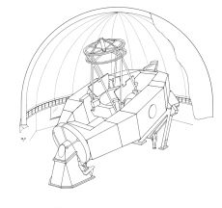

NASA Infrared Telescope Facility

Institute for Astronomy

University of Hawaii

**Revision History**

|  |  |  |  |
| --- | --- | --- | --- |
| **Revision No.** | **Author &**  **Date** | **Approval &**  **Date** | **Description** |
|  |  |  |  |
|  |  |  |  |

**Contents**

[1 Introduction / Document Purpose 3](#_Toc350171983)

[2 Requirements 3](#_Toc350171984)

[2.1 Summary Table for the Instrument Controller 4](#_Toc350171985)

[3 Instrument Controller Overview 5](#_Toc350171986)

[4 Instrument Control Electronics 7](#_Toc350171987)

[4.1 Instrument Control Computer 7](#_Toc350171988)

[4.2 Stepper Motor Control 7](#_Toc350171989)

[4.3 Hall Effect Sensor Conditioning 7](#_Toc350171990)

[4.4 Additional Analog or Digital IO 7](#_Toc350171991)

[4.5 Temperature Control and Monitoring 8](#_Toc350171992)

[4.6 AC Power Control 8](#_Toc350171993)

[4.7 Serial Port Server 8](#_Toc350171994)

[4.8 Packaging, Cabling, Mounting 9](#_Toc350171995)

# Introduction / Document Purpose

This document describes the plans for the iSHELL Instrument Controller. The Instrument Controller is one of the three primary control systems in iSHELL. These 3 control systems are listed below.

* Spectrograph Camera System - The computer, controller, and associated electronics use to readout the H2RG spectrograph array
* Guiding Camera System - The computer, controller, and associated electronic used to readout the Aladdin guider array.
* Instrument Controller System - computers, controllers, and associated electronics used to command motorized mechanism, temperature monitors and controllers, lamp A/C power, and other utility functions of the instrument.

Essentially the Instrument Controller is the non-imaging portion of iSHELL. The user will perform their observations using the spectrograph and guider systems. Each camera system will have its own Graphical User Interface (GUI). The spectrograph and guiding systems will typically be used together, but can also operate independently. For example, the guider can be used as a standalone imager. The GUIs for the camera systems will contains widgets for controlling and monitoring the hardware controlled by Instrument Controller System. Some of the hardware components are unique to each camera system, like each array’s temperature controller. Some mechanisms are common to both systems, like the image rotator, which is in the optical path of each camera. The instrument controller must provide status and control of these shared and dedicated hardware components to each camera system.

# Requirements

This section summaries the Instrument Controller requirements. Its high level requirement can be listed as:

* Command of 12 mechanisms using stepper motors
* Sensing of ~23 mechanism position sensors or switches.
* Command of 5 temperature controllers (2 Arrays, 2 Gratings, Gas Cell)
* Monitor 10 temperature sensors.
* Command the AC power for 3 calibration lamps.
* Communicate seamlessly with the Spectrograph and Guiding Controller Systems.
* Run the software using the CentOS 6.x

## Summary Table for the Instrument Controller

The blue text indicates warm mechanisms.

|  |  |  |  |  |  |  |
| --- | --- | --- | --- | --- | --- | --- |
| ITEM | Desc | Stepper | HE / Mech Sensors | Power Control | Temp. control or  monitoring | Others |
| CalLamp | Mirror: Out/In linear slide, warm Control power Supply for 3 Lamps. | 1 | 2 | 3 |  |  |
| GasCell | Out/In linear slide, warm | 1 | 2 |  | 1 sensor  1 heater |  |
| Window Cover | Out/In Linear slide, warm | 1 | 2 |  |  |  |
| Rotator | Continuous Wheel Mechanism. Cold | 1 | 1 HE |  |  |  |
| Slit Wheel | Detented Wheel Mechanism. Cold 10 positions. InDetent, Home sensor. | 1 | 2 HE |  |  |  |
| Slit Decker | Variable position linear slide, cold | 1 | 2 HE |  |  |  |
| Order Sorter | Detented Wheel Mechanism. Cold 10 positions. InDetent, Home sensor. | 1 | 2 HE |  |  |  |
| Immersion Grating | 2 position Linear slide | 1 | 2 HE |  |  |  |
| XD Wheel | Detented Wheel Mechanism. Cold 12 positions. InDetent, Home sensor. | 1 | 2 HE |  |  |  |
| XD Tilt | Continuous Linear slide. Cold. | 1 | 2 HE |  |  |  |
| Spectrograph Focus | Continuous Linear slide. (Similar to spex). Cold. | 1 | 2 HE |  |  |  |
| Guider FIlter | Detented Wheel Mechanism. Cold 10 positions. InDetent, Home sensor. | 1 | 2 HE |  |  |  |
| Active Temperature Control | Guider Array, Spectrograph Array, Immersion Grating Unit #1, Immersion Grating Unit #2. |  |  |  | 4 sensors 4 heaters |  |
| Temperature Monitoring | Various places in cryostat |  |  |  | 10 sensors |  |
| Summary |  | 3 warm 9 cold | about 23 | 3 | 15 sensors 5 heaters |  |

# Instrument Controller Overview

.

As of Jan 2013, SpeX Instrument upgrade is in-progress. This upgrade will completely replace SpeX’s current array controllers, and it’s Instrument Control System with completely new hardware. One of the requirements for the SpeX upgrade is to build its instrument Controller so that the hardware selected and the software being written can be used by iSHELL. This will provide iSHELL with a proven design that can be implemented very quickly. Essentially, we will fork the SpeX control system and port it to iSHELL.



This diagram shows the iSHELL Data Acquisition and Instrument Control Block diagram. The blue color shows the items that are part of the Instrument Controller System. Key concepts are:

* A separate computer to host the Instrument Controller Software. This computer is located in the TCS Room. The instrument Controller is independent from the Camera Acquisition Systems.
* Various hardware controllers are used for motor control, temperature control, analog and digital IO. These controllers communicate using Ethernet, and are located in the Cool Rack electronic racks on the telescope.

# Instrument Control Electronics

This section presents some of the key hardware to be used in the Instrument Controller. All of the hardware presented have already been used at the IRTF, or is being used as part of the SpeX Instrument Controller. This gives us confidents that they will work well for iSHELL, and can be integrated into the iSHELL system very quickly.

## Instrument Control Computer

* Modest PC (x86 PC with i3 CPU, 8GB RAM, Ethernet) running CentOS 6.x.

## Stepper Motor Control

* DMC-4183 - Gaili Ethernet based Stepper motor Controller.
* 8-axes of stepper motor control with Home, and limits inputs.
* 8 uncommitted analog input (one per axis), 16 Digital Input, 16 Digital Outputs.
* <http://www.galilmc.com/products/dmc-41x3.php>
* Using IM483-34P1 Microstepping Driver

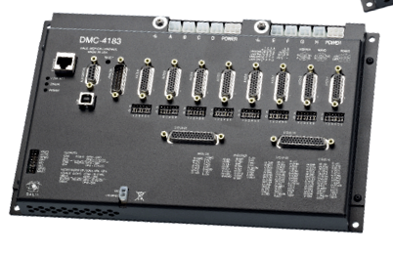

## Hall Effect Sensor Conditioning

* IRTF to manufacture an update version of the current spex comparator board.

## Additional Analog or Digital IO

* Galil RIO-47120-16bit. Ethernet IO Unit.
* 8 analog inputs, 8 analog output, 16 Digitial Input/Outputs
* Low cost, $400 per unit.
* <http://www.galilmc.com/products/rio-47xxx.php>

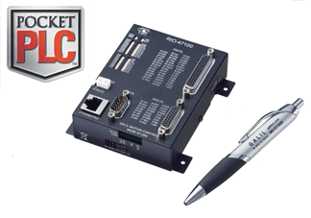

## Temperature Control and Monitoring

* Lake Shore Model 335 Temperature Controller, 4 each (2 array, 2 gratings).
* <http://www.lakeshore.com/products/cryogenic-temperature-controllers/model-335/Pages/Overview.aspx>
* Lake Shore Model 218 Temperature Monitor. Eight sensor inputs. 1 each.
* <http://www.lakeshore.com/products/cryogenic-temperature-monitors/model-218/Pages/Overview.aspx>

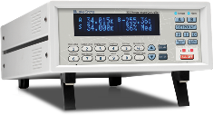 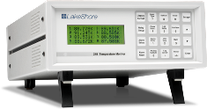

## AC Power Control

* WTI NPS-8HD20-1 Network Power Switch. (8 outlets)
* Updated version of the WTI units currently used by the IRTF.
* <http://www.wti.com/p-186-nps-8hd20-1-network-power-switch-pdu-dual-20a-120v-85-15r.aspx>

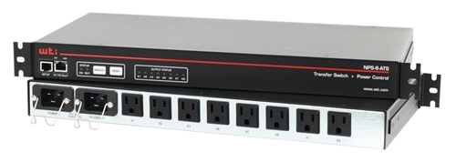

## Serial Port Server

* DigiPort PortServer II 16 Rack
* Provides Ethernet access to  16 EIA-232 serial ports. Used for serial based controllers.
* <http://www.digi.com/products/serialservers/portserverii#overview>

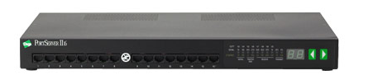

## Packaging, Cabling, Mounting

* iShell’s cassegrain electronics will be located in the NE (north-east) Coolrack. CSHELL currently occupies 2 coolrack (NEI and NEO). This space is available for ISHELL.
* 1 Cool rack location is about 28” of a 19-inch rack.  This provides 16 Rack units (1 Rack Unit is 1.75 inches). Our goal to use just 1 of the 2 coolracks avaiable.
* Electronic will be housed in 19” racks or shelves.  Our goals to allow each rack to be pulled out while HOT for diagnosis.
* MIL-SPEC connectors will be used to connect cable to the electronic boxes.

(See EXCEL worksheet: “HallEffect.xlsx”)