IRTF MORIS Manual

Filename: moris_manual-v2002.odt
Last Saved: 2020-02-19

MORIS (MIT Optical Rapid Images System) is an instrument for use on the IRTF. This high-speed, visible wavelength camera is mounted on the side window of SpeX, a near-IR imager and spectrograph. This design is based on POETS (Portable Occultation, Eclipse, and Transit System), which was developed by MIT and Williams Colleges.
MORIS was built as a joint MIT/IRTF project.
This manual covers the MORIS from Nov 2016 to the present:
- On Nov 2016, MORIS was updated with the iXon (usb) Ultra camera, replace the 2008 iXon (PCI) camear.
- The linux OS was updated from CentOS 5 to 6. And the Windows operation mode was depreciated (although it is still avaiable on the system). The EM option can be used by special request.

The operation for MORIS from 2011 to 2016-10 was covered by the initial MORIS manually, which is on the IRTF MORIS home page.

The IRTF MORIS Home page is located at: http://irtfweb.ifa.hawaii.edu/~moris

Table of Contents
Figure 1 – Moris Block Diagram 3
1. A quick Intro into Moris 4
2. Moris Linux 5
2.1 Running MORIS Linux 5
2.2 Initializing the iXon Camera. 9
2.3 Simple Observing Instructions for Linux 10
2.4 Guiding 11
2.5 Movie Mode 11
2.6 Obslog dialog 13
2.7 Setup Tab 14
2.8 Macro Tab 14
3.9 GPS Tab 15
Appendix A – Staff Start up and Shutdown Procedures for Moris 17
Appendix B - Mounting Checklist 18
Appendix C – Filter Wheel Details 19
Appendix D - Fore-Optics and Mounting Box notes 20
D.1 - Adjustment of the z-extension 20
D.2 Adjustment of mount for lenses 2 & 3 20
Appendix E – Movie Mode Timing 21
Appendix F – Additional notes 23
F.1 Andor Ultra iXon 897 (usb) 23
F.2 Spectrum Instrument TM-4 GPS Unit 23
Appendix G – Problems and Solutions 24

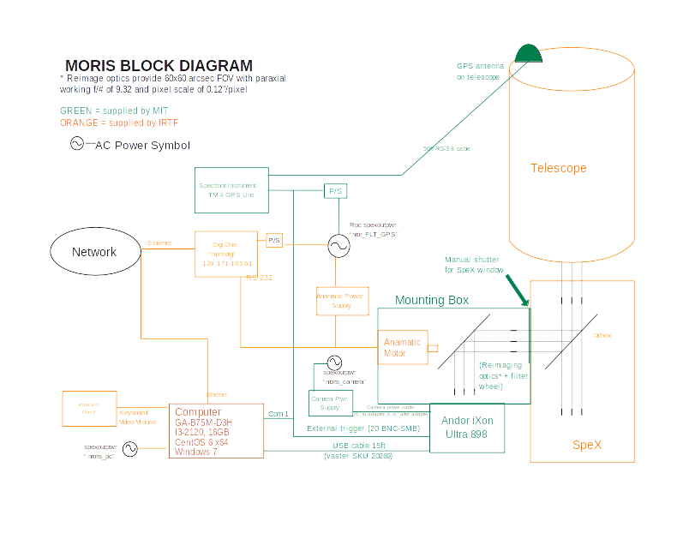

Figure 1 – Moris Block Diagram

1. A quick Intro into Moris

MIT Planetary Astronomy Labs developed the POETS, a portable CCD camera system for Occultation, Eclipse, and Transit observations (http://occult.mit.edu/instrumentation/poets.php). A modify system built for the IRTF was constructed by the MIT and IRTF. This system is called MORIS (MIT Optical Rapid Imaging System).

MORIS is mounted onto SpeX. A dichroic in SpeX provides the optical light to MORIS.

The primary components of MORIS are:

- Ixon CCD Camera System: Andor iXon Ultra DU-897U-CSO camera, using a 512x512 E2V CCD97 sensor. A USB cable connect the camera to the PC ( The MIT Group supplied the original iXon DU-897 + CCI-22 PCI interface. This was replace in 2016/11).

- Computer: A PC located on the bottom of the telescope runs the software for controlling the camera, GPS, and filter wheel. This PC runs CentOS 6 and the IRTF MORIS software (ic, xui, DV) used for observing. This the default operating mode. Windows 7 along with Andor's SOLIS, and TM4 GPS OEM window software is install, but not support by the IRTF. Observer can use the OEM software on request, but without direct IRTF support (vendor manuals for the PC software are on the IRTF MORIS home page)

- GPS: A Spectrum Instruments Model TM-4 GPS system can be used to provide a programmable output pulse to trigger the CCD acquisition. The GPS Programmable pulse output is connect to the iXon’s external trigger input.

- Light-tight Foreoptics box contains:
  - Filter Wheel: A cuctom-built wheel with ten 1” filters. Motorized using a Animatics Smartmotor connected to the LAN via a DigiOne Terminal server.
  - Fold Mirror: protective silver coathing (>90% reflectivity).
  - Reimaging optics:

- VNC Access. The MORIS software GUI (XUI, DV) are executed on the IRTF VNC session stefan:12. Normally observer use this vnc session to run the MORIS software.

  - kvmcass – The MORIS PC keyboard/Video/Mouse ports are connect to the IRTF kmvcass unit. Direct access to the console is available via the IRTF Facility IP KVM “kvmcass”
  - Moris Windows – In running in Windows 7, the window OS provide the VNC server. You must contact the IRTF if you wish to run windows and connect to the WindowsOS VNC session

2. Moris Linux

The MORIS Linux software is a custom IRTF software for observing with MORIS. If features:

- Provide a IRTF like GUI, very similar to Spex’s GUI. (IC, XUI, DV)
- Integrates better with the IRTF TCS, SPeX, and network.
- Simplify user interface.
- MORIS can act as a guider for SpeX.

Of course, simplifying the option is actually hides or sets so options for the user. For most MORIS user, this should not be an issue. The Windows environment with OEM software still provides user with FULL access to Andor capabilities. However, this requires special permission by from the IRTF. Some of the features set by MORIS Linux are:

- Ixon Advance EM Gain is restricted.
- Ixon Readmode is set to “Image”.
- Ixon Frame Transfer is enabled.
- Ixon BaseLineClamp is Disabled.
- Ixon automatic shutter mode not available (only Open or Closed).

2.1 Running MORIS Linux

Normally the MORIS software is running in a IRTF VNC session. You just need to connect to his VNC session to use MORIS.

The MORIS software is running in an IRTF VNC session. You must use the RealVNC client to connect to Stefan.ifa.hawaii.edu:12. Contain the TO or Staff for the vnc password.

1. Connecting to the MORIS VNC session.

- All users, you will need an IRTF program account.
- For remote users, you will need to use the RealVNC vnc viewer on your personal machine.
- For summit observers, run this vnc viewer command in any xterm on IRTF workstation: “vncviewer stefan:12”.
- Refer the IRTF website http://irtfweb.ifa.hawaii.edu for observers instruction.
- Contact the TO or IRTF staff for the VNC password of the day.
- After connecting to the moris VNC, login using program account (ie: 2016B014) and password at the following MORIS XUI login dialog box.

.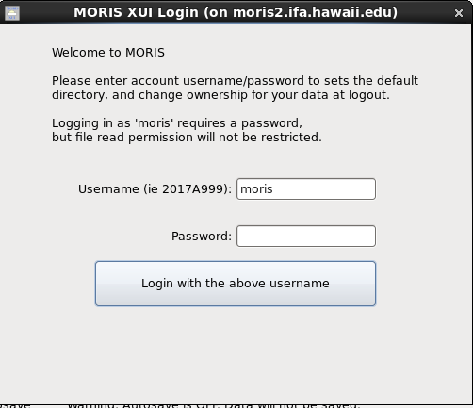

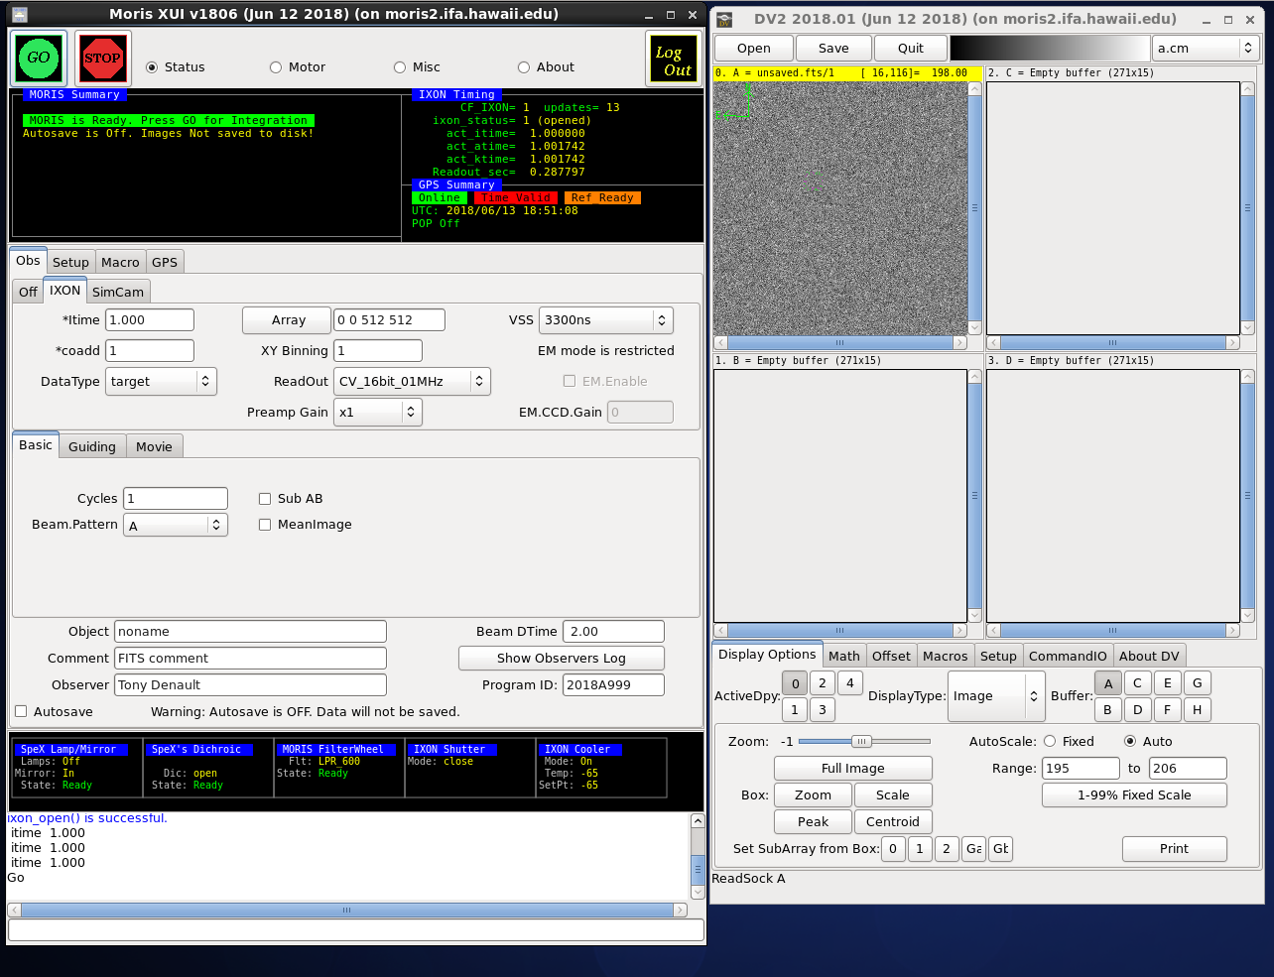
Moris Linux running in the VNC Session

On the left side you should see the Moris XUI (X Users Interface). The XUI provide full control for the camera’s operations.
On the right is DV, IRTF’s standard data viewer for instrumentation. Documentation for DV is at http://irtfweb.ifa.hawaii.edu/Facility/DV/

The follow diagram explains the major sections of the XUI:

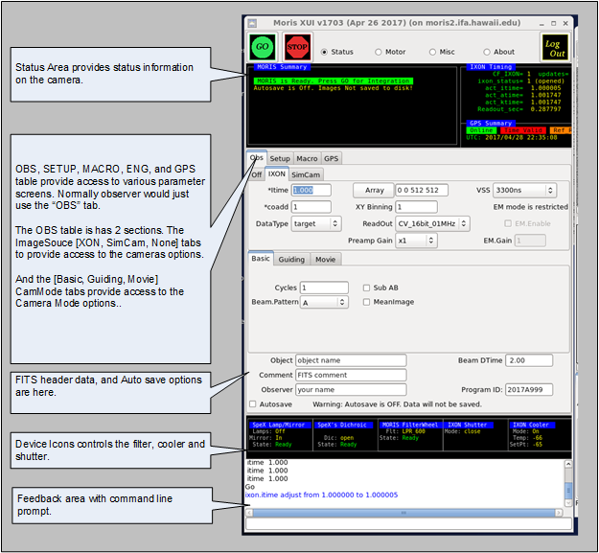

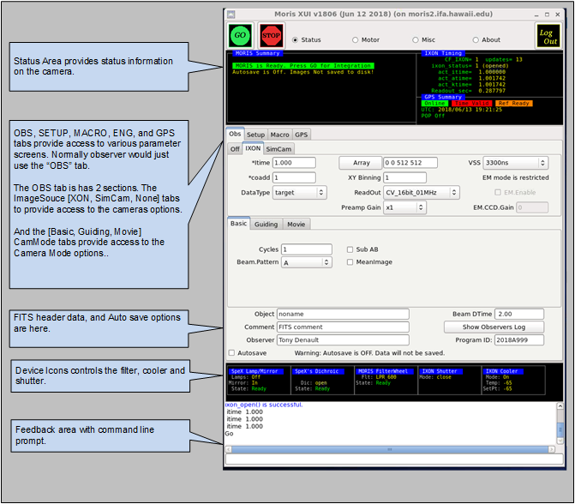

Moris XUI diagram

2.2 Initializing the iXon Camera.

When you are ready to start observing, Set the ImageSource to IXON. This will load the camera driver and initialize the hardware. Once this has be successful opened, check the IXON Cooler and Shutter setup.
By clicking on the Device Icons, you can change the Cooler or Shutter setting.

- After observing, set the Image Source back to “Off”. This closes the camera driver, putting the camera into a safe idle mode.
- If the Ixon camera fails to initialize, type “go.init” to re-iniitialize.
- The Ixon Cooler should be ON, and will take a few minute to reach its setpoint of -65. If it is not ON, click on the Ixon Cooler icon to changed it settings.
- Check the shutter to ensure open or closed.
- Check the Filter setting. If the filter is not “Ready”, go to the Setup tab and do a “Filter.Init”
- If using the GPS, its summary status “Online” and “Time Valid” should be green. If not, inform the TO.

2.3 Simple Observing Instructions for Linux

Once the IXON camera is ready and you are ready to take date, review the ixon parameters:

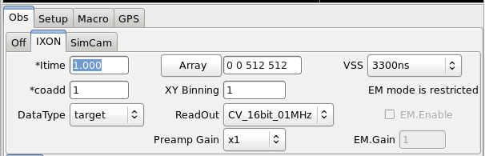
- Itime is the ixon exposure time for a CCD readout.
- Coadd is the number of readouts to accumulate into an image.
- Array text input allows you to change the “X Y Wid Hgt” of the subarray. Clicking on the “Array” button resets the value to readout the full array (0,0 512x512).
- XY Binning set the pixel binning value for the CCD.
- Readout menu sets the iXon’s AMP, Channel, and HSS values. The default “CV_16bits_01MHz”.
- Preamp Gain sets the Ixon Preamplifier gain.
- VSS is the iXon Vertical Shift speed value.
- EM mode is an restricted option. If you are interested in using EM mode, arrangement need to made with your support scientist prior to your observing run.

The follow table summaries the readout rate in seconds of the CCD using various Readout, and VSS options on a full frame (512x512, no binning) readout.

It is recommended that users use “CV_16bits_01Mhz” and VSS=3.3 unless faster readout is necessary. Of course, faster readout rate usually increase the noise. Using subarray and binning can also decrease the readout rate.

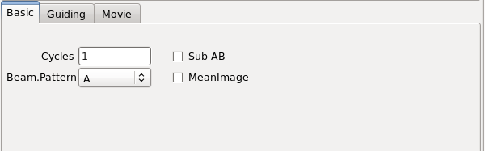

Select CamMode Basic. The Beam.Pattern tells the camera if the image in take is a BEAM A or B image. If beam.pattern is AB, then an A and B beam images are taken while beam switching the telescope. Cycles repeats the Beam.Pattern in basic mode.

Clicking on the Filter wheel icon brings up a menu allow you to select a desired filter.

Autosave controls if the images are saved.

Once you selected the desired options, click GO to take and image.

2.4 Guiding

Select “Guiding” on the Cammode tab enables guiding. The following screen is displayed:
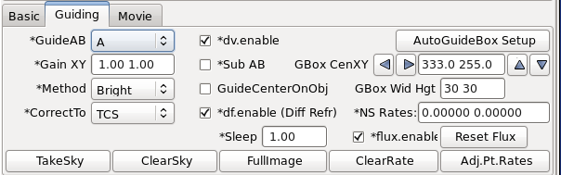

While guiding, images can be saved.
The Telescope operator should assist observer if guiding with MORIS.

2.5 Movie Mode

Selecting “Movie” on the cammode tab enables movie mode. The follow screen is displayed:

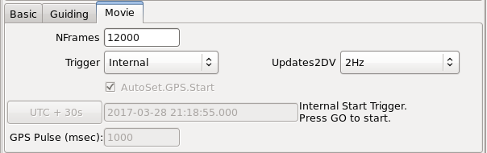
Movie mode is a high speed image mode ( The Ixon calls its Kinetic mode ). The software will buffer images in RAM, and write 3D FITS data when the RAM is filled. Continually writing 3D FITS files until the movie mode is completed. The images in the movie sequence are taken at a fixed rate, with minimal overhead between images.

The general procedures for taking a movie are:

1. Use basic mode to adjust the itime, coadds, Array, XY Binning and other IXON readout parameter to you desired setting. Go on, once you have produced a satisfactory basic image.

2. Switch to movie mode.

3. Setup Movie parameters:

NFrames – are the number of frames in the movie. Movie mode will stop after saving “NFrames” of data, or when the STOP button is press. Enter the desired number of frames, or enter a large number and manual stop the movie sequence. Max input value is 999999.

Trigger – The trigger option are:
- Internal – The ixon will start the movie sequence and acquisition of each frame. This is the simplest option, but the timing of the start and subsequences frame are performed internally by the IXon hardware. The “act_ktime” values shows the period of the subsequence images. The absolute timestamp of your data (or TIME_OBS ) is good to about 0.1 seconds.

- External_Start – A start pulse by the GPS unit will start the movie sequence. The ixon will schedule the subsequence frames. The act_ktime show the period of the subsequence images.

- External – A repeating GPS pulse will trigger each frame of the movie sequence. This provides the most accurate timing of each the image. Frame transfers and readouts are slaved off of the GPS pulses. In External mode, itime becomes an ‘Exposure Delay’ term. In this mode, the software will set itime to 0.000 (No Delay). The GPS Rep_ms is the exposure time between readouts.

AutoSet.GPS.Start – If External or External_Start triggering is selected, you will need to specify the start time of the GPS unit. The AutoSet.GPS.Start, if enable, will auto load the “current UTC Time + 10 seconds” into the GPS when the GO is press. If AutoSet.GPS is not set, you must manual enter the GPS.Start Date and Time.

GPS.Start text box – If you are manually entering the start time, type the UTC Date and Time into the text area under the AutoSet.GPS.Start. The format is YYYY-MM-DD HH:MM:SS.SSS. Hit return to accept this input. The “UTC+30s” button will load the current data and time (plus 30 seconds) into the text area.

GPS Pulse (sec): For External Trigger ONLY, you will need to enter the period of the GPS pulse here. This needs to be larger that the act_ktime (in millseconds). If you enter a value that is too low, the software will set it in a minimal value.

Update2DV – Moris updates the DV image at a rate set by this menu (Images can be cache and saved at a higher rate). Set the desired DV update rate. Note for VNC user a lower rate may be optimal as a higher display rate may saturate the VNC bandwidth.

Enable Autosave. In move mode, autosave must be enabled.

Coadds are not support in Movie mode. Coadds will be set to 1.

It’s best to setup your movie mode inputs, do a test with a limit number of “nframes”. Check the timing. Now you will be ready to start you observing.

“Appendix E – Movie Mode Time” – provide information on determining the timestamps of the movie frames.

2.6 Obslog dialog
This button bring up the observing log dialog box shown below:

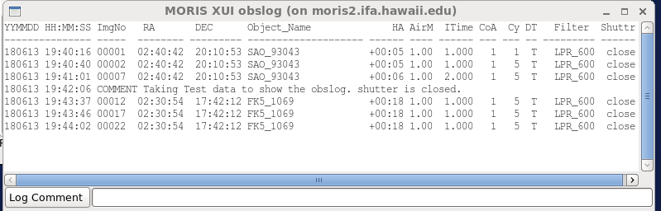

On every GO (with autosave ON) a line it appended to a obslog.txt file in the saved data directory. This dialog box show the contents of this obslog.txt file.
On the bottom of the dialog box, a text input allows you to enter a comment. When the Log Comment button is pressed, this text is append to the log file.
The column for the log file are:
YYMMDD HH:MM:SS – the UTC date and time of the GO.
ImgNo – The image number of the 1st image in the cycle.
RA,DEC – The current postion of the Telescope in FK5 J2000 coordinates.
Object_Name – the object name from the XUI Object field (and FITS OBJECT keyword).
HA – The Hour Angle of the Telescope.
AirM – The AirMass of the Telescope
Itime – The Itime value from the camera.
CoA – The Coadd value from the camera.
Cy – The cycles value from the camera.
DT – The Datatype value from the camera: T=Target, S=Standard, C=Calibration
Filter – The selected MORIS Filter wheel position.
Shutter – The state of the iXon Shutter (open, closed).

2.7 Setup Tab

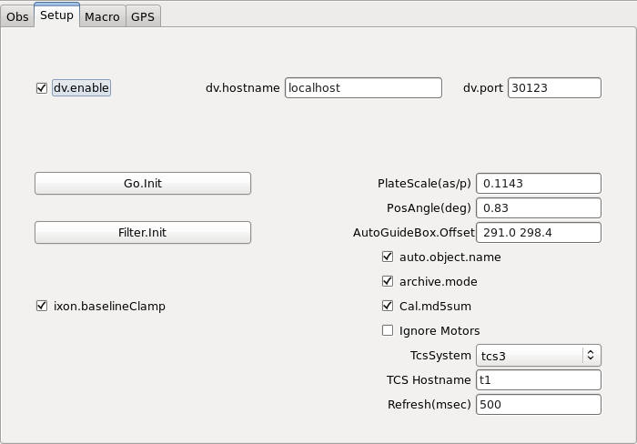

The setup tap provide access to additional software parameter. Observers should not change these. Only the Go.init or Filter.init button may needed to re-initialize. Shown are the normal MORIS setup values.

2.8 Macro Tab

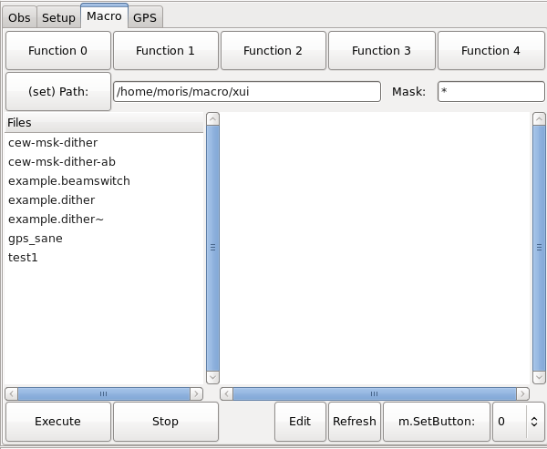

The macro tab allow observer to execute moris IC command located in a text file. Complex or repetitive sequences can be easily done using macros.

3.9 GPS Tab

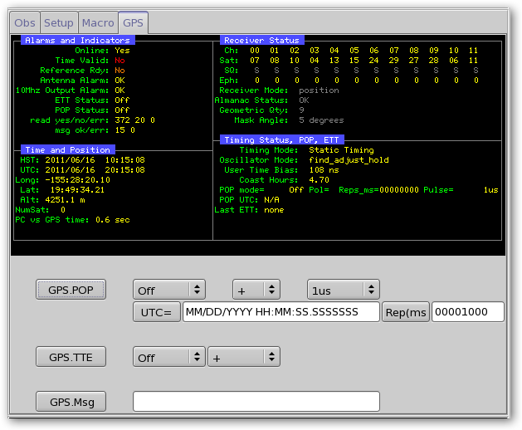
The GPS tab display detail status from the GPS, and provide some widget to command the GPS unit. User should refer to the TM/4 manual, as the spex GUI duplicate the data and term used in the vendor’s TM/4 GPS manual and software.

Appendix A – Staff Start up and Shutdown Procedures for Moris

The Moris PC is connected to KVMCass (http://irtfweb.ifa.hawaii.edu/irtf/computing/network/kvm_201406.php). This provide access to the console if or when the PC is not reachable via the network.

1. Connecting to MORIS VNC session

The moris software runs in stefan's VNC session: stefan:12. Connect to this vnc session.

2. How to start the IC, XUI, DV in the moris VNC session.

Click on the “ssh to moris” desktop icon to bring up 3 terminal.
Start the IC in terminal 1:
- startic

Start the XUI in terminal 2:
- startxui

Start DV in terminal 3:
- startdv

After the IC, XUI, and DV is running initialize the IXON camera and take an image:

- First do a filter.init to initialize the filter wheel (button is in the setup tab).
- Then selection the IXON camera. This tries to load the device driver for the camera.
If it fails on the first thr. Repeat a few time either by selecting the “Off” Tab, then the “IXON” tab again. Or my typing “go.init” in the command line.
- If the camera fails to initialize after 3 attempts, then connect to spexPwr. Power down the “moris_camera” for 30 seconds. Power up. Then repeated from step #2

3. How to terminate the IC, XUI, and DV in moris's VNC session.

To terminate the software:
- Type “die” into the XUI command line prompt. This should terminal the IC, and XUI.
- Click on the “Quit” button in DV.
- All 3 terminal should be at the command prompt. Exit the terminal by type “exit” at the prompt or clicking on the “X” on the upper right area of the window.

If you think that a reboot of the moris PC is necessary, ssh to moris as root, and issue the reboot command:
- ssh moris -l root
- reboot

4. About MORIS's AC power.

MORIS is connected to the “Spexoutpwr” coolrack remote power unit. It has 3 outlet assigned:
1. moris_camera – The ixon camera.
2. moris_pc – The linux PC “moris”
3. mor_FLT_GPS – The filter wheel and GPS power supplies.

Normally the AC power the left ON. These individual components can be powered off or on via the “rpcm” software on stefan (or other IRTF workstations).

Appendix B - Mounting Checklist

See the schematic in Figure 1 for the IRTF MORIS setup.

Important note: power should be off when attaching and detaching cables. The best way to setup is to have all power off, connect everything, then turn all power on.

Items to check in order to confirm proper hardware setup for POETS usage:

 Foreoptics box mounted on side of SpeX
 Camera mounted on bottom of fore-optics box
 Manual shutter between POETS and SpeX is open
 BNC cable attached to GPS antenna at top of telescope
 BNC cable attached to “antenna” port on back of GPS
 Serial octopus cable plugged into the back of the GPS
 The blue usb cable connecting the camera to the computer
 Camera power cable plugged into jack on camera and an outlet (inside the moris electronic box)
 Multiple IO cable plugged into the “external I/O ” connection on camera and the “external trigger” BNC connects to the GPS octopus cable
 The MORIS PC has the following connection
- KVM connection to IRTF Facility “kvmcass” port 2
- Ethernet
- serial connector to GPS unit (located in moris electronic boxx)
- usb cable (blue) to andor camera.

 GPS power cable plugged into jack on the GPS octopus cable and an outlet (inside the moris electronic box)
 Power on for the following:
- GPS [lights on front will glow];
- camera [can’t confirm power on until software is started];
- computer [lights on front will glow].


Appendix C – Filter Wheel Details

Moris has a 10 position filter wheel. The following table summaries the filters installed in this wheel.

Note: Wavelen column contains the values used by the software for differential refraction calculations.

Appendix D - Fore-Optics and Mounting Box notes

D.1 - Adjustment of the z-extension
The camera can be focused by adjusting the “z-extension”. This is the threaded plate system at the base of the box. This system is comprised of three components: (i) an inner- threaded aluminum piece (32 threads per inch), (ii) and outer-threaded steel plate which screws into (i) allowing for a range of xx inches vertical motion, and (iii) an aluminum base plate which attaches to (i) and the camera. Component (ii) sets the camera height and can be adjusted via threading. By loosening the sliding attachments between components (i) and (iii), the camera is decoupled and can move in the z-direction without rotation.

In practice, the sliders on component (iii) are loosened and the camera is allowed to drop to the lowest position. Component (ii) is threaded into or out of component (i) to the desired height. The camera and component (iii) are then lifted until flush with component (ii) (there is fitted groove between components (ii) and (iii) in order for the connection to be light tight), and the sliding attachments on component (iii) are tightened to hold the camera in place.

The system should be setup to be cofocal with SpeX. Different filters should not effect the focus to a detectable degree. Therefore, the focus should not require adjustment during regular use.

Important note: The focusing system was designed to allow for maximum range. If the camera is lifted to the highest position, the mount for lenses 2 & 3 could impact the shutter and/or camera window. Be careful!

D.2 Adjustment of mount for lenses 2 & 3
The mount for lenses 2 & 3 was designed to be adjustable in the z direction. Thus, the mounting component screws into the mounting bracket with threads of 14 per inch. Optimal alignment places the top of lens 2 in the middle of the mounting bracket. This should not need to be adjusted during regular use.

See the important note under “adjustment of the z extension” concerning adjustment of this mount.

Appendix E – Movie Mode Timing

This section provides information on determine the time stamp of your movie mode images. The following example use 1.0 sec itime, 1 coadd.

1. Internal Trigger

In Internal Trigger, the Ixon camera start its data acquition when commanded by the PC.
The PC reads the computer’s system time after command the IXON to start. This time should be accurate to better than 0.1 seconds. The linux computer clock is synced to the GPS using NTP.
Key FIT headers are:

TIME_OBS= '19:57:33.470932' / UT TIME OF ACQISTION ('hh:mm:ss.ss')
DATE_OBS= '2011-08-23' / UT DATE OF ACQUISITION ('yyyy/mm/dd')
ITIME = 1.0000 / INTEGRATION TIME IN SECONDS
A_ITIME = 1.000000 / IXON actual exp sec
A_KTIME = 1.001740 / IXON actual kinetic sec

The TIME_OBS provide the time for the 1st image. The repeat period is given by A_KTIME.
So,
Movie image 0 = DATE_OBS = 19:57:33.470932
Movie image 1 = DATE_OBS + A_KTIME. = 19:57:33.470932 + 1.001740 seconds
Movie image 2 = DATE_OBS + 2*A_KTIME = 19:57:33.470932 + (2*1.001740) seconds
…
Movie image N = DATE_OBS + N*A_KTIME.

The exposure time of a single coadd is provided by ITIME. This should match the A_ITIME.

2. External Start

In External Start, a GPS pulse will start the movie acquisition. The subsequence frames are scheduled by the Ixon camera, and the A_KTIME is the period between frames.

Key FIT headers are:

TIME_OBS= '19:58:52.000000' / UT TIME OF ACQISTION ('hh:mm:ss.ss')
DATE_OBS= '2011-08-23' / UT DATE OF ACQUISITION ('yyyy/mm/dd')
MV_TRIG = 1 / MovieTrigger is External_Start
GPS_CMD = '#21,1,+,08232011,195852.0000000,00001000'#21'
ITIME = 1.0000 / INTEGRATION TIME IN SECONDS
A_ITIME = 1.000000 / IXON actual exp sec
A_KTIME = 1.001740 / IXON actual kinetic sec

MV_TRIG show External Start.
GPS_CMD, show the POP command given to the GPS in order to start the movie. The GPS manual is available on the IRTF MORIS web site. The DATE and TIME_OBS should match the start pulse command by the GPS, in this case 19:58:52.0 is the start time.

The TIME_OBS provide the time for the 1st image. The repeat period is given by A_KTIME.
So,
Movie image 0 = DATE_OBS = 19:58:52.0
Movie image 1 = DATE_OBS + A_KTIME. = 19:58:52.0 + 1.001740 seconds
Movie image 2 = DATE_OBS + 2*A_KTIME = 19:58:52.0 + (2*1.001740) seconds
…
Movie image N = DATE_OBS + N*A_KTIME.

The exposure time of a single coadd is provided by ITIME. This should match the A_ITIME.

3. External

In External, a GPS pulses will cause the image on the CCD to be transferred to the readout area on the rising pulse of the GPS POP signal. The image in the readout area, are then sampled and saved.

Key FIT headers are:

TIME_OBS= '23:32:50.000000' / UT TIME OF ACQISTION ('hh:mm:ss.ss')
DATE_OBS= '2011-08-24' / UT DATE OF ACQUISITION ('yyyy/mm/dd')
MV_TRIG = 2 / MovieTrigger is External
GPS_REP_= 1000 / GPS Pulse Repeat Period, milliseconds
GPS_CMD = '#21,2,+,08242011,233250.0000000,00001000,6 '
ITIME = 0.0000 / INTEGRATION TIME IN SECONDS
A_ITIME = 0.000010 / IXON actual exp sec
A_ATIME = 0.287280 / IXON actual Accum sec
A_KTIME = 0.287280 / IXON actual kinetic sec

The GPS_CMD, show the POP command given to the GPS in order to start the movie. The GPS manual is available on the IRTF MORIS web site. The DATE and TIME_OBS should match the start pulse command by the GPS. Note the TIME_OBS match up with the GPS_CMD start pulse (23:32:50.0), and the GPS_REP is 1000 ms (same value used in the GPS_CMD).

The 1st image should be discarded. The Time Stamp values are valid for the remaining images.

The TIME_OBS provide the time for the 1st image. The repeat period is given by A_KTIME.
So,
Movie image 0 = DATE_OBS = Undefined.
Movie image 1 = DATE_OBS = 23:32:50
Movie image 1 = DATE_OBS + 1*GPS_REP = 23:32:50 + (1*1.000) seconds.
Movie image 2 = DATE_OBS + 2*GPS_REP = 23:32:50 + (2*1.000) seconds.
…
Movie image N = DATE_OBS + N*GPS_REP.

The exposure time is equal to the GPS_REP, in this example it is 1.000 seconds.

Appendix F – Additional notes

F.1 Andor Ultra iXon 897 (usb)

The camera for this system is an Andor Technology iXon. It is an off-the-shelf camera, with a back-illuminated, frame-transfer CCD (512 x 512, with 16 μm square pixels).

The 2016 MORIS Andor camera is an iXon Utrax Model DU-897U-CS0-#BV Serial No X-10936.
The following vendor documents:

- iXon Ultra 897 Hardware Guide 1.3.pdf - Andor Hardware Guide
- iXon Ultra 897 Quick Start Guide.pdf - Quick Start setup guide.
- Andor_iXon_Ultra_897_Specifications.pdf - iXon Ultra 897 Specifications
- 1608-andor-system_performance.pdf - Performance Sheet for iXon Ultra 897 SN X-10936
can be found at the moris web site: http://irtfweb.ifa.hawaii.edu/~moris/.

F.2 Spectrum Instrument TM-4 GPS Unit

The GPS for this system is a Spectrum Instruments, Inc. Intelligent Reference TM-4. The vendor's user manual can be found on the moris web site: http://irtfweb.ifa.hawaii.edu/~moris/.

The GPS is connected to the computer, trigger cable, and power via an octopus serial cable. A serial connection goes to the computer, a BNC connection from the “output” octopus cable goes to the “external trigger” SMB on the camera, and power comes from an adapter (Input: 120-140 V, 0.4 A, Output: 24 V, 0.4 A) with a standard 120 V U.S. plug. A BNC cable runs from the “antenna” GPS port to the GPS antenna mounted at the top of the telescope.

Appendix G – Problems and Solutions

Some Troublelog problems and solutions are described here as a resource for future problems.

- Red Filter Wheel Message “IOBits!=Filter”.

Each filter position in moris has unique bit value.
After moving the filter wheel, moris checks to see if the IO Bit value matches the filter position. If it does not match, you will see this message. It is likely the filter is not in the correct position. The user should initialize the will and perform the move again.

- “sock communication error” while performing a filter init or move.

Moris communicates to the filter wheel via a telnet connect to a digiport. This indicates an error with the telnet connection. Try the following to clean the problem:

First “ping morisdigi”. If the ping fails, the digi is offline. Check power and cabling to the digi.

- Kill any lingering telnet connection to the digi:
  - From Stefan, telnet to moris digi: “telnet morisdigi”
  - Login as “root”, passwd is “ dbps”.
  - Type “kill 1” to kill any connections on port 1.
  - “quit” to exit moris digi.
  - Initialize the filter wheel on moris.

If the “kill 1” does not work, substitute “boot action=reset”. This warm boots the digi.

