IRTF MOC Manual

Filename: moc_manual-draft.odt
Last Saved: 2020-05-21

NOTE: This is a preliminary version of the MOC Manual. Some MORIS information is contain here as the MORIS Manual was used for the early draft ( ie some screen shot show MORIS’s XUI). This manual will be updated soon.

Table of Contents
Figure 1 – MOC Block Diagram 3
1. A quick Intro into MOC 4
2. MOC Software 5
2.1 Running MOC Linux 5
2.2 Initializing the iXon Camera. 7
2.3 Simple Observing Instructions for Linux 8
2.4 Guiding 9
2.5 Movie Mode 9
2.6 Obslog dialog 11
2.7 Setup Tab 12
2.8 Macro Tab 12
Appendix A – Staff Start up Procedures for MOC 14
Appendix C – Filter Wheel Details 15
Appendix E – Movie Mode Timing 18
Appendix F – Additional notes 20
F.1 Andor Ultra iXon 897 (usb) 20
Appendix G – Problems and Solutions 21

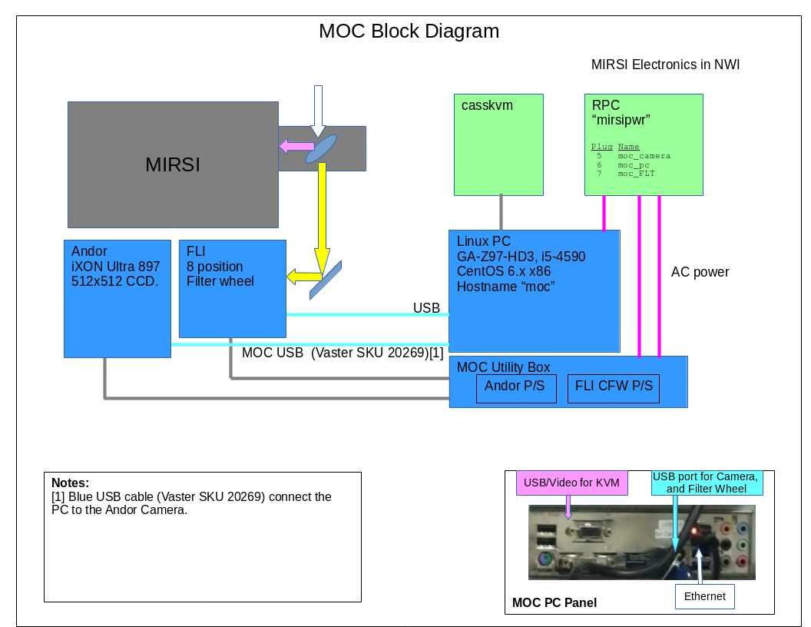

Figure 1 - MOC Block Diagram

1. A quick Intro into MOC

MIRSI Optical Camera (MOC) is a visible wavelength camera attached to the MIRSI Infrared Insturment. A dichroic len in MIRSI allows both infrared and visible observation for MIRIS. MOC is based on the IRTF's MORIS and MIT POETS.
The IRTF MOC Home page is located at: http://irtfweb.ifa.hawaii.edu/~moc/

The primary components of MOC are:

- Ixon CCD Camera System: Andor iXon Ultra DU-897U-CSO camera, using a 512x512 E2V CCD97 sensor. A USB cable connect the camera to the PC.

- Computer: A PC located on the bottom of the telescope runs the software for controlling the camera and filter wheel. This PC runs CentOS 6 and the IRTF MOC software (ic, xui, DV) used for observing.

- Light-tight Foreoptics box contains:
  - Filter Wheel: A motorized FLI 8 position wheel with 1” filters.
  - Fold Mirror:
  - Re-imaging optics:

- VNC Access. The MOC software GUI (XUI, DV) runs in the IRTF VNC session stefan:06.

2. MOC Software

MOC run custom IRTF software for observing. If features:

- Provide a IRTF like GUI, very similar to Spex’s GUI. (IC, XUI, DV)
- Integrates better with the IRTF TCS, MIRIS, and network.
- Simplify user interface.
- MOC can act as a guider for MIRSI.

MOC does not provide access to the Andor OEM software. Only the IRTF software is supported.

2.1 Running MOC Linux

Normally the MOC software is running in a IRTF VNC session. You just need to connect to his VNC session to use MOC.

The MOC software is running in an IRTF VNC session. You must use the RealVNC client to connect to stefan.ifa.hawaii.edu:06. Contain the TO or Staff for the vnc password.

1. Connecting to the MOC VNC session.

- All users will need an IRTF program account.
- For remote users, you will need to use the RealVNC vnc viewer on your personal machine.
- For summit observers, run this vnc viewer command in any xterm on IRTF workstation: “vncviewer stefan:6”.
- Refer the IRTF website http://irtfweb.ifa.hawaii.edu for observers instruction.
- Contact the TO or IRTF staff for the VNC password of the day.
- After connecting to the MOC VNC, login using your program account (ie: 2019B015) and password at the following MOC XUI login dialog box.

.

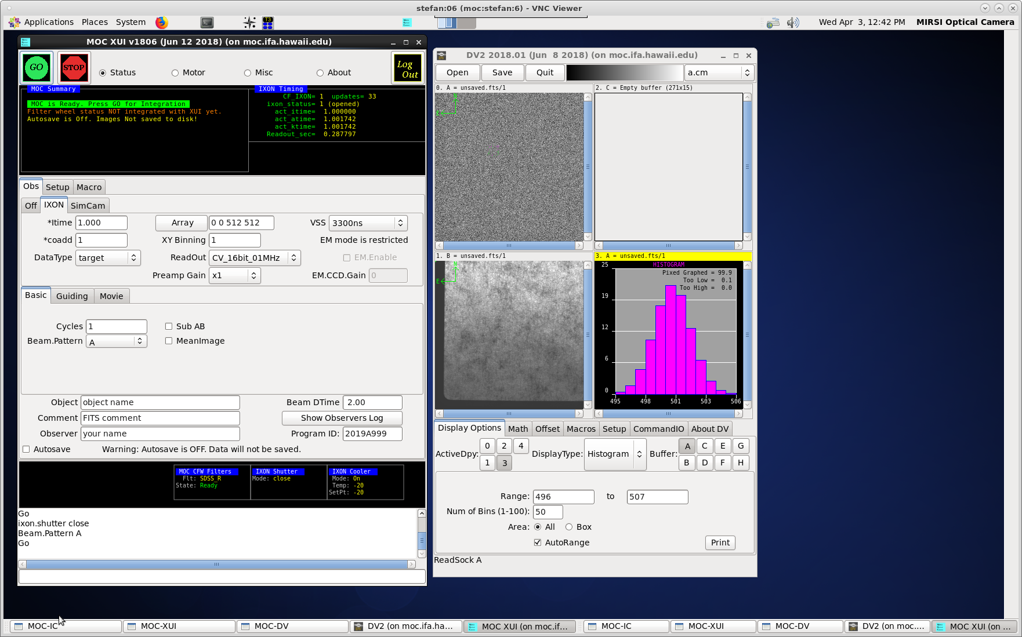

MOC running in the VNC Session

On the left side you should see the MOC XUI (X Users Interface). The XUI provide full control for the camera’s operations.
On the right is DV, IRTF’s standard data viewer for instrumentation. Documentation for DV is at http://irtfweb.ifa.hawaii.edu/Facility/DV/

The follow diagram explains the major sections of the XUI:

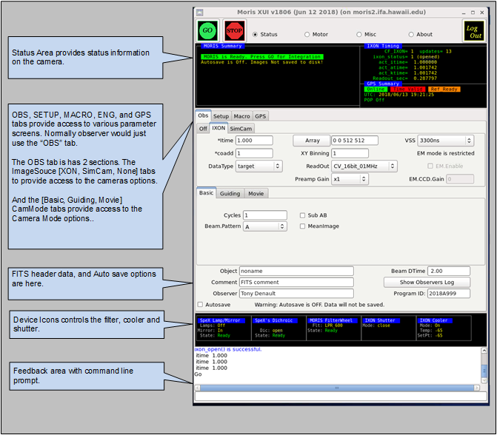

MOC XUI diagram

2.2 Initializing the iXon Camera.

When you are ready to start observing, Set the ImageSource to IXON. This will load the camera driver and initialize the hardware. Once this has be successful opened, check the IXON Cooler and Shutter setup.
By clicking on the Device Icons, you can change the Cooler or Shutter setting.

- After observing, set the Image Source back to “Off”. This closes the camera driver, putting the camera into a safe idle mode.
- If the Ixon camera fails to initialize, type “go.init” to re-iniitialize.
- The Ixon Cooler should be ON, and will take a few minute to reach its setpoint of -65. If it is not ON, click on the Ixon Cooler icon to changed it settings.
- Check the shutter to ensure open or closed.
- Check the Filter setting. If the filter is not “Ready”, go to the Setup tab and do a “Filter.Init”

2.3 Simple Observing Instructions for Linux

Once the IXON camera is ready and you are ready to take date, review the ixon parameters:

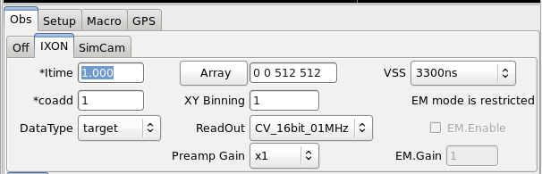
- Itime is the ixon exposure time for a CCD readout.
- Coadd is the number of readouts to accumulate into an image.
- Array text input allows you to change the “X Y Wid Hgt” of the subarray. Clicking on the “Array” button resets the value to readout the full array (0,0 512x512).
- XY Binning set the pixel binning value for the CCD.
- Readout menu sets the iXon’s AMP, Channel, and HSS values. The default “CV_16bits_01MHz”.
- Preamp Gain sets the Ixon Preamplifier gain.
- VSS is the iXon Vertical Shift speed value.
- EM mode is an restricted option. If you are interested in using EM mode, arrangement need to made with your support scientist prior to your observing run.

The follow table summaries the readout rate in seconds of the CCD using various Readout, and VSS options on a full frame (512x512, no binning) readout.

It is recommended that users use “CV_16bits_01Mhz” and VSS=3.3 unless faster readout is necessary. Of course, faster readout rate usually increase the noise. Using subarray and binning can also decrease the readout rate.

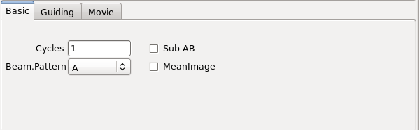

Select CamMode Basic. The Beam.Pattern tells the camera if the image in take is a BEAM A or B image. If beam.pattern is AB, then an A and B beam images are taken while beam switching the telescope. Cycles repeats the Beam.Pattern in basic mode.

Clicking on the Filter wheel icon brings up a menu allow you to select a desired filter.

Autosave controls if the images are saved.

Once you selected the desired options, click GO to take and image.

2.4 Guiding

Select “Guiding” on the Cammode tab enables guiding. The following screen is displayed:
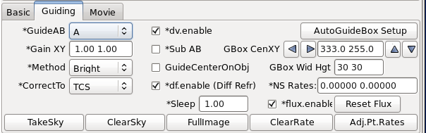

While guiding, images can be saved.
The Telescope operator should assist observer if guiding with MOC.

2.5 Movie Mode

Selecting “Movie” on the cammode tab enables movie mode. The follow screen is displayed:

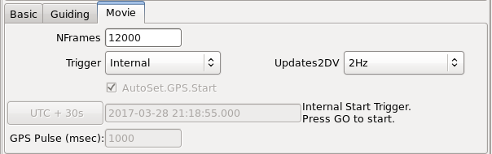
Movie mode is a high speed image mode ( The Ixon calls its Kinetic mode ). The software will buffer images in RAM, and write 3D FITS data when the RAM is filled. Continually writing 3D FITS files until the movie mode is completed. The images in the movie sequence are taken at a fixed rate, with minimal overhead between images.

The general procedures for taking a movie are:

1. Use basic mode to adjust the itime, coadds, Array, XY Binning and other IXON readout parameter to you desired setting. Go on, once you have produced a satisfactory basic image.

2. Switch to movie mode.

3. Setup Movie parameters:

NFrames – are the number of frames in the movie. Movie mode will stop after saving “NFrames” of data, or when the STOP button is press. Enter the desired number of frames, or enter a large number and manual stop the movie sequence. Max input value is 999999.

Trigger – The trigger option are:
- Internal – The ixon will start the movie sequence and acquisition of each frame. This is the simplest option, but the timing of the start and subsequences frame are performed internally by the IXon hardware. The “act_ktime” values shows the period of the subsequence images. The absolute timestamp of your data (or TIME_OBS ) is good to about 0.1 seconds.

- External_Start – A start pulse by the GPS unit will start the movie sequence. The ixon will schedule the subsequence frames. The act_ktime show the period of the subsequence images.

- External – A repeating GPS pulse will trigger each frame of the movie sequence. This provides the most accurate timing of each the image. Frame transfers and readouts are slaved off of the GPS pulses. In External mode, itime becomes an ‘Exposure Delay’ term. In this mode, the software will set itime to 0.000 (No Delay). The GPS Rep_ms is the exposure time between readouts.

AutoSet.GPS.Start – If External or External_Start triggering is selected, you will need to specify the start time of the GPS unit. The AutoSet.GPS.Start, if enable, will auto load the “current UTC Time + 10 seconds” into the GPS when the GO is press. If AutoSet.GPS is not set, you must manual enter the GPS.Start Date and Time.

GPS.Start text box – If you are manually entering the start time, type the UTC Date and Time into the text area under the AutoSet.GPS.Start. The format is YYYY-MM-DD HH:MM:SS.SSS. Hit return to accept this input. The “UTC+30s” button will load the current data and time (plus 30 seconds) into the text area.

GPS Pulse (sec): For External Trigger ONLY, you will need to enter the period of the GPS pulse here. This needs to be larger that the act_ktime (in millseconds). If you enter a value that is too low, the software will set it in a minimal value.

Update2DV – MOC updates the DV image at a rate set by this menu (Images can be cache and saved at a higher rate). Set the desired DV update rate. Note for VNC user a lower rate may be optimal as a higher display rate may saturate the VNC bandwidth.

Enable Autosave. In move mode, autosave must be enabled.

Coadds are not support in Movie mode. Coadds will be set to 1.

It’s best to setup your movie mode inputs, do a test with a limit number of “nframes”. Check the timing. Now you will be ready to start you observing.

“Appendix E – Movie Mode Time” – provide information on determining the timestamps of the movie frames.

2.6 Obslog dialog
This button bring up the observing log dialog box shown below:

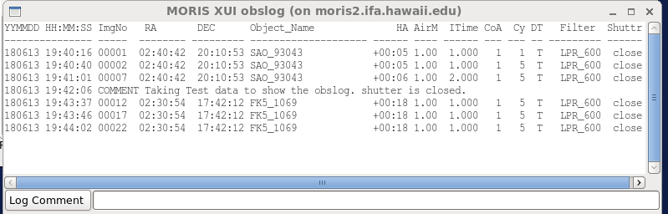

On every GO (with autosave ON) a line it appended to a obslog.txt file in the saved data directory. This dialog box show the contents of this obslog.txt file.
On the bottom of the dialog box, a text input allows you to enter a comment. When the Log Comment button is pressed, this text is append to the log file.
The column for the log file are:
YYMMDD HH:MM:SS – the UTC date and time of the GO.
ImgNo – The image number of the 1st image in the cycle.
RA,DEC – The current postion of the Telescope in FK5 J2000 coordinates.
Object_Name – the object name from the XUI Object field (and FITS OBJECT keyword).
HA – The Hour Angle of the Telescope.
AirM – The AirMass of the Telescope
Itime – The Itime value from the camera.
CoA – The Coadd value from the camera.
Cy – The cycles value from the camera.
DT – The Datatype value from the camera: T=Target, S=Standard, C=Calibration
Filter – The selected MOC Filter wheel position.
Shutter – The state of the iXon Shutter (open, closed).

2.7 Setup Tab

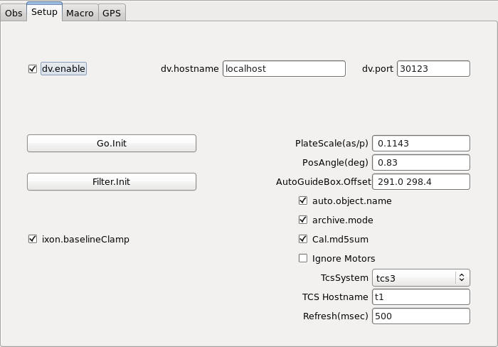

The setup tap provide access to additional software parameter. Observers should not change these. Only the Go.init or Filter.init button may needed to re-initialize. Shown are the normal MOC setup values.

2.8 Macro Tab

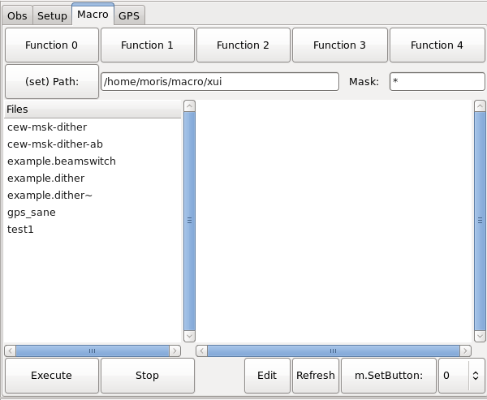

The macro tab allow observer to execute MOC IC command located in a text file. Complex or repetitive sequences can be easily done using macros.

Appendix A – Staff Start up Procedures for MOC

MOC IC, XUI, DV runs in the vnc session Stefan:06. Inside this VNC, setup the IC, XUI, and DV.

IC:
Select “xterm to MOC PC” on the openwin menu.
Login
- cd current/ic
- mocic

XUI:
Select “xterm to MOC PC” on the openwin menu.
Login
- cd current/xui
- mocxui

IC:
Select “xterm to MOC PC” on the openwin menu.
Login
- cd current/dv
- dv

After the IC, XUI, and DV is running initialize the IXON camera and take an image:

- First do a filter.init to initialize the filter wheel (button is in the setup tab).
- Then selection the IXON camera. This tries to load the device driver for the camera. It usually fails on the first they. Repeat a few time either by selecting the “Off” Tab, then the “IXON” table again. Or my typing “go.init” in the command line.
- If the camera fails to initialize after 5 attempts, then connect to ???. Power down the “MOC_camera” for 30 seconds. Power up. Then repeated these steps.

Appendix C – Filter Wheel Details

MOC has a 8 position filter wheel. The following table summaries the filters installed in this wheel.

Note: Wavelen column contains the values used by the software for differential refraction calculations.
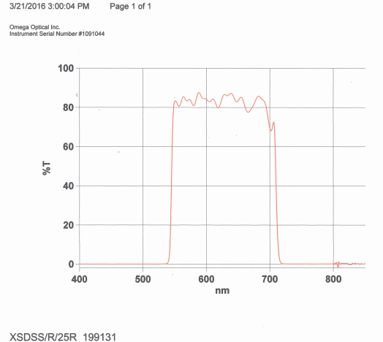
SDSS_R Filter Scan

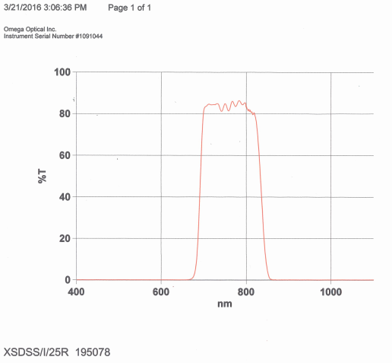
SDSS_I Filter Scan

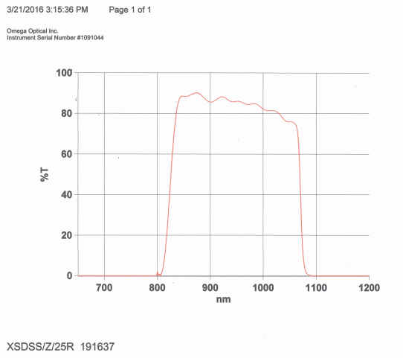
SDSS_R Filter Scan

Originial Filter Scan document for SDSS_R, SDSS_I, and SDSS_Z are located in http://irtfweb.ifa.hawaii.edu/~moc/irtf/vendor_info/omega_optical/160323_filter_scans.pdf

Appendix E – Movie Mode Timing

This section provides information on determine the time stamp of your movie mode images. The following example use 1.0 sec itime, 1 coadd.

1. Internal Trigger

In Internal Trigger, the Ixon camera start its data acquition when commanded by the PC.
The PC reads the computer’s system time after command the IXON to start. This time should be accurate to better than 0.1 seconds. The linux computer clock is synced to the GPS using NTP.
Key FIT headers are:

TIME_OBS= '19:57:33.470932' / UT TIME OF ACQISTION ('hh:mm:ss.ss')
DATE_OBS= '2011-08-23' / UT DATE OF ACQUISITION ('yyyy/mm/dd')
ITIME = 1.0000 / INTEGRATION TIME IN SECONDS
A_ITIME = 1.000000 / IXON actual exp sec
A_KTIME = 1.001740 / IXON actual kinetic sec

The TIME_OBS provide the time for the 1st image. The repeat period is given by A_KTIME.
So,
Movie image 0 = DATE_OBS = 19:57:33.470932
Movie image 1 = DATE_OBS + A_KTIME. = 19:57:33.470932 + 1.001740 seconds
Movie image 2 = DATE_OBS + 2*A_KTIME = 19:57:33.470932 + (2*1.001740) seconds
…
Movie image N = DATE_OBS + N*A_KTIME.

The exposure time of a single coadd is provided by ITIME. This should match the A_ITIME.

2. External Start

In External Start, a GPS pulse will start the movie acquisition. The subsequence frames are scheduled by the Ixon camera, and the A_KTIME is the period between frames.

Key FIT headers are:

TIME_OBS= '19:58:52.000000' / UT TIME OF ACQISTION ('hh:mm:ss.ss')
DATE_OBS= '2011-08-23' / UT DATE OF ACQUISITION ('yyyy/mm/dd')
MV_TRIG = 1 / MovieTrigger is External_Start
GPS_CMD = '#21,1,+,08232011,195852.0000000,00001000'#21'
ITIME = 1.0000 / INTEGRATION TIME IN SECONDS
A_ITIME = 1.000000 / IXON actual exp sec
A_KTIME = 1.001740 / IXON actual kinetic sec

MV_TRIG show External Start.
GPS_CMD, show the POP command given to the GPS in order to start the movie. The GPS manual is available on the IRTF MOC web site. The DATE and TIME_OBS should match the start pulse command by the GPS, in this case 19:58:52.0 is the start time.

The TIME_OBS provide the time for the 1st image. The repeat period is given by A_KTIME.
So,
Movie image 0 = DATE_OBS = 19:58:52.0
Movie image 1 = DATE_OBS + A_KTIME. = 19:58:52.0 + 1.001740 seconds
Movie image 2 = DATE_OBS + 2*A_KTIME = 19:58:52.0 + (2*1.001740) seconds
…
Movie image N = DATE_OBS + N*A_KTIME.

The exposure time of a single coadd is provided by ITIME. This should match the A_ITIME.

3. External

In External, a GPS pulses will cause the image on the CCD to be transferred to the readout area on the rising pulse of the GPS POP signal. The image in the readout area, are then sampled and saved.

Key FIT headers are:

TIME_OBS= '23:32:50.000000' / UT TIME OF ACQISTION ('hh:mm:ss.ss')
DATE_OBS= '2011-08-24' / UT DATE OF ACQUISITION ('yyyy/mm/dd')
MV_TRIG = 2 / MovieTrigger is External
GPS_REP_= 1000 / GPS Pulse Repeat Period, milliseconds
GPS_CMD = '#21,2,+,08242011,233250.0000000,00001000,6 '
ITIME = 0.0000 / INTEGRATION TIME IN SECONDS
A_ITIME = 0.000010 / IXON actual exp sec
A_ATIME = 0.287280 / IXON actual Accum sec
A_KTIME = 0.287280 / IXON actual kinetic sec

The GPS_CMD, show the POP command given to the GPS in order to start the movie. The GPS manual is available on the IRTF MOC web site. The DATE and TIME_OBS should match the start pulse command by the GPS. Note the TIME_OBS match up with the GPS_CMD start pulse (23:32:50.0), and the GPS_REP is 1000 ms (same value used in the GPS_CMD).

The 1st image should be discarded. The Time Stamp values are valid for the remaining images.

The TIME_OBS provide the time for the 1st image. The repeat period is given by A_KTIME.
So,
Movie image 0 = DATE_OBS = Undefined.
Movie image 1 = DATE_OBS = 23:32:50
Movie image 1 = DATE_OBS + 1*GPS_REP = 23:32:50 + (1*1.000) seconds.
Movie image 2 = DATE_OBS + 2*GPS_REP = 23:32:50 + (2*1.000) seconds.
…
Movie image N = DATE_OBS + N*GPS_REP.

The exposure time is equal to the GPS_REP, in this example it is 1.000 seconds.

Appendix F – Additional notes

F.1 Andor Ultra iXon 897 (usb)

The camera for this system is an Andor Technology iXon. It is an off-the-shelf camera, with a back-illuminated, frame-transfer CCD (512 x 512, with 16 m square pixels).

The 2016 MOC Andor camera is an iXon Ultra Model DU-897U-CS0-#BV Serial No X-10744.
The following vendor documents:

- iXon_System_Performance_SN_X-10744.pdf - Performance Sheet for iXon Ultra 897 SN X-10744. Used from 2018-05 to Present.
- Andor_iXon_Ultra_897_Specifications.pdf - iXon Ultra 897 Specifications
- iXon Ultra 897 Quick Start Guide.pdf - Quick Start setup guide.
- iXon Ultra 897 Hardware Guide 1.3.pdf - Andor Hardware Guide
can be found at the moc web site: http://irtfweb.ifa.hawaii.edu/~moc/

Appendix G – Problems and Solutions

Some common problems and solutions are described.

